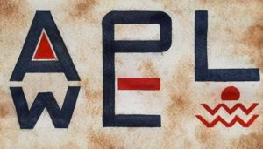

AWPEL (2.1) 2018
SPECIAL ISSUE
Ethnographic accounts of linguistic issues
in the Yugoslav successor states

Guest editor
Roswitha Kersten-Pejanić

TABLE OF CONTENTS
Editorial
Language issues in former Yugoslav space: Current perspectives
Costas Canakis (ii-iii)

Ethnographic accounts of linguistic issues in the Yugoslav successor states:
An introduction
Roswitha Kersten-Pejanić (iv-xvii)

Linguistic emancipation within the Serbian mental map:
The implementation of the Montenegrin and Macedonian standard languages
Christian Voß (1-16)

Peeling the onion top-down: Language policy in Serbia between power and myth
Branimir Stanković & Marija Stefanović (17-41)

Rediscovering the border region in linguistics: Cases from Southeastern Europe
Lumnije Jusufi (42-58)

Languages of loss and mourning beyond (the) borders: Bosnia
Snežana Stanković (59-83)

Contributors

AWPEL

EDITORIAL

Language issues in former Yugoslav space: Current perspectives

Costas Canakis

University of the Aegean
c.canakis@sa.aegean.gr

Embarking on a special issue on former Yugoslavia is no mean task for any journal, as it involves taking into consideration the many, significant contributions of scholars over the last three-odd decades. From grammarians to sociolinguists, historians, geographers, and anthropologists, scholars have succeeded in offering a kaleidoscopic account spanning over periods of peace and warfare, which, combined with official policy-making texts (and, no less, the virulent propaganda in public discourse just about everywhere) give a much more comprehensive picture of the linguistic state of affairs in the former Yugoslav lands today than are available for most other polities. And this is a legacy rarely afforded to scholarship as well as a burden to be borne with the respect it deserves.
Although there is little doubt that former Yugoslavia and the successor states have often attracted the “pornographic gaze” of international journalism and scholarship, it is nonetheless certain that, in the long run, this has had some serious consequences: today it takes serious professional engagement to talk about either Yugoslavia or the successor states –it is not exactly a topic allowing for dabbling, either locally or, what is worse, internationally. And all contributors to this issue –some of them locals, some of them foreigners– are manifestly aware of this.
The merits of this special issue, as I see them, have to do both with the diverse themes tackled and theoretical approaches assumed by contributors as well as the areas they focus on: although none of the contributions focuses exclusively on Croatia, I am especially pleased to have contributions problematizing language issues in Macedonia both because of its close ties with BCMS and because it is less frequently discussed in relation to it. The downside is the absence of a contribution on Croatia and Slovenia, (which, despite its separate history, can hardly be convincingly considered outside the context of the breakup of former Yugoslavia). It must be stressed that this does in no way reflect editorial choices (or predilections). I believe that the absence of a contribution on Croatia is partly remedied by Roswitha Kersten-Pejanić’s insightful introductory chapter, which reflects her long-standing interest and specialization in this area of the South-Slavic continuum, and the references to Croatia in other contributions. Ideally, however, we would have wished for individual contributions focusing on each and every constituent part of former Yugoslavia.
On a different note, I would like to express my gratitude to the guest editor of this special issue, Roswitha Kersten-Pejanić, for persistently and unfailingly doing her best to secure high quality papers which will foster continuing dialogue in a field to which, all of us involved, share a long-standing commitment.
Last, I would like to introduce and extend a warm welcome to my doctoral student, Daphne-Nicoletta Christoulaki, our new copy editor, to the editorial team of AWPEL.

Daphne Nicoletta Christoulaki received her BA in sociology from Panteion University and her MA in gender & sexuality studies from the University of the Aegean. In her MA thesis she focused on the linguistic landscape of Mytilene, Lesvos vis-à-vis gendered and sexed signs. Her current research interests focus on ethnographic linguistics and linguistic landscape studies. She has recently started working towards her doctoral dissertation providionally entitled “Contested linguistic landscapes: Mytilene”.
AWPEL

Ethnographic accounts of linguistic issues in the
Yugoslav successor states: An introduction

Roswitha Kersten-Pejanić

Center for Advanced Studies of Southeastern Europe (CAS SEE)
University of Rijeka
roswitha.kersten-pejanic@uniri.hr

Doing ethnographic linguistics (or linguistic ethnography) in the area of what used to be Yugoslavia is both a challenging and a promising undertaking. Challenging, in that there are so many ideological traps to take into consideration. Promising, in that there are so many complex matters to take a closer look at. These matters, even when exclusively realized in linguistic means, may have great influence on people’s everyday political, cultural, and social meaning-making. Especially so, as indexical relations and the ideological premises and effects of choosing to use one linguistic realization over the other, has played an important role for all speech communities in the region.
As is well known from many accounts, doing linguistics can be a highly political undertaking. It bears manifold potential traps even when not adhering to a specific ideological stance –ideological stance being the commonest problem. This is true especially, but not only, for the language debates over the successor standards and semi-standards of former Serbo-Croatian/Croato-Serbian (Kordić 2010; Gröschel 2009; Bugarski 2012 to name just a few). Linguistic encounters on Southeastern Europe both within and outside the former Yugoslav lands have been able to study and contribute to a wide range of language planning activities in the region over the past decades (Friedman 1998; many of the contributions in Schaller 1997; Toporišič 1997; Kamusella 2016). This possibility of linguistics being used as a political tool is exponentially increased in times of ideological debates based on nationality, ethnicity or any other aspect of identity-making. Such debates have been plentiful in ex-Yugoslavia and they add up to an “extremely interesting and complex language situation” as Milorad Radovanović and Randall A. Major (2001: 2) rightly put it.
In this sense, looking at the research outcomes of language studies from the last couple of decades on a meta-level, we realize how linguistics itself is an interesting object of ethnographic accounts in former Yugoslavia and its successor states. Both side-taking as well as deliberately impartial accounts assuming different stances on the relationship of language and nationality, for example, are necessarily embedded in their political and historical context. The decision to adhere or not to the claim of different varieties of former Serbo-Croatian being categorized as national languages of the newly founded states, makes a difference both on research impacts and the careers of individual scholars.
What used to be called Serbo-Croatian has always been a matter of regional variation rather than a monocentric linguistic reality. Still, the falling apart of one language into four both continues and mirrors the wider political claims and discussions on geopolitical hegemonies and liberation struggles again and again. With every new discussion, the different forces crossing both national and ideological boundaries are clearly displayed. And these boundaries are, of course, far from identical with current state borders but can rather be located within as well as between successor states of Yugoslavia.
A fascinating and current aspect of the ongoing debate is the Deklaracija o zajedničkom jeziku (Declaration on the common language), released in March 2017 by numerous high-profile academics from the four countries where Serbo-Croatian is a mother tongue (i.e., Bosnia and Herzegovina, Croatia, Montenegro, and Serbia). This declaration is a frequent reference point in conversations on language use in the countries that used to share a language until the official nationalization and standardization of four separate languages –Bosnian, Croatian, Montenegrin, and Serbian– took place, at different stages, after the breakup of Yugoslavia. The harsh critique from linguists opposing the declaration shows how the topic still evokes animosity.
Language and linguistics, as the discipline offering expert opinion and guidelines on how to use it, has arguably played a significant role in the violent wars in former Yugoslavia (Bugarski 2001; Hodges 2016). Clearly, Croatia has been in the focus of many different accounts of showing the involvement of linguists in nationalist meaning-making. This is consistent with Croatia’s open and energetic efforts to quickly establish its own standard language (Kapović 2010; Bertoša & Skelin Horvat 2012). Yet, neither Serbia (Ivić 2001), nor Macedonia (Friedman 1998; Topolinjska 1998), Montenegro (Glušica 2011; Nakasawa 2015), Slovenia (Toporišič 1997), Kosov@ (Kamusella 2016) nor Bosnia (Tolimir-Hölzl 2011; Mønnesland 2004) have been inactive when it comes to the macro-level of nationalist language policies.
As the contributions in this special issue of Aegean Working Papers in Ethnographic Linguistics show, both the macro and the micro-level of languaging (Shohamy 2006: 14) confirm the deep political influences of the recent past. The interaction and mutual influence of the linguistic macro- and micro-level are a central issue of ethnographic accounts in linguistics (Shaw, Copland & Snell 2015: 8), as they both form part of one and the same context. No matter how local or regional the specifics might seem, the holistic and comprehensive view of ethnographically informed linguistics (or linguistically informed ethnography) can hardly neglect the sociopolitical context. The meaning of the broader political (i.e., the macro-linguistic) framework of a given language policy, for example, is hardly fully comprehensible without taking into consideration its impact on the individual language user (and, hence, on the linguistic micro-level). It is the main endeavor of ethnographic linguistics to look at language and communication by considering contextual relations at all possible levels. Therefore, the understanding of linguistic meaning-making as a highly hybrid and fluent human activity does not end at this integration of relevant aspects of the contemporary macro and micro-level. Rather, it also needs to consider historical realities and interpretations, social features of all kinds and, last but not least, geographically and socio-politically constituted space.
With these general theoretical characteristics of ethnographic accounts in mind, we can see an amplitude of research possibilities when looking at the area of what used to be Yugoslavia in different state structures for over 100 years. Many different ontological and epistemological perspectives allow to spot manifold sets of empirical material, research questions and possibilities to develop and test theories for anyone interested in researching the interaction of social, cultural and political questions with language usage. For ongoing border shifts in the region have left indelible traces; and so has voluntary or forced relocation of populations from one part of the region to another. Such traces are reflected in the linguistic reality of individuals in the region.
Just as in many other national movements throughout Europe in the 19th century, language rights and the struggle against linguistic aspects of colonialization have been pivotal in national movements in Southeastern Europe. Despite the wide range of linguistic varieties, these national movements also provided fertile ground for spreading the claim of ‘one people-one language’ which dominated language policies in Southeastern Europe as it did elsewhere, for example in Gottfried Herder’s widely studied German-based accounts of the linguistic basis of cultures and nations. This discourse on the necessity of linguistic unity existed both at the official political macro-level and in the many movements that over the years were striving to further develop and spread the usage as well as the reputation of one or the other language to become part of a given local reality. And really, linguistic unity did, in fact, precede political unity. The Vienna Literary Agreement –dating back to 1850– determined that the dialectal base of the common language was to be Štokavian, which Vuk Karadžić, among others, had used in his collections of folk tales and songs (Narodne P(j)esme). This document was a means of support for South Slavic struggles to gain sovereignty from the then great powers, the Habsburg monarchy and the Ottoman empire, and their political and linguistic dominance (Peti-Stantić & Langston 2016: 319).
This significance of language for national movements has never lost meaning ever since. Even more, the interaction of nationalism and language use is of special importance for the linguistic discussion in and about former Yugoslavia and its successor states. When it comes to the differences as well as the commonalities of the linguistic entities of present-day BCMS (Bosnian-Croatian-Montenegrin-Serbian), what is most relevant is a careful distinction of communicative space from symbolic space (Peti-Stantić & Langston 2016: 323; Škiljan 2002: 274). Despite a high degree of mutual inteligibility, the symbolic function of distinct national/standard languages is not to be underestimated.
Many scholars have provided broad-scale (Greenberg 2008, Voss & Jusufi 2013), nation-specific (Langston & Peti-Stantić 2014), and cross-border (Bugarski 2001, 2012; Balažev 2016) accounts of the influence of nationalism (mostly to be understood as ethnonationalism) in the area. The latest nationalist outbursts in the late 20th century are, of course, the main focus of current research. The situation in the former Yugoslav lands is clearly complicated because of a rather recent (yet enduring) trend to use chauvinist nationalism as a major political instrument. Nationalist and sovereignty struggles led to sweeping changes at the macro-level in that a range of new nation states have been founded. And with them came new national languages.
The secessions from former Yugoslavia that entailed violent wars contributed to a “culture of conflict” (Dimitrijević & Kovács 2004: XXII) which is still to be fully overcome. A crucial reason for this endurance of the past in the official discourse is an ongoing influence of nationalist and hostile ideologies in political leadership. Yet, such general picture of official and state-level discourses bears the danger of concealing the documented linguistic diversity in this area (what Blommaert & Rampton (2011) and Blommaert (2013) call superdiversity) of people’s everyday reality. Both these political realities are eye-catching for everyone involved in linguistic analysis and –even more so– in everyday languaging in the region: people’s language use goes far beyond such monolinguistic claims, showing standard language ideology (Milroy 2001) to be of negligible relevance for everyday language-making in the region. This, of course, does not curb the insistence of political and linguistic authorities on the importance of national languages for the purposes of nation-building. And it is this insistence which strengthens the authoritative meaning of prescriptivism in linguistic accounts in the region (Kapović, Starčević & Sarić 2016).
Superdiversity –mostly a function of multilingualism or multidialectalism– has been historically important for many people after almost five decades of (maybe superficial but nonetheless enduring) efforts to dissolve ethnic boundaries during socialism in Yugoslavia. What is more, nationalist language planning has, ironically, even led to more diversity. In Croatia, for example, the new standard is often used in parallel with the older standard variant. Frequently, the new standard is used mostly by the younger generation within family, while elders are much more likely to speak the language they have learned during their own years of language acquisition at home and linguistic refinement at school during the ‘Croato-Serbian period’.
This discrepancy between efforts at the macro-level of language politics and linguistic prescriptivism to normalize a language use that proves to be often negligible for everyday languaging, might not be a unique feature of this region. What seems to be rather specific, though, is the frequency of such top-down initiatives and the publicity some of them achieve. An interesting field of research in that respect is the interplay of gender and language. The many accounts of discussions and prescriptivism in the field of professional titles and function names for women can shed some light on the relevance of linguistic meaning-making in the region. Even more, even in the field of gender and language use, which seems to be more than distinct from the non-stoppable attempts of distancing one national language from the other, the intersection of one (i.e. gendered) with the other (nationalized) identity-making process plays an important role. This is why the following examples from Croatia and Serbia, show us some interesting accounts of the interrelation of political discourses with language use, language regulation and authoritative language management:
1) In Serbia, the Committee for the standardization of the Serbian language published a “long expected” decision in May 2018 stating that there is no need to use feminine forms for women professionals, as masculine forms do not exclude women. The main argument of the paper is that linguistic theory has determined this and, furthermore, grammars maintain that masculine word forms should be understood as generics, applicable to all genders. This is a well-known stance in more traditional Serbian linguistics (see also example 2). Now, what is problematic about it is its neglection of different linguistic and scientific accounts. First, it overlooks a whole branch and tradition of linguistics (i.e., feminist, queer, and/or gender linguistics) that has worked on the documentation of an ongoing and widespread ignorance of non-male realities by this linguistic practice (i.e., the so-called generic masculine). It also fails to admit that feminine word forms are commonly used in less valued professional contexts as well as in most private instances of referring to women. Just as in so many discussions of this sort in other languages and national contexts, the problem arises when feminine word forms reach more prestigious professions. Less prestigious professions in Serbian are also regularly realized in feminine word forms and are used for gender specification for all manner of linguistic sense-making. Interestingly, the document does acknowledge that in actual language use feminine word forms for denoting professional women are increasing (Odbor za standardizaciju srpskog jezika 2018: paragraph 2). Furthermore, it claims to go against the political mainstream, as it must obey linguistic theories (ibid.: paragraph 5). The example shows how both more recent linguistic studies and actual language use are to be neglected when language policy-making is at stake, a point linguists have come to appreciate through bitter experience.
2) The claim that the importance of the feminine grammatical gender for linguistic indexing of women is to be neglected when it comes to (certain) professions and public functions in standard Serbian has been regularly articulated in newspaper releases and public announcements in the last years (see also the contributions in Pavlidou 2006). As it happens, such discussions typically appear following publication of relevant books by Svenka Savić and her colleagues at Novi Sad University. As Simone Rajilić shows (2014; 2015), a central argument of Serbian linguists countering feminist linguists’ attempts to discuss problematic issues of traditional language use with regard to gender identity, is pointing to the fact that feminine word forms are widely used in the new Croatian standard language. Therefore, the argument goes, this would render them non-acceptable for usage in Serbian. Now, not using a specific shared grammatical structure (such as feminine word forms for women in prestigious professional and public positions) while absolutely using equal grammatical realizations in so many other contexts, is an interesting argument here. And it is worth researching in the wider context of language use in society. If one thinks about the given equivalence of morpho-syntactic features and realizations (also) in nowadays Serbian and Croatian, such explanations hardly seem linguistically based but simply attempt to curb the ongoing language due to a significant change in gender relations over the last century.
3) On the other side of this game, ‘selling’ feminine word forms for female professionals as a unique Croatian instance of language usage has proven to be very practical for Croatian activists striving for gender-sensitive language use (although, here too, attention has to be paid as some suffixes are perceived as ‘Serbian’). As leading Croatian linguists have educated the Croatian public ever since Croatia seceded from Yugoslavia in 1991 that their language needs to be distinguished from Serbo-Croatian and, especially, from Serbian, showing that feminine forms for occupational titles effectively realize such distinctiveness, is a very useful argument when promoting gender-specific language use in the public sphere in Croatia. And really, Croatian feminists have not only had the backup of traditional Croatian linguists (Barić 1988; Babić 2006) on this matter, but they also had a much easier go through institutions and into general and public language use. This is, of course, also due to the recent EU integration process which clearly allowed for a convincing argument with regard to gender equality policies of all kinds (Kersten-Pejanić 2010; 2014a; 2015a). Furthermore, even the usage of graphic signaging (such as the ‘slash-variant’ as in student/ica) for deconstructing the use of masculine forms as generic has spread into institutional settings (Kersten-Pejanić 2014b; 2015b; 2017). Job advertising, for example, is to be realized in a way that refers to ‘both’ genders by law (sее the by now third amendment of the Gender equality act: Hrvatski Sabor 2017: paragraph 13.2). In this, the legal provision in Croatia goes against the stance of the well-known prescriptivist linguist Stjepan Babić, who claims neutrality for masculine word forms when referring to people in general, while supporting the use of feminine word forms for specific women (Babić 2006).
Those ethnographic encounters on language use and its relevance for gender equality policing in two states that have been central parts of Yugoslavia (and the two name-giving entities of the Croato-Serbian or Serbo-Croatian language) display different levels and approaches to linguistic management in the area. Despite the authority and importance official institutions are still entitled to, linguistic normalization can take different routes. Furthermore, alliances for linguistic norm-making and breaking show interesting and sometimes surprising activities (Kersten-Pejanic forthcoming).
Another promising new path in exploring linguistic realities in ex-Yugoslavia is to be found in the evolving number of recent accounts of the linguistic landscape in the Yugoslav successor states (Canakis 2016, 2018; Canakis & Kersten-Pejanić 2016; Ivković 2015a, 2015b; Kramer, Friedman & Ivković 2014; Vuković 2012; Grbavac 2013; Bilkić 2018). Linguistic Landscape Studies (Ben-Rafael et al. 2006; Pennycook 2009; Kasanga 2014; Blommaert & Maly 2014; Blackwood, Lanza & Woldemariam 2016 to name just a few) aim to engage sociolinguistics with other disciplinary accounts (such as human geography and different branches of political, sociocultural, and historical studies) and, hence, at exploring a given space by focusing on its linguistic features. Therefore, Linguistic Landscape Studies allow for a convincing ethnographic gaze at the value and the meaning of language in (public) space. Furthermore, they permit linguistic analysis to be part of broader scientific accounts of a certain region.
Although interdisciplinary research in the humanities and social sciences on former Yugoslavia is well-developed and reputable, linguistic accounts are frequently missing in the discussions evolving from what may be called Southeastern European Area Studies. Yet, given the relevance of linguistics when tackling ethnicity, aspects of post-conflict societies, nationalism, etc. –all of which are essential in producing cogent accounts of the region– linguists should certainly (re)claim their place in broader discussions, reaching well beyond grammatical forms. While these possibilities of engagement with current and politically challenging questions have been deployed compellingly in historical, social, political, and literary studies, linguistics still needs to find ways of engaging with these research strands. Linguistic Landscape Studies are a convincing possibility for using linguistically informed methodologies while studying politically and socially relevant issues. For example, concepts of ethnic (and other) identity-making, national belonging, citizenship, and activism and their potential to influence people’s everyday-life, clearly is a pivotal aspect of linguistic landscape research. The wars of the 1990s and the breakup of the Socialist Federal Republic of Yugoslavia left deep traces in the Yugoslav successor states that can hardly stay unnoticed up until today, twenty years after the last armed conflicts took place in the region (Canakis 2016; Canakis & Kersten-Pejanić 2016). Public discourses show ongoing political irritation and uncertainties. With that come considerable tendencies of radicalization, especially given a devastating economic reality and a changing (‘transforming’) –and, for some, alienating– everyday life (Tomić 2016; Blagojević Hughson 2012 among many others).
Glaring signs of increasingly manifested ideological conflicts, and ethnicity-based hostilities between the different national groups of former Yugoslavia (Bieber 2011) can be perceived in the physical landscape. Yet, those discourses of ethnic hatred (Bilkić 2018) are also clearly visible in people’s ‘writings on the wall’, and so are other discourses of hatred, such as homophobia (Canakis & Kersten-Pejanić 2016). Furthermore, the coexistence of different national entities in former Yugoslavia have shown to significantly shape the linguistic landscapes in terms of multiculturalism and superdiversity (Grbavac 2013; Vuković 2012). In addition to visible legacies of the violent war in the landscape –such as wrecked buildings, signs warning citizens of unremoved land mines, war-related monuments, etc.– it is the linguistic landscape of these former war zones that shows the boundaries the war has left in this previously diverse and heterogeneous society.
National homogenization appears to be an ongoing process that was certainly not completed with the end of the wars. Instead of a ‘corporate sense’ of Yugoslavia, manifested –or at least officially proclaimed– in the maxim of ‘bratstvo i jedinstvo’ (Cvetković-Sander 2012), there are obvious trends of enduring (ethno)nationalism (Bieber 2011) and a “renewed traditionalist discourse” (Ramet 2015: 357). Those trends do not only impact the societies in question but, of course, permeate space, as occupied and turned into place by human agency (Canakis & Kersten-Pejanić 2016): by people in these societies. My own ongoing research on the linguistic landscape in two designated fields at Croatian borderlands shows how nationalist and revisionist politics of memory (Radonić 2010; Kuljić 2010) are significant for the linguistic landscape in post-conflict rural areas. These political stances (Đurašković 2016) have very clearly and outspokenly made their way into the linguistic landscape of former Croatian war zones. More than the mere existence of nationalist and hostile signs in the form of unofficial graffiti at outer house walls, e.g., it is their apparent normalcy and a striking lack of disapproval or perceivable dismissal that make them appear as signs of a dominant discourse instead of a supposed “heretical discourse” (Bourdieu 1991: 129) of an imaginable minority of radical nationalists.
Such observations in studying the linguistic landscape allow us to trace the meaning of language use far beyond its mere linguistic features. Using the ‘right language’ has been a political issue in the region for a long time, and official language politics has rightly been characterized as a matter of violence by Ranko Bugarski, already in the early 1990s (Bugarski 1994: 117). Moreover, language is used to display and spread political messages while simultaneously addressing (certain) readers by performing (certain) political attitudes and claiming identity politics: in more cases than not, such identity politics focus on politics of ethnic belonging. In this way, not only is a given space and the physical landscape influenced by people, but residents of a given space are also affected by it. And it is linguistic performance in this space which allows for direct and explicit spread of meaning among the people addressed.
Altogether, ethnographic accounts have been central to debates on language questions during and after the fall of Yugoslavia and the official disavowal of Croato-Serbian –and they certainly still are. The gradual dissolution of the pluricentric Serbo-Croatian standard has been accompanied by active language policies in most of the new nation-states emerging after the breakup of the Socialist Federal Republic of Yugoslavia, using linguistic features and public discussions about language use as a means of nation-building and delimitation from the new neighboring sovereign countries. However, these specific post-conflict incidents of the lingua franca of the region are not the only areas of research afforded by everyday reality in the region adopting an ethnographic perspective on language. A rich history, as well as a multilayered political, cultural and, undeniably, linguistic everyday life in Bosnia and Herzegovina, Croatia, Kosov@, Macedonia, Montenegro, Serbia, and Slovenia, make these countries good case studies for theoretical and empirical questions on the role of language in people’s everyday life.
The papers in this special issue are indicative of such possibilities. Christian Voß’s contribution is a comparative work on language politics in Macedonia and Montenegro. As he shows in his paper, this comparison is worth our while even though the two countries had their high-time of nationalist language-making in different periods of time. His ethnographic approach to the study of language policies, dictionaries, grammars, and other prescriptive linguistic material vividly points to the close relation of efforts of nation-building and the implementation of standard languages. Starting with a recent act of linguistic meaning-making in the region, namely the “Deklaracija o zajedničkom jeziku”, Christian Voß develops his argument leading to the conclusion that the omnipresence of Serbian as a high variety has been a constant challenge to standardization processes both in Macedonia and Montenegro.
Branimir Stanković and Marija Stefanović allow the reader to trace some of the specificities of language politics in Serbia and its effect on speakers of the Southern Serbian dialect, Torlak. Their analysis of the interaction and mutual influence of the macro- and the micro-level of language attitudes shows a convincing example of why and how standard ideology can be harmful for the very people it is supposed to benefit. Basing their argument on sociological and sociolinguistic theories, the authors trace the implications of language use and standard ideology for people’s lives. Furthermore, assuming a holistic approach to the enormous importance of the broader context and the dominant discourse on language use in Serbia, Branimir Stanković and Marija Stefanović allow for insights into the linguistic realities in a specific regional setting, i.e. Southern Serbia.
In her contribution to this special issue, Lumnije Jusufi combines the study of language attitudes with the analysis of the influence of a state border in the Dibra-region at the Albanian-Macedonian border. Based on the author’s extensive fieldwork in this region, this paper is a neatly delimited case study but with the pronounced aim of reevaluating the importance of border regions for understanding linguistic meaning-making. Hence, the comparison of Albanian speakers’ attitudes towards other languages on both sides of the state border reveals the importance of the political and historical context and its influence on language attitudes. Lumnije Jusufi’s research shows why the micro-level needs to be given great attention and how the focus on a border-region can show the very impact of the political border on the language user.
Snežana Stanković takes us to the area of linguistic meaning-making in the post-conflict society of former Yugoslavia. Her work shows, again, how there is hardly any possibility of separating the micro- from the macro-level, especially not when it comes to the aftermath of violent conflicts following in the secession of the constituent parts of Socialist Yugoslavia. Snežana Stanković’s careful observation of the language produced in the needle-work of female Srebrenica survivors in Berlin, who use handcrafted handkerchiefs as a means of commemorative grief-work, is based on both linguistic and ethnographic theories. The paper also points to another important aspect of linguistic meaning-making for the area, namely that neither its causes nor its effects can be limited to the area itself anymore. Rather, due to large-scale migration before, during, and after the violent secession wars, the discussion is now rightly spread all over the planet.
As guest editor of this special issue of a promising new journal on ethnographic linguistics, it has been a true gift for me to be able to collaborate with all the above-mentioned scholars. Moreover, those not mentioned here, for the sake of anonymity as required by the process of academic peer-reviewing, have made this issue much more valuable. I sincerely thank the scholars who spent precious time in order to guarantee the quality of this special issue as anonymous reviewers.
I sincerely hope that future collaboration will enable further development of ethnographic accounts on language issues, in ex-Yugoslavia as well as in all other fascinating parts of the world. It is my firm belief that linguistically informed ethnographic explorations will allow us to observe the complexity in both linguistic and other social matters around us in a much more comprehensive way.

References
Alvanoudi, A. 2015. Grammatical Gender in Interaction: Cultural and Cognitive Aspects. Leiden & Boston: Brill.
Babić, S. 2006. “Hrvatski jezik, zakonodavstvo i ravnopravnost spolova” [Croatian language, legislation and gender equality]. Jezik 53(3): 81-87.
Balažev, M. 2016. “The (de)construction of national identity: Teaching in Croatian in Vojvodina, Serbia.” Etnološka tribina 39(46): 16-21.
Barić, E. 1988. “Kada sudac a kada sutkinja?” [When judje_{+MASC} and when judge_{+FEM}?]. Jezik 35(3): 85-88.
Ben-Rafael, E., Shohamy, E., Amara, M. H. & N. Trumper-Hecht. 2006. “Linguistic landscape as symbolic construction of the public space: The case of Israel.” In D. Gorter (ed.), Linguistic Landscape: A New Approach of Multilingualism. Clevedon: Multilingual Matters, 7-30.
Bertoša, M. & A. Skelin Horvat. 2012. “Language ideological debates: The case of Croatia.” In P. Studer & I. Werlen (eds.), Linguistic Diversity in Europe: Current Trends and Discourses. Berlin: De Gruyter, 87-111.
Bieber, F. 2011. “Popular mobilization in the 1990s: Nationalism, democracy and the slow decline of the Milošević regime.” In D. Djokić & J. Ker-Lindsay (eds.), New Perspectives on Yugoslavia: Key Issues and Controversies. London & New York: Routledge, 161-175.
Bilkić, M. 2018. “Emplacing hate: Turbulent graffscapes and linguistic violence in post-war Bosnia-Herzegovina.” Linguistic Landscape 4(1): 1-28.
Blackwood, R., Lanza, E. & H. Woldemariam (eds.). (2016). Negotiating and Contesting Identities in Linguistic Landscapes. London: Bloomsbury.
Blagojević Hughson, M. 2012. “Undoing gender, undoing the Balkans: Towards ethnic and gender reconciliation.” In R. Kersten-Pejanić, S. Rajilić & C. Voß (eds.), Doing Gender-Doing the Balkans: Dynamics and Persistence of Gender Relations in Yugoslavia and the Yugoslav Successor States. Munich: Kubon & Sagner, 17-41.
Blommaert, J. 2013. Ethnography, Superdiversity and Linguistic Landscapes. Bristol: Multilingual Matters.
Blommaert, J. & B. Rampton. 2011. “Language and superdiversity: A position paper.” Working Papers in Urban Language and Linguistics 70.
Blommaert, J. & I. Maly. 2014. “Ethnographic linguistic landscape analysis and social change: A case study.” Working Papers in Urban Language and Literacies 133.
Bourdieu, P. 1991. Language and Symbolic Power. Cambridge: Harvard University Press.
Braun, F., Sczesny, S. & D. Stahlberg. 2002. “Das generische Maskulinum und die Alternativen: Empirische Studien zur Wirkung generischer Personenbezeichnungen im Deutschen.” In T. Faschingbauer (ed.), Neuere Ergebnisse der Geschlechterforschung. Hildesheim: Georg Olms, 77-87.
Braun, F., Sczesny, S. & D. Stahlberg. 2005. “Cognitive effects of masculine generics in German: An overview of empirical findings.” Communications 30: 1-21.
Bugarski, R. 2012. “Language, identity and borders in the former Serbo-Croatian area.” Journal of Multilingual and Multicultural Development 33(3): 219-235.
Bugarski, R. 2001. “Language, nationalism and war in Yugoslavia.” International Journal of the Sociology of Language 151: 69-87.
Bugarski, R. 1994. Jezik od mira do rata [Language from peace to war]. Belgrade: Čigoja [Η γλώσσα από την ειρήνη στον πόλεμο: Η γιουγκοσλαβική εμπειρία. Μτφρ. & επιστημονική επιμέλεια Κ. Κανάκης. Αθήνα: Εικοστός Πρώτος, 2011].
Canakis, C. 2018. “Contesting identity in the linguistic landscape of Belgrade: An ethnographic approach.” BELLS 10: 229-258.
Canakis, C. 2016. “Snapshots of the Balkans through ethnographic Investigation of the linguistic landscape.” Punctum 2(2): 24-65.
Canakis, C. & R. Kersten-Pejanić. 2016. “Spray-canned discourses: Reimagining gender, sexuality, and citizenship through linguistic landscapes in the Balkans.” In S. Goll, M. Mlinarić & J. Gold (eds.), Othering in Southeastern European Societies: Debates on Right-Wing Extremism, Antiziganism, Homophobia, and Ethnocentrism. Wiesbaden: Harrassowitz, 129-159.
Cvetković-Sander, K. 2012. “Die unmögliche Nation: Jugoslawen im Land von ‘Brüderlichkeit und Einheit’” [The impossible nation: Jugoslavs in the country of “brotherhood and unity”]. Südosteuropäische Hefte 1(1): 42-56.
Dimitrijević, N. & P. Kovács. 2004. “Introduction. Managing hatred and distrust: Change from the bottom and the top.” In N. Dimitrijević & P. Kovács (eds.), Managing Hatred and Distrust: The Prognosis for Post-Conflict Settlement in Multiethnic Communities in Former Yugoslavia. Budapest: Central European University Press, xxi-xxvi.
Đurašković, S. 2016. “National identity-building and the ‘Ustaša-nostalgia’ in Croatia: the past that will not pass.” Nationalities Papers 44(5): 772-788.
Friedman, V. A. 1998. “The implementation of standard Macedonian: Problems and results.” International Journal of the Sociology of Language 131: 31-57.
Grbavac, I. 2013. “Linguistic landscape in Mostar.” Jezikoslovlje 14(2-3): 501-515.
Greenberg, R. D. 2008. Language and Identity in the Balkans: Serbo-Croatian and Its Disintegration. 2nd edition. Oxford: Oxford University Press.
Gröschel, B. 2009. Das Serbokroatische zwischen Linguistik und Politik: Mit einer Bibliographie zum postjugoslavischen Sprachenstreit [Serbocroatian between linguistics and politics: With a bibliography on the post-Yugoslav language quarrel]. Munich: LINCOM Europa.
Gygax, P., Gabriel, U., Sarrasin, O., Oakhill, J. & A. Garnham. 2008. “Generically intended, but specifically interpreted: When beauticians, musicians, and mechanics are all men.” Language and Cognitive Processes 23(3): 464-485.
Hodges, A. 2016. “Croatian language standardization and the production of nationalized political subjects through language? Perspectives from the Social Sciences and Humanities.” Etnološka tribina 39(46): 3-12.
Hrvatski Sabor [Croatian Parliament] 2017. Zakon o ravnopravnosti spolova [Gender equality law]. Available at: https://www.zakon.hr/z/388/Zakon-o-ravnopravnosti-spolova (last accessed: November 2018).
Ivić, P. 2001. “Language planning in Serbia today.” International Journal of the Sociology of Language 151: 7-17.
Ivković, D. 2015a. “Језички крајолик Србије (први део): Перцепција присуства ћирилице и латинице у јавној сфери” [The linguistic landscape of Serbia (part one): Perception of alphabet presence in the public sphere]. Antropologija 15(2): 87-110.
Ivković, D. 2015b. “Језички крајолик Србије (други део): Жанровска диграфија и семиотизација писама” [The linguistic landscape of Serbia (part two): Genre digraphia and script semiotization]. Antropologija 15(3): 69-99.
Kamusella, T. 2016. “The idea of a Kosovan language in Yugoslavia’s language politics.” International Journal of the Sociology of Language 242: 217-237.
Kapović, M. 2010. Čiji je jezik? [Whose language?]. Zagreb: Algoritam.
Kapović, M., Starčević, A. & D. Šarić. 2016. “O preskripciji I preskriptivizmu u Hrvatskoj” [On prescription and prescriptivism in Croatia]. In B. Kryżan-Stanojević (ed.), Jezična politika: Između norme i jezičnog liberalizma [Language policy: Between norm and linguistic liberalism]. Zagreb: Srednja Europa, 45-67.
Kasanga, L. A. 2014. “The linguistic landscape: Mobile signs, code choice, symbolic meaning and territoriality in the discourse of protest.” International Journal of the Sociology of Language 230: 19-44.
Kersten-Pejanić, R. Forthcoming. “The anti-language of feminist and queer activism: Linguistic norm-breaking and the formation of the heretical discourse in Croatia.” Women’s Studies International Forum.
Kersten-Pejanić, R. 2018. “Playing by the rules of linguistic norms: Effects of person appellation forms conditioned by the social institution of language.” In S. Kempgen, M. Wingender & L. Udolph (eds.), Deutsche Beiträge zum 16. Internationalen Slavistenkongress, Belgrad 2018. Wiesbaden: Harrassowitz: 167-177.
Kersten-Pejanić, R. 2017. Die Macht von Sprachnormen: Perzeption, Produktion und Dekonstruktion von personaler Appellation im Kroatischen. Berlin: edoc-server, Humboldt-Universität zu Berlin. Available at: https://edoc.hu-berlin.de/handle/18452/19314# (last accessed: November 2018).
Kersten-Pejanić, R. 2015a. “Are times of Europeanisation times of the gender experts? The window of opportunity in the EU accession process in Croatia.” Femina Politica 2: 28-40.
Kersten-Pejanić, R. 2015b. “‘Imenice muškog roda imenice su općeg roda…’: Why questioning androgendering naming practices for people is still worth the (slavicist’s) while.” In D. Scheller-Boltz (ed.), New Approaches to Gender and Queer Research in Slavonic Studies. Wiesbaden: Harrassowitz, 129-147.
Kersten-Pejanić, R. 2014a. “Antisexistischer Sprachgebrauch als politisches Aktionsfeld in Zeiten der EU-Annäherung: Das Beispiel Kroatien.” In A. Bazhutkina & B. Sonnenhauser (eds.), Linguistische Beiträge zur Slavistik. XXII. JungslavistInnen-Treffen in München, 12.-14-September. Munich: Biblion Media 2015, 59-81.
Kersten-Pejanić, R. 2014b. “Grenzen und Möglichkeiten geschlechtergerechten Sprachgebrauchs: Aktuelle Trends genderlinguistischer Forderungen am Beispiel Kroatiens.” In C. Voß & W. Dahmen (eds.), Babel Balkan? Politische und soziokulturelle Kontexte von Sprache in Südosteuropa. Munich: Kubon & Sagner, 295-311.
Kersten-Pejanić, R. 2010. “Gendergerechte Sprache in Kroatien und Serbien im Kontext der EU-Integration.” In S. Rajilić & R. Kersten-Pejanić, Theoretische und empirische Genderlinguistik in Bosnien, Kroatien und Serbien. Munich: Kubon & Sagner, 17-99.
Khosroshahi, F. 1989. “Penguins don’t care, but women do: A social identity analysis of a Whorfian problem.” Language in Society 18: 505-525.
Kordić, S. 2010. Jezik i nacionalizam [Language and nationalism]. Zagreb: Durieux.
Kramer, C. E., Friedman, V. A. & D. Ivković. 2014. “Seeing double: Latin and Cyrillic in linguistic landscapes.” Proceedings of the International Applied Linguistics Conference: Practice in Language, Language in Practice. FON University: Skopje, 14-20.
Kuljić, T. 2010. Umkämpfte Vergangenheiten: Die Kultur der Erinnerung im postjugoslawischen Raum. Berlin: Verbrecherverlag.
Kusterle, K. 2011. Die Macht von Sprachformen: Der Zusammenhang von Sprache, Denken und Genderwahrnehmung. Frankfurt am Main: Brandes & Apsel.
Langston, K. & A. Peti-Stantić. 2014. Language Planning and National Identity in Croatia. Basingstoke: Palgrave.
Liben, L. S. Bigler, R. S. & H. R. Kogh. 2002. “Language at work: children’s gendered interpretations of occupational titles.” Child Development 73(3): 810-828.
Milroy, J. 2001. “Language ideologies and the consequences of standardization.” Journal of Sociolinguistics 5(4): 530-555.
Mønnesland, S. 2004. “Is there a Bosnian language?” In R. Bugarski & C. Hawkesworth (eds.), Language in the Former Yugoslav Lands. Bloomington: Slavica Publishers, 127-161.
Odbor za standardizaciju srpskog jezika [Committee for the standardization of the Serbian language]. 2018. Језик родне равноправности. Родно диференцирани језик и граматичка категорија рода у српском језику [Language of gender equality. Gender-differentiating language and the grammar of the category of gender in the Serbian language]. Аvailable at: http://www.isj.sanu.ac.rs/2018/05/14/jezik-rodne-ravnopravnosti/ (last accessed: November 2018).
Pavlidou, T.-S. (ed.). 2006. Gender Studies: Trends/Tensions in Greece and Other European Countries. Thessaloniki: Zitis.
Pennycook, A. 2009. “Linguistic landscapes and the transgressive semiotics of graffiti.” In E. Shohamy & D. Gorter (eds.), Linguistic Landscape: Expanding the Scenery. New York & London: Routledge, 302-312.
Peti-Stantić, A. & K. Langston. 2016. “Borderlands and transborder regions of the Croatian language: How far back in history is enough?” In T. Kamusella, M. Nomachi & C. Gibson (eds.), The Palgrave Handbook of Slavic Languages, Identities and Borders. Basingstoke: Palgrave, 309-329.
Radonić, L. 2010. Krieg um die Erinnerung: kroatische Vergangenheitspolitik zwischen Revisionismus und europäischen Standards. Frankfurt am Main: Campus.
Radovanović, M. & R. A. Major. 2001. “Introduction: On Serbian (socio)linguistics.” International Journal of the Sociology of Language 151: 1-6.
Ramet, S. P. 2015. “Conclusion.” In C. M. Hassenstab & S. P. Ramet (eds.), Gender (In)equality and Gender Politics in Southeastern Europe. Basingstoke: Palgrave, 354-361.
Rajilić, S. 2015. “Gegendiskurse zu feministischer Sprachkritik in serbischen digitalen Kommunikationsforen.” In A. Bazhutkina & B. Sonnenhauser (eds.), Linguistische Beiträge zur Slavistik. XXII. JungslavistInnen-Treffen in München, 12.-14-September 2013. Leipzig: Biblion Media, 135-157.
Rajilić, S. 2014. “Silovanje jezika! – Vergewaltigung von Sprache! Debatten über Gender und Sprache in der serbischen Presse 2001-2012.” In C. Voß & W. Dahmen (eds.), Babel Balkan? Politische und soziokulturelle Kontexte von Sprache in Südosteuropa. Munich: Otto Sagner, 271-293.
Schaller, H. (ed.). 1997. Sprache und Politik: Die Balkansprachen in Vergangenheit und Gegenwart. Munich: Otto Sagner.
Shaw, S., Copland, F. & J. Snell. 2015. “An introduction to linguistic ethnography: Interdisciplinary explorations.” In F. Copland, S. Shaw & J. Snell (eds.), Linguistic Ethnography: Interdisciplinary Explorations. Basingstoke: Palgrave, 1-13.
Shohamy, E. 2006. Language Policy: Hidden Agendas and New Approaches. London & New York: Routledge.
Steiger-Loerbroks, V. & L. von Stockhausen. 2014. “Mental representation of gender-fair nouns in German legal language: An eye-movement and questionnaire-based study.” Linguistische Berichte 237: 57-80.
Škiljan, D. 2002. Govor nacije: Jezik, nacija, Hrvati. Zagreb: Golden Marketing.
Tolimir-Hölzl, N. 2011. “Linguistic divergence in Bosnia: Considerations about vertical and horizontal leveling.” International Journal of the Sociology of Language 212: 55-68.
Tomić, Đ. 2016. “Post-Yugoslavia’s ‘political wasteland’ and the radical right: Between state sponsored nationalism and neoliberal pro-European reform course.” In S. Goll, M. Mlinarić & J. Gold (eds.), Minorities under Attack: Othering and Right-Wing Extremism in Southeast European Societies. Wiesbaden: Harrassowitz, 237-256.
Topolinjska, Z. 1998. “In place of a foreword: Facts about the Republic of Macedonia and the Macedonian language.” International Journal of the Sociology of Language 131: 1-11.
Toporišič, J. 1997. “Slovene as the language of an independent state.” International Journal of the Sociology of Language 124: 5-28.
Valdrová, J. 2008. “‘Žena a vědec? To mi nejde dohromady’: Testy generického maskulina v českém jazyce” [‘Woman and scientist_{+MASC}? This does not fit’: Tests of the generic masculine in the Czech language]. Naše řeč 91(1): 26-38.
Vervecken, D. & B. Hannover. 2015. “Yes, I can!: Effects of gender fair job descriptions on children’s perception of job status, job difficulty, and vocational self-efficacy.” Social Psychology 46(2): 76-92.
Voß, C. & L. Jusufi. 2013. “Plurizentrik im Albanischen sowie im Serbokroatischen und seinen Nachfolgesprachen.” In D. Müller & M. Wingender (eds.), Typen slavischer Standardsprachen: Theoretische, methodische und empirische Zugänge. Wiesbaden: Harrassowitz, 177-195.
Vuković, P. 2012. “Jezični krajobraz Subotice” [The linguistic landscape of Subotica]. Godišnjak za znanstvena istraživanja Zavoda za kulturu vojvođanskih Hrvata 4: 163-178.

AWPEL

Linguistic emancipation within the Serbian mental map:

The implementation of the Montenegrin and

Macedonian standard languages

Christian Voß

Humboldt-Universität zu Berlin
christian-voss@hu-berlin.de

Abstract
This paper explores the striking similarity in the hesitant implementation of the new Macedonian and Montenegrin standards, which has taken unusually long in both cases. As will be shown, a comparative look at the two standardisation processes reveals parallels of language politics in Macedonia after 1944 and Montenegro after 2006. In both cases the implementation of the new standard is hesitant, slow, and shows policy shifts. A key conclusion of this paper is that this normative vacuum is possible because Serbian, as the traditional H-variety, is omnipresent in both countries. This observation however implies an optimistic outlook for Montenegrin since Macedonian standardisation today can be assessed as a success story, despite continuous contestation from neighbouring countries. The paper focuses on both differences and commonalities of the standardisation process in these two Yugoslav successor states.

Introduction
In the following I would like to go beyond the context of the four post-Serbocroatian languages BCMS (Bosnian, Croatian, Montenegrin, and Serbian) and compare two languages of which only one is a successor language of Serbo-Croatian, but which are tied to one another by the common experience of two 20th century Yugoslav states.
My point of departure for comparing the Montenegrin and Macedonian cases is the online publication of the so-called “Deklaracija o zajedničkom jeziku” on March 30th, 2017 by the NGO “Krokodil” (cf. jezicinacionalizmi.com/deklaracija/). The discussion triggered by the publication revolves around the question of perceived dominance of Serbian within the pluricentric model; and the relationship with Serbian shows interesting parallels between Montenegrin and Macedonian.
This Declaration on the common language had about 200 initial signatories, among them prominent representatives of post-Yugoslav civil society, and by July 2017, 8500 people had signed it online –most of them from Serbia and Western Europe. Nevertheless, sustainability seems minimal, since it does not formulate concrete political propositions. Its very first sentence provides a highly negative assessment of the Post-Yugoslav language situation, focussing on the “negative societal, cultural and economic consequences of the political manipulation of languages”, among them segregation in the educational system in multiethnic regions like Bosnia-Hercegovina. Linguistic support of nation-building is stigmatised and even blamed for the failure of the Yugoslav idea.
Anyone traveling by car through the former Yugoslav countries today will be quick to notice the widespread vandalism, especially in Bosnia-Herzegovina or Kosovo, of bilingual street signs, one language being covered up, giving those public road signs an ethnonational form. Is this vandalism justified by the declaration of a common language? Does it contribute to resolving the conflict around Cyrillic roadsigns in Vukovar or pacifying minority conflicts? Can the extensive segregation of the population in Bosnia-Herzegovina be halted if one blurs cultural differences rather than approving them? How can this be reconciled with the European standards on minority rights that took so long to negotiate (cf. Barkijević 2014)?

The “Declaration on the common language” of March 30, 2017
What is most precarious about this collective declaration on a common language is, in the end, its proximity to ultra-nationalist Serbian positions. The pamphlet “Slovo o srpskom jeziku” published in 1998 takes a position that could have been heard already in the early 19th century, namely that the pluricentrism so central to Yugoslavian or BCMS (Bosnian-Croatian-Montenegrin-Serbian) is actually purely Serbian. This ambivalence between Serbian-national and Yugoslav-synthetic positions runs through the culture model of the proto-Yugoslav movement of the 19th century (cf. Wachtel 1998: 52). The pluricentric model thus has an implicit reading that is often beyond foreign linguists, but is called to mind immediately in the communicative memory of Croatia and Bosnia-Herzegovina as a result of the wars of the 1990s. In doing so, the declaration reiterates the traditional discourse of those who use linguistic criteria to delegitimise or even deny the existence of neighbour nations.
In the interwar period, Macedonia and Montenegro find themselves in the same position from Belgrade's perspective, that is, as non-existent. The dynamic of the Tito-Yugoslav period then led to both being given republic status, even if only the emergence of Macedonia was underlined by a concrete language policy. The present-day Republic of Macedonia is witness to the fact that the top-down Macedonian nation-building focused on language that since 1944 led to a situation where Macedonia is no longer part of the Serbian mental map. An anecdotal but quite significant marker for the longue durée effect of such spatial images is the weather report in the Serbian media. Maps both on television and in print media continue to transport a Serbian mental map that includes Kosovo, Montenegro, and the Bosnian Republika Srpska, but not the Republic of Macedonia, which shows how a consistent language policy can have a stabilising effect on foreign relations.
The quantitative evaluation of Croatian linguistic purism by Peti-Stantić and Langston (2013), in which the authors demonstrate a broad acceptance of puristic xenophobic substitutions in Croatian society, points in the same direction: the statement “U nastavi treba upotrebljavati samo riječi, izraze i gramatičke konstrukcije koji neupitno pripadaju čistom hrvatskom jeziku” met with 83.4% approval in 2000 and 85.5% approval in 2005 (Peti-Stantić & Langston 2013: 239). That said, these findings also show significant differences with regard to the use of duplicates such as delegat vs. izaslanik, avion vs. zrakoplov or muzika vs. glazba (258ff).

The term standard language and the discussion on the status of the BCMS languages
The question of whether we should describe the successor languages of Serbo-Croatian as one or four languages after 1991 has long split the expert community: proponents of formal linguistics focusing on examining grammatical structures argue that we are still dealing here with only one language that is spoken in Bosnia-Herzegovina, Croatia, Serbia and Montenegro. Two quite prominent South Slavists have published grammars of the BC(M)S languages (Alexander 2006, Thomas & Osipov 2012). Proponents of sociolinguistics on the other hand, insist on the consideration of user attitudes and the symbolic value of language and argue for the existence of four languages.
The discussion on BCMS should thus not be conducted using the imprecise term “language”, but with the term “standard language”, which has very specific defining characteristics. This intersection of sociopolitical and, at the same time, linguistic criteria makes it clear that both sides in the “one or four languages” debate have legitimate arguments.
A standard language must have some sort of norm (a dictionary or grammar) and an elaborated vocabulary, that is, it must be able to express the totality of modern knowledge. It is important to note that these two criteria are a matter of degree, that is, they can be developed. A look at the Internet encyclopaedia Wikipedia reveals how vigorous some small and minority languages such as Sorbian or Breton or dialects such as Plattdeutsch are today; they are developing their polyvalence step by step and every year several hundred new Wikipedia articles emerge in these languages. Dictionaries for Bosnian and Montenegrin exist today that would have been unthinkable 25 years ago.
In addition, however, there is a very important non-linguistic criterion for the definition of a language as a standard language, namely, its so-called obligatoriness, i.e. the binding nature of the standard. The rules of a standard language must be collectively accepted, and this usually exists alone in the modern territorial national-state with its monopoly on education and violence. This criterion leads, ultimately, to the fact that it is not linguists and language politicians, but rather politicians and statesmen who decide on the status of languages.
The argument raised by laypeople on the mutual intelligibility of languages does not really play a role in the scholarly discussion on the standard language. And when we turn to our comparison of Macedonian and Montenegrin in what follows, we will see that both cases challenge the existing models of standard languages, because both languages took at least one or two decades to implement the new standard while at the same time the traditional social practice of diglossic bilingualism (Serbian + local vernacular) came to dominate referential and communicative functions.

3.1 The ‘Pluricentric’ model
In the 1980s, German linguistics developed the model of pluricentricity to describe the situation in the German-speaking countries (FRG/GDR, Austria and Switzerland), each of which has its own national centres and normative institutions. Anyone who has ever read a menu in a Viennese restaurant knows of the small, largely lexical differences.
Transferring this model to the former Yugoslavia is problematic in several respects. On the one hand, the cultural differences in Yugoslav pluricentricity since the Middle Ages (Roman Catholic vs. Byzantine Orthodox christianisation of Croatia and Serbia and/or islamisation of Bosnia) are much more significant than in the German-speaking countries. This aspect is often (over)emphasized as culturally determinant by nationalists (up to and including the dichotomy “Europe vs. Balkans”); for our purposes it remains peripheral.
Above all, however, the implicit but indispensable prerequisite for pluricentrism, namely the commitment to (or at least the acceptance of) the common language in the individual national centres, is not given in the Yugoslav case. Therefore, the German sociolinguist Ulrich Ammon, as one of the leading scholars of pluricentrism has developed the model further to include the case of “divided languages” (Ammon 2005: 1539).
It is only possible to speak of a form of Serbo-Croatian pluricentrism for the period from 1850 to 1967. The year 1850 is considered to be the birth of Serbian-Croatian linguistic convergence, long before Yugoslavism became a political project; in 1967 Serbocroatian ended in the Croatian Declaration, which must be seen in the context of the liberalisation and renationalisation tendencies of Tito's Yugoslavia. The current linguistic situation is the long-term result of Tito's renationalisation policy, as it emerged in the second half of the 1960s, and developed into a “one republic-one nation-one language” ideology.
Serbo-Croatian, like Yugoslavism, has lost much of its legitimacy at least since the 1980s. The Serbo-Croatian question, that is, the language question, was extremely politicised in the 1960s-1980s, but it was certainly not the central reason behind the collapse of the Yugoslav state. Here one might ask whether an even more proactive linguistic and cultural policy in monarchist and later socialist Yugoslavia (i.e. 1918-1941 and 1944-1991) including, for example, a radical planned language (“yugoesperanto”) that would have demanded compromises from all speakers involved would have overcome the long-standing duality between Cyrillic and Latin, might have saved the Yugoslav idea. Do we not see similar tendencies in the present-day existential crisis of the European Union, that is, the lack of common, supranational cultural and linguistic symbols the routine use of which might one day develop into a form of EU-European patriotism?

Unimplemented standards?
In what follows, I will combine findings discussed in my monograph (Voß 2004) on the Macedonian standard-dialect continuum with impressions from an ERASMUS+ funded Staff Training in Montenegro in October 2016. It is important from the very beginning to be aware of differences and commonalities of the two cases and in general their basic comparability. I will first describe the similarities (a) and then list the differences (b).
(a) My working thesis is the striking similarity in the hesitant implementation of the new Macedonian and Montenegrin standards, which took (or is taking) between 10 to 20 years in both cases. How can a language variety as a top-down mechanism be declared a sovereign and official national language without even existing as such, that is, without meeting the classical criteria for a standard language as formulated by the structuralist Prague School in the late 1920s of possessing a normative variety and an elaborated vocabulary? How can I go shopping, how can my children be instructed at school and what do I read in the newspapers, if the variety launched by politicians is not yet available?
The answer seems to be a phenomenon made possible by South Slavic intercomprehension, that is, semi-communication: non-reciprocal language use as performed on Macedonian television when music or film stars from Serbia speak Serbian and the moderator or locals from Skopje speak Macedonian. The same phenomenon can be observed in the language choice of Macedonians of the older generation when addressed in Macedonian somewhere in Western Europe or in Belgrade or Zagreb, where they automatically answer in Serbo-Croatian (cf. Tomić 1992: 442ff). It seems that the strict diglossia as developed in the two Yugoslav states between H-variety (Serbo-Croatian) and L-variety (Macedonian) has brought Macedonians to restrict their national language to the level of a vernacular, in-group code.
This brings us to the second similarity: Both in Macedonia and in Montenegro the codification arises from a situation of clear dominance of Serbian or Serbo-Croatian respectively, and the persistence of this linguistic condition ensures functioning communication beyond any political disruption. The concept of habitus as developed by Pierre Bourdieu (cf. 1979) can help to make this plausible: Habitus is the appearance and performance of a person, including his/her lifestyle, language and dress in the social field. We should bear in mind that generations of schoolchildren in Macedonia have since 1913 been socialised linguistically in Serbian, with brief interruptions during the Bulgarian occupation periods in the two World Wars, when this socialisation took place in Bulgarian. The "Y-ish Big Brother", as Joshua Fishman (1993: 338) described the dominant neighbouring and closely related language, leads in this case to stabilisation and allows for a slow and gradual implementation of the new standard.

(b) Three important differences between the case studies need to be mentioned. First, there are the different political contexts: While the “First Congress Phenomenon” (Fishman 1993) in the Macedonian case took place in the period of High Stalinism, where positions deviant from the Party line were marginalised and eliminated, Montenegrin codification is taking place in a post-Yugoslav and democratic context that allows for pluralistic discussion and the formation of a radical and a moderate camp, one in Cetinje and one in Nikšić, respectively.
Secondly, there are differences concerning the linguistic and dialectal distinction (“Abstand”) to Serbian, and it is insufficient to describe this relationship in both cases simply as successful intercomprehension. Montenegrin dialects are part of the Štokavian continuum and pass over into Ijekavian Serbian without salient isoglosses. Macedonian dialects on the other hand are part of the “Balkansprachbund” and share analytic features in morphosyntax. The language has thus for more than 100 years belonged to the Bulgarian mental map.
This correlates with the political contexts. For Macedonians, Serbia was (between 1878 and 1912) no different than Greece and Bulgaria, that is, just another young nation developing irredentist claims legitimised by dialectology, folklore studies, and historiography which, during the partition of European Turkey in 1912/1913 conquered, along with Greece, the greatest part of the Ottoman region of Macedonia and coined the concept of “Old Serbia” to justify the internal colonisation of Vardar Macedonia in the interwar period (cf. Trifunović 2015). Since the 1920s, it was the Komintern that postulated national emancipation for Macedonia as an anti-Yugoslav reflex.
The success of the Macedonian language is due to the double alienation from Bulgaria as well as from Serbia circumscribed by the architect of literary Macedonian, Blaže Koneski, by equidistance of Macedonian from these two established South Slavic languages. There are, moreover, no considerable Bulgarian or Serbian minorities in the country that could be instrumentalized from outside. The Serbian minority in Macedonia –the result of the immigration of Yugoslav technocratic elites– is very small, residing only in Skopje and Kumanovo. Today the Macedonian standard is stable and is generally considered a success. This cannot be said of Montenegrin.
Montenegro was a sovereign state between the Berlin Congress (1878) and the end of World War I in 1918. That said, it was, and continues to be, influenced by the pro-Serbian orientation of large parts of its population. This is why in 1918 the National Assembly in Podgorica voted for unification with Serbia, the proud victor of World War I which became the core nation of the Kingdom of the Serbs, Croats and Slovenes, and in 1929 of the Kingdom of Yugoslavia. These two aspects –the lacking linguistic distinctiveness to Serbian and a widespread national Serbian consciousness in the population– make for a much less comfortable point of departure for linguistic nation-building than in the Macedonian case. In the 1991 census, 9% of Montenegro's population reported Serbian nationality, in 2003 32%, in 2011 29%. Moreover, identification with the Montenegrin nation is significantly higher than identification with the Montenegrin language. In 2003, 43% of the population declared itself Montenegrin by nationality, but only 22% by mother tongue. To compare these figures with Serbian (also from 2003), 32% identified as Serbian by nationality but 63% by mother tongue (cf. Kölhi 2012: 83-84). This indicates that the correlation between national and linguistic identity is weak and not 1:1, not unlike the situation in the Ukraine, where the spreading of Russian as mother tongue does not automatically equal a spreading of Russian nationality (cf. Bilaniuk 2005).

Concepts of standardisation and purism
In what follows, I will use two models in as a methodological tool. First, the phase model for language standardisation developed by Neustupný (1970) and Radovanović (1986) (who adds two final stages: evaluation and reconstruction) and applied to Macedonian by Victor Friedman (1998). We can see a clear asynchronicity in the implementation of Macedonian and Montenegrin:

Implementation and standardisation process
Problem |  | Selection | Stability | Expansion | Differentiation
Process |  | Policy decisions | Codification | Elaboration  • Pure implementation (acceptance)  • Established implementation (expansion) | Cultivation
Macedonia |  | 1942-44 | 1944-1950 | 1950s-1970s | 1990s
Montenegro |  | 2000s | 2000s

The second concept is the model of purism as defined by George Thomas (1991) in his overview of European purism. Based on three axes (“social” with the two poles “ethnographic” or “elitist”, “temporal” with the poles “reformist” or “archaizing”, and “perspective” with the poles “xenophobic” or “non-xenophobic”), Thomas develops a cubic model (i.e. oriented towards folklore texts).
Tito-Yugoslav Macedonian pretended to be “reformist” and “ethnographically inspired”, conforming to the ideology of the Peoples’ Republics; implicitly, it was anti-puristic as it reversed the puristic principles of Bulgarian.
In terms of intensity, Thomas differentiates between “mild”, “moderate”, and “extreme” purism –not only on the basis of quantity, but by categorising the targets and the preferred replacements of puristic movements (Thomas 1991, fig. 10, 11):

Intensity of purism
 | Targets | Preferred replacements
Intensity
MILD | Loanwords from a single non-related source | Internationalisms, loanwords from related languages, calques
MODERATE | Loanwords from related languages/ internationalisms | Assimilated loans from related languages, calques conforming to native word-building rules, neologisms, dialectalisms
EXTREME | Calques (loan translations/ loan transfers) | Some calques, neologisms, dialectalisms, archaisms

Early Macedonian language policy can be classified as moderate or extreme, whereas after 1956 it has become mild. Purism is an oscillating phenomenon and always depends directly on the political context –this has become extremely obvious for Croatian, which during the Ustaša-regime, between 1941-1945, and the Tuđman-era of the 1990s has experienced extreme purism with a great many ludicrous and, on the whole, unsuccessful neologisms. For the Montenegrin case, it is much too early to say how intensive lexicological purism might become since terminological work and corpus planning have yet to be initiated.
In what follows, the comparison will be carried out on the basis of four categories: (a) history of pre-standardisation, (b) dates of codification, (c) monitoring of implementation, and (d) identity debates and discourses.

5.1 Macedonian
(a) History of pre-standardisation: The immediate context for Macedonian standardisation was Tito's bratstvo i jedinstvo (‘brotherhood and unity’) ideology, which was already being spread and implemented in the region by the communist partisans during World War II. Its linguistic component was the emancipation and codification of Macedonian vernacular (cf. Szobries 1999). Language policy in Aegean Macedonia after the Tito-Stalin-split in 1948 slipped out of Tito's control and became in the 1950s a dangerous antagonistic model for Skopje.
With the collapse of the “Democratic Army” in 1948-49, about 60,000 communist fighters fled from Greece to other countries. About 35,000 of them were Slavic-speakers. Moscow was able to instrumentalise these Egejci as an alternative Macedonian national experiment to destabilise Tito's Yugoslavia. The beginning of destalinisation in the Soviet Union in 1956 led to a Yugoslav-Soviet rapprochement, which meant the end of this anti-Yugoslav policy.
This exodus from Greece also marked the chance for Moscow to regain the prerogative to interpret Macedonianness and to blame so-called “Tito-fascism” for any failings. In 1952, partisan “People's Liberation Front” (NOF) was dissolved for being pro-Yugoslav and substituted by “ILINDEN”. This diasporic-Macedonian experiment combined a Bulgarian and Russian umbrella language with a Macedonian vernacular. Although this policy, centred in Bucharest, was terminated after the political thaw in 1956, it influenced the early stage of status planning in Skopje by the simple reproach of it being simply a Serbian variety. It resulted in a highly puristic attitude concerning Serbian loans that was given up completely in the course of the 1960s.
The idea of a Balkan federation under Tito's leadership was relevant until 1948 and Bulgaria promoted the Macedonian language and consciousness in Pirin-Macedonia. The 1948 Cominform conflict, immediately led to hardened fronts: Sofia became, with Moscow's support, the most prominent mouthpiece for delegitimising Yugoslav Macedonia and its new standard language at any price, as can be seen in the Bulgarian boycott of the obščeslavjanskij dialect atlas in 1982, a prestigious project of the World Association of Slavicists which started in 1958 for the simple reason that Macedonia was allowed to participate.
On the other hand, Yugoslavia had managed to avoid its incorporation into the emerging Moscow-controlled Eastern bloc and received immediate support from the United States. Macedonia thus came to profit from the work of Harvard linguist Horace Lunt, who between 1948 and 1952 formulated the first normative Macedonian grammar in the US embassy in Belgrade. Thus, Macedonian was able to survive and even benefit from a radical political shift in world politics.

(b) Dates of codification: Between August 1944 and May 1945, the standardisation commission met four times (Friedman 1993). In the early 21st century, that is, in the first years of neo-nationalist and anti-Yugoslav revisionist VMRO government in Macedonia, the fact that Blaže Koneski, the most important actor in the codification process, had argued for the complete adoption of the Serbian alphabet for Macedonian in these meetings was heavily criticized in the media. The result of Koneski’s stance was a compromise that saw the borrowing of several Serbian graphemes and the introduction of several new Cyrillic Macedonian graphemes (ѓ, ќ, ѕ). Macedonian thus acquired an interdialectal basis and –in contrast to Bulgarian– included several Balkansprachbund features in its norm (like obligatory object reduplication or the differentiation of local deixis with the postponed article: -ot, -ov-, -on). Other salient features (and unique selling points in the South Slavic context) are the accent on the antepaenultima or the so-called Roman perfect (има дојдено).

(c) Monitoring of the implementation: Since Koneski's monolingual Macedonian dictionary in three volumes was printed only from 1961 until 1966, a period in which taboos concerning Serbian lexical impact fell, it is worthwhile analysing the dictionary of Russian linguist Tolstoj from 1961 to get an impression of the situation in the 1950s. Tolstoj excerpted Macedonian poetry and fiction from 1945 to 1958, but, as a foreigner, he was not involved in Macedonian language planning and therefore offers a purely descriptive approach.
The comparison of the lexical stock in Koneski (1961-66) and Tolstoj (1961) reveals a lexicographic layer of ethnographic purism which –at least until 1948– cultivated Russian and Bulgarian elements, dialectalisms, neologisms, and Turkish loans. Koneski favoured Serbian loans for the lexical expansion of Macedonian. Some examples are calques from Turkish like шеќерпаре (‘sugarmoney’) or double imperative compounds like туримешај (‘polenta’) or јавнибодни (‘a careless person’), молчитолчи (‘a deceitful person’) or плашидеца (‘bogey man’).
A second level of analysis are the metalinguistic debates which can be traced in the early scientific journals Makedonski jazik and Literaturen zbor, where examples from everyday practice are described. These materials can be used as examples of the usage of early Macedonian standard. It turns out that most Macedonians perceived minimally nativised Serbian loans (in terms of phonology or suffixes) as sufficiently correct Standard Macedonian. This includes different continuations of Proto-Slavic nasals, of jers and the elimination of exclusively Serbian suffixes in -aj, -ara, -nja, -aja and agentive nominal forms in -aš und -lac.

Phonetic adaptation:

Serbo-Croatian: Macedonian:
ванредан вонреден <*[ъ]
ванредан вонреден <*[ь]
рукомет ракомет <*nasal

Since this mechanism allows direct borrowing from Serbian, calques of the following types are rare (Serbian vs. Macedonian): проналазак vs. пронајдок (‘invention’), запремнина vs. зафатнина (‘space’), потражњa vs. побарувачка (‘request’), запосленост vs. вработеност (‘appointment’).
The journal “Makedonski jazik” took a clearly puristic position in the 1950s (“Да се води постојана борба на чистотата на нашиот јазик…”), which stands in sharp contrast to later statements made by Koneski (1967: 83-84: “…ние сме далеку од оној степен на јазичното «чистунство» што го гледаме на пример при оформувањето на чешкиот литературен јазик…”).
In Voss 2004 I collected ca. 1000 synonymous word pairs that were discussed intensively by the protagonists of purism across three political phases: 1950-1956, 1960-1980s, and after 1991. A significant number of these were debated in the early and post-Yugoslav purism discussions. This indicates that they were an integral part of Macedonian parole for decades. The fact that some of them found entry into Koneski's dictionary 1961-66 (e.g. одлука (‘decision’), озбилно (‘serious’), очигледен (‘obvious’), стално (‘constantly’), стварно (‘really’), снажност (‘physical strength’), осим (‘except’) while others did not (e.g. nouns with salient vernacular suffixes typical for Serbian like догађај (‘event’), изузев (‘exception’), обавеза (‘engagement’), покушај (‘attempt’), прилагоди (‘adapt’) show the oscillating character of Macedonian purism. To sum up, the equidistance of Macedonian to Serbian and Bulgarian is not realised in the lexicon but has to be seen as the combination of a densely serbified vocabulary with a Balkan-Slavic morphosyntax.

(d) Identity debates and discourses: Korubin was for several decades editor of the linguistic advisory column Jazično katče of the state newspaper Nova Makedonija (collected in six volumes labeled Jazikot naš denešen between 1969 and 2001). He justified the alleged objectivity of language evolution and change. In his eyes, Serbian interference did not damage or threaten the Macedonian norm but served as a symbol of modernity and a Yugoslav political reality where national identity was subordinated to supranational.
This position is mirrored in his biography. Korubin was convicted in the early 1950s for his translations of Stalin and was interned on Goli Otok, an uninhabited island in the northern Adriatic Sea that was the site of a political prison between 1949 and 1989. In the years that followed he argued repeatedly that criticising Serbian loans was a form of national deviation. He answered letters from the Australian diaspora complaining about too many Serbian loans in Macedonian since the 1960s by accusing the authors of being the “last of the Mohicans” to oppose progress in Socialist Yugoslavia (Korubin 1980: 315).

5.2 Montenegrin
(a) History of pre-standardisation: As mentioned above, in 1918, Montenegro became a nameless member in the troimeni narod (‘people with three names’) of the Kingdom of Serbs, Croats, and Slovenes. The disappearance of Montenegro from the political map was compensated by the reputation of having been or being the “better Serbs”. Linguistically, the people living within Montenegro's borders could easily be integrated into the vernacular model developed by Vuk Karadžić, since Vuk, who, like all Montenegrin dialect speakers spoke the Ijekavian variety himself, emancipated Ijekavian from the prestigious Ekavian of Belgrade and the Serbs of southern Hungary (Naylor 1980).
With the partisan ASNOM conferences in 1942 and 1943, Montenegro reappeared as one of the five constituent nations (narodi) of Tito's Yugoslavia, initially without linguistic consequences. In the Novi Sad agreement of 1954, which would neutralise fascist Croatian language policy and reconcile language planners, Montenegro is not mentioned beyond the first sentence, which merely states that Narodni jezik Srba, Hrvata i Crnogoraca jedan je jezik. It was only in 1971 that Montenegrin became a “subvariant” of Serbo-Croatian and a standardnojezički izraz.

(b) Dates of codification: In 2006, the Montenegrin Parliament voted to leave the “State Union of Serbia and Montenegro” and declared Montenegrin the official language of the newly independent state. Two years previously, in March 2004, the Education Ministry had already changed the school subject of Srpski jezik i književnost into Maternji jezik i književnost.
In 2008-2009 a council of 13 scholars, the Savjet za standardizaciju crnogorskog jezika, worked out two different codification solutions, since the discussions were highly controversial. As can be read in the introduction of the new Pravopis (published in 2009, the Ministry appointed a small expert group to vote on one of these proposals. They favoured the version with the so-called “late jotation”: ć (<tj), đ (<dj), ś (<sj), ź (<zj), e.g.: ćelohranitelj, ćelodnevni, ćenovnik, ćesnoća, ćenjkati se, beśediti A second, revised edition of the Pravopis was printed in 2010 (as well as a Gramatika, cf. Čirgić, Pranjković & Silić 2010).
The group from Cetinje who favoured “late jotation” had better access to financial resources and to government support and continues to control the relevant Wikipedia-entries. It continues the line of Vojislav Nikčević (1993, 1997, 2001) whose books, written during the Milošević regime and a period of ultranational Serbian orientation towards Ekavian and the Cyrillic script, are characterized by three core elements: autochthonous myths of descent, phonetic and orthographic “late jotation” and use of Latin script. Surprisingly, accent patterns of the old-štokavian dialects (called zetsko-lovćenski govor) in southeastern Montenegro which are unique on the territory of former Yugoslavia, are not cultivated as salient non-Serbian features (cf. Kölhi 2012: 84).
As a result of the decision to favour “late jotation”, the phonemes /ć/, /đ/, /ś/, and /ź/ have become part of the new Montenegrin norm. Two of them already exist in Serbian and two of them appear as new graphemes: in Latin as <ś> and <ź>, in Cyrillic as ć and з with a diacritic accent.
Besides “late jotation”, the new grammar has been criticised for its archaisms (e.g. živimo u Crnu Goru), extended jotation (novijeg, novijeh) and its similarity with Croatian grammar (two of the three authors of the Gramatika, Ivo Pranjković and Josip Silić, are Croatian).
The antagonism within the Codification Working Group continues and reveals various stages of institutionalisation: after the founding of a study program “Montenegrin language and South Slavic literatures” in Nikšić in 2008, the Institut za crnogorski jezik i književnost founded 2010 in Cetinje became an autonomous faculty for Montenegrin in 2014 with Adnan Čirgić as director. Both groups have their own publications: Lingua montenegrina in Cetinje, Riječ and Zbornik radova Njegoševi dani in Nikšić.

(c) Monitoring of implementation: Since neither the media, the administration nor the public sphere make use of the new jotation forms, its implementation will only be realised, if at all, via the education system. Glušica wrote in 2010 that new textbooks were being prepared by the Ministarstvo prosvjete for secondary education system.
But to appease the pro-Serbian opposition, the law on education was changed, the amended article 11 now stating that teaching will be in the Montenegrin language and, “having in mind the common linguistic basis”, also in Serbian. This formulation is ambiguous and allows the interpretation of Serbian and Montenegrin as one and the same language (cf. Kölhi 2012: 88).
The appearance of the first volume of the Rječnik Crnogorskog Narodnog i Književnog Jezika, published by the Montenegrin Academy of Sciences and Arts in April 2016, resulted in much debate (cf. Steinacker 2016). As it was edited by the moderates from Nikšić around Glušica and Bečanović, it met with critique from the Cetinje group, who were able to mobilise Muslim minority groups to declare the volume as being religiously discriminatory.
Mønnesland wrote in 2009 that in official language use, the Orthography of Croatian and Serbian Matica from 1960 (a result of the compromise of the 1954 Novi Sad Agreement mentioned above) was still valid –a status that in Croatia, for example, was came to an end already in 1967 with the Deklaracija of an independent Croatian. He argues further that the radical phase of Montenegrin linguistic nation-building is over, since Nikčević's standard model has not been realised. This assessment still holds true almost a decade later.

(d) Identity debates and discourses: The Cetinje group understands a Montengrin language without “late jotation” as proof of assimilation, of unification, of inferiority, and servility towards Serbian (cf. Glušica 2010: 40); a typical victimisation discourse comparable to discourses in Skopje since 1998. The compensation, and this is another similarity to today's Macedonia, are megalomaniacal myths of antiquity, facilitated by the rich Old Roman archeographic heritage in the region.
In 2012, Kölhi published his material gathered in interviews with students in Montenegro, discerning four types of linguistic identities: a strong/fundamental and a moderate/pragmatic stance towards Montenegrin or Serbian respectively. He gives three main factors for the adoption of a certain linguistic identity: nationality, family background, and schooling. His results mirror the general language situation, which is complicated and polarised. The new standard as codified in 2009 has not been accepted by all of its potential speakers, so that the ultimate nature and status of the Montenegrin language remains an unresolved issue (cf. Kölhi 2012: 104-105).

Conclusion
The comparison of Macedonian and Montenegrin seems to be surprising, since Macedonian as an East South Slavic variety with typical features of Balkan morphosyntax (loss of cases, loss of infinitive etc.) does not belong to the basic dialect of Serbo-Croatian, so-called Štokavian. Nevertheless, the comparability is guaranteed by the simple fact that both nations have been recognised as titular nations in Tito-Yugoslavia (decision taken on the communist partisans’ AVNOJ-conferences in 1942 and 1943), after having been part of the Serbian nation and territory in the interwar period.
A closer look at the standardisation process reveals similarities of Macedonian after 1944 and Montenegrin after 2006: In both cases the implementation of the new standard is hesitating, slowly and shows policy shifts. This normative vacuum is possible because the traditional H-variety Serbian is omnipresent in both countries. This observation however implies an optimistic outlook for Montenegrin since the Macedonian standardisation today can be assessed a success story despite continuous contestation from the neighbouring countries.
A comparative look beyond the constellation of Bosnian-Croatian-Montenegrin-Serbian furthermore reveals the naivety of the initiators of the “Deklaracija o zajedničkom jeziku” from 2017, since it supports the position of the neighbouring “Big Brother” (Fishman 1993) and ignores the cultural and especially the communicative memory of the language communities involved. Should we try to be more impartial when it comes to national symbol policy and the drawing of state borders in Southeast Europe?

References
Alexander, R. 2002-2003. “Bosnian, Croatian, Serbian: One language or three?” International Journal of Slavic Linguistics and Poetics 44-45: 1-36.
Alexander, R. 2006. Bosnian, Croatian, Serbian: A Grammar with Sociolinguistic Commentary. Madison: University of Wisconsin Press.
Ammon, U., Bickel, H. & J. Ebner (eds.). 2004. Variantenwörterbuch des Deutschen: Die Standardsprache in Österreich, der Schweiz und Deutschland sowie in Liechtenstein, Luxemburg, Ostbelgien und Südtirol. Berlin: De Gruyter.
Ammon, U. 2005. “Pluricentric and divided languages.” In Ammon, U. et al. (eds.): Sociolinguistics: An International Handbook of the Science of Language and Society. Vol. 2. Berlin & New York: De Gruyter, 1536-1543.
Banac, I. 1984. The National Question in Yugoslavia: Origins, History, Politics. Ithaca, NY: Cornell University Press.
Barkijević, I. 2014. “Die Umsetzung der Europäischen Charta der Regional- oder Minderheitensprachen in Montenegro, Serbien, Slowenien und Kroatien im Bildungsbereich.” In C. Voß & W. Dahmen (eds.), Balkan Babel? Politische und soziokulturelle Kontexte von Sprache in Südosteuropa. Munich: Peter Lang, 77-92.
Bilaniuk, L. 2005. Contested Tongues: Language Politics and Cultural Correction in Ukraine. Ithaca, NY: Cornell University Press.
Bourdieu, P. 1979. La distinction: Critique social du jugement. Paris: Les Éditions de Minuit.
Bulić, R. 2017. “Zbilja, kako nam se zove zajednički jezik?” [Really, how do we call our common language?]. Stav 6.4.2017: 30-32.
Fishman, J. (ed.). 1993. The Earliest Stage of Language Planning: The “First Congress” Phenomenon. Berlin & New York: De Gruyter.
Friedman, V. 1985. “The sociolinguistics of literary Macedonian.” International Journal of the Sociology of Language 52: 31-57.
Friedman, V. 1993. “The first philological conference for the establishment of the Macedonian alphabet and the Macedonian literary language: Its precedents and consequences.” In J. Fishman (ed.), The Earliest Stage of Language Planning: The “First Congress” Phenomenon. Berlin & New York: De Gruyter, 159-177.
Friedman, V. 1998. “The implementation of Standard Macedonian: Problems and results.” International Journal of the Sociology of Language 131: 31-57.
Glušica, R. 2009. “O radu na Pravopisu crnogorskog jezika” [On the work on the Orthography of the Montenegrin language]. Njegoševi dani. Zbornik radova 1: 287-299.
Glušica, R. 2010. “Crnogorski jezik u čeljustima nacionalizma” [Montenegrin language in the jaws of nationalism]. Riječ 4: 25-45.
Glušica, R. 2011. “O novousvojenoj gramatici crnogorskog jezika” [On the newly founded grammar of the Montenegrin language]. Njegoševi dani. Zbornik radova 3: 317-329.
Glušica, R. 2013. “O naučno-metodološkim osnovama standardizacije crnogorskoga jezika” [On the scientific-methodological basis of the standardization of the Montenegrin language]. Njegoševi dani. Zbornik radova 4: 347-359.
[Gramatika:] Čirgić, A., Pranjković, I. & J. Silić. 2010. Gramatika crnogorskoga jezika [Gramar of the Montenegrin language]. Podgorica: Ministarstvo prosvjete i nauke Crne Gore.
Greenberg, R. 2004. Language and Identity in the Balkans: Serbo-Croatian and Its Disintegration. Oxford: Oxford University Press.
Kölhi, J. 2012. “Language and identity in Montenegro: A Study among university students.” In J. Lindstedt & M. Wahlström (eds.), Balkan Encounters: Old and new Identities in South-Eastern Europe. Helsinki: Slavica Helsingiensia, 41, 79-106.
Koneski, B. 1961-1966: Rečnik na makedonskiot jazik so srpskohrvatski tolkuvanje [A dictionary in the Macedonian language with Serbian-Croatian interpretation]. Skopje: Institut za makedonski jazik (vol. 1: A-N, 1961; vol. 2: O-P, 1965; vol. 3: P-Š, 1966).
Koneski, B. 1967. Gramatika na makedionskiot literaturen jazik [Grammar of the Macedonian literary language], Parts I & II. Skopje: Kultura.
Korubin, B. 1980. Jazikot naš denešen [Our language today], Vol. 3. Skopje: Naša kniga.
Mønnesland, S. 2009. “Sociolingvistička situacija u Crnoj Gori” [The sociolinguistic situation in Montenegro]. In L. Badurina, I. Pranjković & J. Silić (eds.), Jezični varijeteti i nacionalni identiteti. Zagreb: Disput, 125-136.
Müller, D. & M. Wingender (eds.). 2013. Typen slavischer Standardsprachen: Theoretische, methodische und empirische Zugänge. Wiesbaden: Harrassowitz.
Naylor, K. E. 1980. “Serbo-Croatian.” In A. Schenker & E. Stankiewicz (eds.), The Slavic Literary Languages: Formation and Development. New Haven, CT: Yale Concilium on International and Area Studies, 65-83.
Neustupný, J.V. 1970. “Basic types of treatment of language planning problems.” Linguistic Communications 1: 77-100.
Nikčević, V. 1993. Piši kao što zboriš [Write the way you talk]. Podgorica: Crnogorsko Društvo Nezavisnih Književnika.
Nikčević, V. 1997. Pravopis crnogorskog jezika [Orthography of the Montenegrin language]. Cetinje: Crnogorski PEN centar.
Nikčević, V. 2001. Gramatika crnogorskog jezika [Gramar of the Montenegrin language]. Podgorica: Dukljanska akademija nauka i umjetnosti.
[Pravopis:] Ekspertska Komisija. 2010. Pravopis crnogorskoga jezik [Orthography of the Montenegrin Language]. 2nd revised edition. Podgorica: Ministarstvo prosvjete i nauke Crne Gore.
Peti-Stantić, A. & K. Langston. 2013. Hrvatsko jezično pitanje danas: Identiteti i ideologije [The Croatian language question today: Identities and ideologies]. Zagreb: Srednja Europa.
Radovanović, M. 1986. Sociolingvistika [Sociolonguistics]. Novi Sad: Književna zajednica Novog Sada.
Steinacker, G. 2016. “Kontroverse um das erste Wörterbuch der montenegrinischen Volks- und Literatursprache.” Südosteuropa-Mitteilungen (4): 74-79.
Szobries, T. 1999. Sprachliche Aspekte des nation-building in Mazedonien. Die kommunistische Presse in Vardar-Mazedonien (1940-1943). Stuttgart: Franz Steiner.
Thomas, G. 1991. Linguistic Purism. London: Longman.
Thomas, P.-L. & V. Osipov, 2017. Grammaire du bosniaque-croate-monténégrin-serbe. 2nd edition. Paris: Institut d’études slaves.
Tolstoj, N. I. et al. 1963. Makedonsko-russkij slovar’ [Macedonian-Russian dictionary]. Moscow: Gosudarstvennoe izdatel’stvo innostranych i nacional’nych slovarej.
Tomić, O. M. 1992. “Macedonian as an ausbau language.” In M. Clyne (ed.), Pluricentric Languages: Differing Norms in Differing Nations. Berlin: De Gruyter, 437-454.
Trifunović, B. 2015. Memory of Old Serbia and the Shaping of Serbian Identity. Warsaw: DiG Wydawnictwo.
Voß, C. 2004. Das makedonische Standard/Dialekt-Kontinuum im 20: Jahrhundert. Sprachplanung und Sprachverhalten in der Republik Makedonien (Vardar-Makedonien) und im nordgriechischen Minderheitensprachraum (Ägäis-Makedonien). Unpublished Manuscript. Habilitation. Freiburg i. Br.
Voß, C. 2008. Einheit in der Vielfalt? Eine Gegenüberstellung der Kulturpolitik in Tito-Jugoslawien und der Europäischen Union. Berlin: e-doc server Humboldt-Universität. Available at: https://edoc.hu-berlin.de/handle/18452/2379 (last accessed: November 2018).
Wachtel, A.B. 1998. Making a Nation, Breaking a Nation: Literature and Cultural Politics in Yugoslavia. Stanford, CA: Stanford University Press.
Wingender, M. 2003. “Überlegungen zur Weiterentwicklung der Theorie der Standardsprache.” In W. Gladrow (ed.), Die slawischen Sprachen im aktuellen Funktionieren und historischen Kontakt. Frankfurt am Main: Peter Lang, 133-152.

AWPEL

Peeling the onion top-down:

Language policy in Serbia between power and myth

Branimir Stanković

Faculty of Philosophy, University of Niš, Serbia
branimir.stankovic@filfak.ni.ac.rs

Marija Stefanović

Faculty of Philosophy, University of Niš, Serbia
marijastefa@hotmail.rs

Abstract
This paper considers the issue of language policy and planning in Serbia, as managed by the main competent institution, the Serbian Language Standardization Committee, a trans-state, national institution dealing with vital issues of language policy and planning. Specifically, assuming a Bourdieusian perspective, it investigates the ideology behind the Committee’s policies, grounded in a series of language myths, and the way these policies influence professionals and everyday language users. The effects of a rigid, strict educational system and a standard language culture by educators are shown in detail focusing on the Torlak dialect in Southern Serbia. The Serbian case reveals a constant promotion of censorship and a heightened understanding of the benefits of self-censorship in the language market. This can be seen in the pressure exerted on certain speakers and the threat their mother tongue represents for their status in the labor market.

Introduction
This paper considers the issue of language policy and planning in Serbia, as managed by the main competent institution, the Serbian Language Standardization Committee. Specifically, it investigates, from Bourdieu’s (1977, 1991) perspective, the ideology behind its policies, grounded in a series of language myths, and the way in which these policies influence professionals and everyday language users, enforcing speakers to employ certain strategies. First of all, there is the myth that languages are separate, discrete entities, and not social constructs invented by states and nations through the production of powerful discourses of certain language ideologies, as argued by Makoni and Pennycook (2007). Speakers in so-called standard language cultures (Milroy 2001), such as Serbian, consider it crucial that their language exists in a standardized form and their language attitudes are conditioned by powerful ideological positions (Milroy 2001, Milroy & Milroy 1999; Milroy 2007), even though they “believe their attitudes to language to be common sense and assume that virtually everyone agrees with them”, as Milroy (2007: 133) has put it. Thus, the existence of a shared belief system ensures that the particular set of language practices does not appear as if it were chosen by some specific groups to protect their interests or promote their ideologies. The top-down language policy in Serbia is based on the myth that only certain exclusive language varieties should be valued as acceptable, desirable or attractive, while the rest of them are unacceptable, undesirable, and unattractive, both in the public and private domains. The language authorities are convinced by common beliefs that the media are ruining the language, that speakers with certain geographical or socioeconomic backgrounds are verbally deprived, and that the grammar of certain varieties is bad, truncated or that it simply does not exist, as illustrated by Bauer and Trudgill (1998) for English.
Using a Bourdieusian theoretical frame, in which every language exchange is seen as expressing power relations, we will shed light on the issue of (re)production of the legitimate language (Serbian standard language) and its role in establishing a specific language variety hierarchy. We will analyze the dichotomy of legitimate standardized language vs. non-legitimate non-standardized varieties (dialects), which is an opposition that necessarily emerges from the laws of the language market (Bourdieu 1991; Blommaert 2005, 2015a), and then illuminate the myth (or Bourdieusian ‘illusion’) about Serbian standard language, which is taken for granted by prescriptivist linguists, but mostly defines language policy in Serbia. As a matter of fact, we will demonstrate that Serbian language policy, through its legitimate representatives (Serbian Language Standardization Committee) is perpetuating and imposing these myths. The symbolic power and violence (Bourdieu 1991, Bourdieu and Passeront 1977), identified in imposing the legitimate language (qua standardized Serbian), will be observed from a top-down perspective. At the very top, it will be based on a discourse analytic approach of the language of the so-called codifiers (legitimate language authority) on a large set of data, consisting of official documents as enacted by the Serbian Language Standardization Committee, but also interviews, public lectures, media shows, and other sources. This will be combined with insights into the way the symbolic dominance of these authorities is reflected upon educators and on the mechanisms of enforcement and reproduction of legitimate language through the educational system.
Special attention will be paid to testimonies on linguicism which is openly displayed in Serbian classrooms, resulting in the fallacious conviction of Southern students as linguistically inferior –their mother tongue allegedly being a sign of rurality– and that they should abandon it as soon as possible for the benefit of a brighter future in the job market, where another variety enjoys the prestige of approval. Following this, we will pay close attention to codifiers’ measures and initiatives oriented to implementors, qua everyday speakers, and explore the experiences they share when exposed to the symbolic violence of the standard language.
Since language is a channel for expressing power relations (Mey 1985; Fairclough 2001, Mayr 2008), our goal is to try to gain insight into the ideological background of the concept of standard language and the way in which different ideologies are reflected in everyday language practices and speakers’ strategies, as well as insight into the mechanisms which enable that the present power relations are maintained and reproduced. The analysis of purist academic discourse and academic practices concentrated on the perpetuation of the myth of legitimacy and naturalness of the imposed language hierarchy, and of “(standardized) language decay” instantiate the Bourdieusian language market, where “prices” are formed for various language products. The prestige of the Serbian standard is imbued by a nationalistic ideology (cf. Wodak 1989), although Serbia is neither emblematic nor an exception to what is commonly observed in standard language cultures. In Section 2, we introduce the foundations of Bourdieu’s theory, which is our basis for interpreting the data in Section 3.

Language and symbolic power
Following Saussure’s (1916) canonical principle that language should be investigated in isolation from the social context, structural and formal linguistics see language as an abstract, closed, and self-sufficient structure, deprived of any extra-linguistic relations. Saussure’s dichotomy between langue vs. parole suggests that all speakers are in principle replaceable, assuming commonality vis-à-vis use of language and everyday speech practices. This means that language itself, as an independent structure, is exempted from social, economic, and cultural context –as corroborated by Chomsky:

Linguistic theory is concerned primarily with an ideal speaker-listener, in a completely homogeneous speech-community, who knows its language perfectly and is unaffected by such grammatically irrelevant conditions as memory limitations, distractions, shifts of attention and interest, and errors (random or characteristic) in applying his knowledge of the language in actual performance. (Chomsky 1965: 3)

This popular linguistic standpoint –which disregards socio-historical and socio-political context, and, consequently, inequality and power relations in society– implies that all languages and varieties are treated as equal, that language policy and planning are free from ideology and politics, and all linguistic cultures are treated as interchangeable (Schiffman 1996). The viewpoint of “the impartial observer”, as assumed by formal, descriptive, and structural linguistics, excludes the performative power of language, reducing it to a “dead letter” with little practical use save its potential for interpretation, much as one interprets a work of art (Bourdieu & Wacquant 1992: 141).
Therefore, both ordinary speakers and experts presuppose the validity of the myth of the common standard language, which posits a particular set of linguistic practices as a normative model of “correct” usage, even though such a thing as “linguistic communism” (Bourdieu 1991: 43) or “linguistic democracy” (Mey 1985) is, demonstrably, not the case. On the other hand, this kind of approach to the study of language, “divorced from both the wider socio-historical and socio-political context, and issues of language use, power and inequality” (May 2011), suggests that all languages should be treated as being equal.
Bourdieu (1991) sees language as a product of the relation between a “linguistic habitus” and a “linguistic market”, as a medium of power through which individuals pursue their interests and display their practical competence. The more linguistic capital (capacity to produce expressions for a particular market) a speaker possesses, the more (s)he is able to exert symbolic power (Bourdieu 1977, 1991; Bourdieu & Boltanski 1977). As previous studies have shown, language usage depends on many factors, such as class, age, ethnicity, geographical region, etc. (Bernstein 1972; Labov 1972; Trudgill 1972; May 1985; Fairclough 2001; Holmes 2013; Blommaert & Rampton 2013). Competence in the official standardized language can be considered a kind of linguistic capital which affords its holders symbolic power (Bourdieu 1991), so consequently all non-standard variety speakers possess less of this symbolic power.
Bourdieu describes the social processes related to language using the metaphor of the economic market and associating language practices with notions such as interest, price and capital. The language market, as any other market, is characterized by a certain mechanism for establishing price values. The linguistic market represents “a system of relations of force which impose themselves as a system of specific sanctions and specific censorship, and thereby help fashion linguistic production by determining the price of linguistic products” (Bourdieu & Wacquant 1992: 145). Morevoer, Grenfell notes that “[f]or a value to be set, a ‘base rate’ needs to be defined: this is the linguistic norm. Such a ‘norm’ can be particular to a specific field, or indeed a microcosm within it, for example, the language of science, or culture, or politics” (2011: 128).
Standardized language, as a product of its privileged creators, is a code regulating language practices according to a set of ground rules. It is important to highlight that standardized (official) languages are always deeply connected with the state and its institutions:

The official language is bound up with the state, both in its genesis and in its social uses. It is in the process of state formation that the conditions are created for the constitution of a unified linguistic market, dominated by the official language. Obligatory on official occasions and in official places (schools, public administrations, political institutions, etc.), this state language becomes the theoretical norm against which all linguistic practices are objectively measured. Ignorance is no excuse; this linguistic law has its body of jurists –the grammarians– and its agents of regulation and imposition –the teachers– who are empowered universally to subject the linguistic performance of speaking subjects to examination and to the legal sanction of academic qualification. (Bourdieu 1991: 44)

Standardized language is accorded legitimation through the educational system, which is, in turn, tightly related to the job market. Bourdieu even considers the possibility that speakers are actually induced to collaborate in the “destruction of their own instruments of expression” (Bourdieu 1991), in order to obtain both a better position in the scholastic language-market and a better position in the job market.
Therefore, every standardized language can be seen as a form of capital enabling symbolic power and leading to a situation in which all non-standardized varieties are devalued in the local market; non-speakers of the standardized variety possess less symbolic power, and are thus handicapped, when not totally blocked, on their path to success in all fields.
Consequently, if we stop describing linguistic structures and focus on the conditions governing the use of language (Mey 1985), several questions arise: who produces that myth? Or, how is the common-standard-language illusion maintained? How does this power game work?

Who made up the game in the first place? Or: How are the rules applied? And (maybe the most interesting of them all): Does anybody get cheated at this game? If yes, who, how, and why? And who does the cheating, how, and why? (Mey 1985: 208)

In order to answer these questions, we should consider the path and the visibility of power hidden both behind standard language production (Mey 1985) and behind its utilization in communication. Since “the decisions about which languages will be planned for what purposes ultimately reflect power relations among different groups and sociopolitical and economic interests” (Ricento 2006a: 5-6), we will first demonstrate how these power relations affect language planning and policy in Serbia (executed by the so-called language codifiers). Following the top-down direction, we will display how power is “steered”, reflecting on the language educators and ordinary speakers qua implementors, as well as their everyday communication. We will focus on all three levels of the “pyramid” codifiers-educators-implementors, in order to capture the language myths that maintain and enforce these power relations.

Language policy in Serbia
Language policy in Serbia is “an excellent case of language management or language leadership model of language policy” (Filipović & Vučo 2012), that includes language leaders and managers (individuals and/or institutions), as well as “the explicit and observable effort by someone or some group that has or claims authority over the participants in the domain to modify their practices or beliefs” (Spolsky 2009: 5).
In this paper we analyze the activities of the first group, representing official language policy and planning in Serbia. Filipović and Vučo (2012) demonstrate that the official Serbian language policy is rooted in certain nationalistic ideologies, which gained prominence after the disintegration of Yugoslavia, when the language formerly known as Serbo-Croatian split up into many standardized languages bearing national names (Bugarski 2012). These authors highlight issues regarding the Serbian standard language which are significant for our discussion. First, they emphasize that, like the majority of European standard languages, the Serbian standard language has been created following the nationalist model of standardization (Anderson 1983; Wright 2007) and that it is viewed as a symbol of national statehood, i.e. as the most important cultural and historical heritage (in footnote 16 we present the statement of the current Serbian president Aleksandar Vučić regarding the historical relation between language and nationhood). They also identify the top-down language policy as a model for promoting the direct outcomes of the ideology of the standard. Furthermore, Filipović and Vučo note that language cultures, such as the Serbian one, “are resistant to any type of change in standard language structures and insensitive to social, cultural and political shifts in cultural models of given societies” (Filipović & Vučo 2012: 290).
Considering the above, in the following subsection we will analyze some official statements, decisions, recommendations, measures, and initiatives enacted by the Serbian Language Standardization Committee and its representatives. This will corroborate the nationalistic discourse of Serbian language policy authorities and reveal how this discourse creates a specific, ideologically based linguistic culture.

3.1.1. Codifiers
We have already introduced the notions of language codifiers (kodifikatori), educators (edukatori) and implementors (realizatori), as initially defined in Normativna gramatika srpskog jezika (‘Normative Grammar of the Serbian language’, Piper & Klajn 2013). The term codifiers refers to “linguistic institutions and well-experienced experts in the field of normative linguistics” (Piper & Klajn 2013: 7), whose direct role is determining the language norm. The educators “as intermediaries between those who make decisions and those who implement them” (ibid.), have a task to disseminate and implement codifiers’ solutions. Finally, implementors are those members of the language community who are supposed to apply the prescribed language norm as consistent as possible. The three terms, according to Piper and Klajn, denote “the participants with their specific communication roles” within the normative linguistics discourse. Since interpreting the listed roles properly is the key for maintaining the quality of the language norm (consisting of normative solutions, normative education and normative practices), “constant, full awareness of [the] complementary roles [of participants] is very important, as well.” (ibid.).
The 3-level structure postulated by the two linguists perfectly illustrates the dominant course of language policy and planning in Serbia. On the one hand, it appears as if a certain non-political, non-ideological, pragmatic and even technicist paradigm (May 2006) is offered –each participant has his/her own place, function, and tasks within an already defined system. Moreover, this may give the impression that the paradigm is only descriptive, as if it describes a genuine, existing unified communication model. On the other hand, this concept is presented within a certain dominant ideology which advocates for the linkage between notions of nation and language, with common language being one of the properties perceived as essential for a nation. As a result, language is reputed to be a warrant of national unity and stability:

The stability of the standard language largely depends on the stability of the language norms, just as the stability of the national culture depends on the stability of the standard language, the way that the entire social stability in one society depends on the stability of the national culture. (Piper & Klajn 2013: 9)

A good cooperation between the scientific institutions and the state is a precondition for a successful language policy in each country, including ours. And –and this is very important– the concern about the status of Serbian language, the language planning tasks, language policy and language standardization, they all represent a continuous process. Language is the best guardian of the past of one nation, a treasury of its spiritual treasures, the most reliable witness of the material goods and the history of a nation; national language is the companion of the society in every current moment, as well. A well-arranged language, with well-designed language policy, is the precondition or a good and cultured communication in the country in all aspects of social life. Finally, language, with its identity, preserves the national identity and culture in the best manner. […] One can freely say that there is no successful national politics if language policy is not embedded in it, because that is the way to pursue a responsible policy in the preservation of the national integrity, protection of the cultural heritage and cultural identity. (Tanasić 2014: 48-49)

Sreto Tanasić, a prominent member of the Serbian Language Standardization Committee, considers the disintegration of Yugoslavia a threat to the status of the Serbian language, although Serbian had already been enduring “unfavorable consequences” during the Yugoslav federation because of the “self-proclaimed right of other republics and nations, which used to claim right over the language [Serbian] by labeling it with some other, different names” (ibid.). Nevertheless, Tanasić concludes that although “the state did not react timely” on these “creators of new languages”, “today the question of Serbian as used among Serbs does not depend” on these “other nations”, which are “actually using Serbian as their means of communication.”
The logic of the proposed concept is based on the myth that there is a particular autochthonous, pristine language variety that ought to be nurtured and saved (e.g. in campaigns such as “Let's nurture the Serbian language” (see 3.3), because it represents the key element of national identity.

Every society tends to be organized in the best possible way, including the domain of language knowledge and usage […] one of the main features of civilizations, both ancient and contemporary ones, is their explicit orderliness in all important areas, including the domain of language. (Piper & Klajn 2013: 5-6)

It is exactly this approach to language that Makoni and Pennycook (2007) address when stating that the notion of languages as separate, discrete entities is a social construct and that languages are invented; they are invented by states and nations through the production of powerful discourses, i.e. language ideologies. Such discourses or ideologies suggest that some languages or language varieties (dialects) are eligible and some are ineligible for the state, i.e. they are “positioned as relatively ‘good, useful, valuable’ or ‘bad, useless, valueless’ within the state system” (Ricento 2006b: 233).
In addition to this, the top-down hierarchy presented in Piper & Klajn (2013) clearly ignores actual linguistic practice and the communicative demands of the speakers. Such abstract construction suggests that speakers are in the service of language, and not vice versa.
A somewhat similar approach, containing the idea of hierarchical dominance between different varieties, is offered in Brborić’s (2001) “three-floor building” metaphor. The former secretary of the Serbian Language Standardization Committee uses the “three-floor building” metaphor to describe language stratification into distinct non-standard, substandard, and standard varieties. Non-standard varieties are located on the first floor of the building, urban substandard varieties are on the second floor, and the highest floor is reserved for the most prestigious, most representative language variety, which is highly uniform, consciously nourished and standardized. Even though Brborić himself admits that his “three-floor building” has been criticized as promoting linguicide, with the standard language being “of all others idioms”, he dismisses these remarks as part of the standard language mythology, labeling the criticizing linguists “mythologists” and “turmoil-causers”. It is a paradox that the abstract language building is actually mapping the reality –the standardized Serbian language is a prestigious variety and all other varieties are worthless in the public domain and usually associated with the notions of uneducated rurality, and economical and cultural backwardness or lower social classes (in section 3.3. we will illuminate the modus in which this hierarchy affects the ordinary speakers, i.e. the implementors).
As a matter of fact, from all of the varieties of Serbian language, only the so-called Torlak dialect (the non-standard variety located in the South-East of Serbia) is listed by UNESCO as an endangered language with vulnerable vitality. The problem is that the exposed linguicism viewpoint manifests a clear tendency for maintaining the hierarchy and its hegemonistic ideology. In a context where linguistic unification is promoted, it is neglected that this kind of policy “would favour those who already possessed the official language as part of their linguistic competence” unlike those “who knew only a local dialect” and who “would become part of a political and linguistic unit in which their traditional competence was subordinate and devalued” (Thompson 1991: 6).
The preferred status quo is justified by the idea that Serbian linguistics should be on a mission of preserving the authentic, genuine Serbian language. And, again, we are witnessing a preposterous dialectic: the reality in which language stratification is associated with extra-linguistic context has been declared a myth, while the myth of one special, dominant, and legitimate language is promoted as a fact. Nevertheless, since these statements come from a legitimate authority, the statements themselves are taken as legitimate.
It is interesting that one finds similar policy models in the post-Yugoslav terrain, for instance, in Croatia (Kordić [2010], Bertoša & Skelin Horvat [2012]). Kordić (2010) identifies a certain matrix, in which all authors (language authorities, codifiers) use the same strategies, arguments, and stereotypes in order to legitimize the changes in the standardized language, or to motivate the speakers to use certain language phrases, by creating a specific moral panic. “Moral panic is created when, all of a sudden, too much attention in the public discourse is given to a certain phenomenon, when these problems are discussed in an obsessed, moralizing and alarming fashion, as if bespeaking of a coming major catastrophe” (Busch 2004: 82 as quoted in Kordić 2010). Analyzing the nationalistic discourse of the “language authorities” and the initiatives for “saving the language” (for instance, the campaign “Let’s nurture the Serbian language”), oriented to the educators and implementors, one reveals the same mechanisms for triggering public moral panic concerning language and its purity, and all based on its deep connections to nationhood.
At this point, we could gain a clearer insight into the power mechanisms related to language:

Symbolic power (...) is a power that can be exercised only if it is recognized, that is, misrecognized as arbitrary. This means that symbolic power does not reside in ‘symbolic systems’ in the form of an ‘illocutionary force’ but that it is defined in and through a given relation between those who exercise power and those who submit to it, i.e. in the very structure of the field in which belief is produced and reproduced. (Bourdieu 1991: 170)

As observable, the shared belief (doxa) that some variety is a priori dominant and that such language hierarchy is natural, demanded, and necessary is the key for understanding the power relations in language. This belief enables the invisibility of power, but it enables its recognition, as well, thus symbolic power is an ‘invisible’ power which is ‘misrecognized’ as such and thereby ‘recognized’ as legitimate (Thompson 1991: 23). Therefore, the existence of a shared belief ensures that the particular set of language practices promoted as dominant does not appear as if it was chosen by some specific groups to protect their interests or promote their ideologies. For instance, the mentioned “three-floor building” is explained as some sort of solution for the potential “language misunderstandings and conflicts”, useful in “helping the broader interested parties to easily digest the whole thing” (Brborić 2001: 150).
This mechanism is at play particularly in so-called standard language cultures. Speakers in standard language cultures believe it is crucial that their language exists in a standardized form (Milroy 2001; Milroy & Milroy 1999; Milroy 2007). Moreover, in these cultures speakers’ language attitudes are conditioned by powerful ideological positions, even though they “believe their attitudes to language to be common sense and assume that virtually everyone agrees with them” (Milroy 2007: 133).
Therefore, even though speakers of one language community use language in different ways, they do have to be in agreement about evaluative norms:

The speech community is not defined by any marked agreement in the use of language elements so much as by participation in a set of shared norms; these norms may be observed in overt types of evaluative behavior, and by the uniformity of abstract patterns of variation which are invariant in respect to particular levels of usage. (Labov 1972: 120–121)

In other words, in standard language cultures, the dominant and legitimate language is taken for granted as a common-sense concept. The very notion of “linguistic correctness” (the belief that the standard variety is the only correct language version) is most often simply accepted by the majority of speakers in a speech community –this is a proof of its recognition and legitimacy.
Considering the above, we can reach the conclusion that language standardization consists of the imposition of uniformity. Actually, standard language can be described “as the consequence of a need for uniformity that is felt by influential portions of society at a given time” (Milroy & Milroy 1999: 22). Beside the principle of uniformity, Milroy (2007) singles out the following important characteristics of language standardization: the notion of correctness, the importance of authority, the relevance of prestige, and the idea of legitimacy. All of these features were identified in the Serbian language policy. Always on the edge of initiating public moral panic, language authorities are in a desperate need of enemies, so that their “protective” role in society can become prominent. After the “dissolution” of the Yugoslav federation, left without visible enemies at the local language market, language authorities oriented their moral panic attack of linguicism towards language minorities in the South, who had already been “stamped” as economically and culturally deficient (see 3.2). The spontaneous process of language change, present also in the (standardized) northern varieties, is observed as another kind of “balkanization” of the language, and as if it were managed by some well-organized and ideologically oriented market force coming from the South. Such declarative concern about the standard language is both excessive and unfounded: even more so since the variety that is understood to be a threat to the Serbian language (Torlak) is a language listed by UNESCO as endangered.
Building upon the considerations outlined above, in the next section we will present the brief, twenty-year-long history of the Serbian Language Standardization Committee and show how language authorities gradually gained power. This is important for conceiving the broader power relations established between the SLSC and the other two groups present on the language market, namely, educators and implementors, to whom we will turn next.

3.1.2. Serbian Language Standardization Committee (1997-2017)
When dealing with the issue of authority and de jure and de facto power, the actual power held by the Serbian Language Standardization Committee (SLSC) in the first decade of its existence (1997–2007) was minimal and its role really boiled down to that of an advisory council. In 2002, in the midst of the activities of the Commission for drafting the constitutional charter of the State Union of Serbia and Montenegro, SLSC was timidly recommending its own services to the current highest political figures, “considering that the legal act should be exemplary both from a linguistic and a stylistic point of view” (SLSC Documents 2002: 139). In these notes, members of SLSC express the hope that “their initiative will be interpreted correctly and that their offers will be willingly accepted” (ibid.).
It the middle of this ten-year period, Egon Fekete, a member of SLSC, raised the question of SLSC’s institutional purpose: “Is the Committee a group of linguists publishing books or a broader forum with visible and recognized influence in the ‘language culture’ domain?” (SLSC Documents 2002: 9). Caught in the myth that the media promote bad language (Bauer & Trudgill 1988), Fekete expresses fear of the massive influence of television –“the announcers produce grammatical errors and prosodic/stress mistakes; much frivolousness is at play in the language domain, chaos almost” (ibid.). He advocates a broad campaign for visibility in the system that, otherwise, excludes influence on the “public word”, but he also thinks that prominence in the public discourse implies certain conditions. First of all, SLSC members should establish close relations with political authorities –“we must establish a direct relation with the authorities, (as) we cannot allow this to remain at the level of proclamation alone, but rather at the level of personal contacts” (ibid.). The following years saw remarkable activity. A dozen letters, signed by the SLSC members, were addressed to the most important current political figures (the prime minister, the president, the ministry of education, etc.), resulting in frequent meetings with political authorities.
The Committee members admit that they are trained to implement the tasks of language policy and planning, including language standardization itself. However, they point out that they should not be held responsible for the “communicative functioning of the language in the native countries”; they further express hope that the collaboration between the Committee and the distinguished political institutions and figures will be advanced in the future (SLSC Documents 2002: 21-28).
It is important to note that, initially, Committee members used to describe themselves as volunteers– “without remuneration, because we already carry out a lot of activities without asking for money” (SLSC Documents 2002: 139). Once preliminary steps were taken to establish close relations with the authorities, an elegant method for financial benefit was designed. For instance, book items from a list approved by the Committee (all of them authored by SLSC members) were offered with a special 35% discount if purchased by the Ministry of Education and Sport, the Ministry of Religion, the Ministry of Culture and Media, the Ministry of Science and Environmental Protection and the Ministry for Diaspora (SLSC Documents 2007: 49-53). During 2006, considerable financial support was requested and obtained from the same sources. This indicates that established power legitimacy, in the sense of Milroy (2007), is converted and literally cashed in under the flag of “the mission of language maintenance and revitalization”. Ultimately, this makes Bourdieu’s “market” metaphor applicable to the situation in a banal way.
As Blommaert (2015: 9) points out, Bourdieu’s important social-theoretical legacy is the “ethnographic invitation, in which longitudinal and slow processes of social structuration can be read, followed and appraised, so to speak, through the lens of register development and change in actual moments of social interaction”. In the following two subsections we will assume an ethnographic approach in order to reveal the power relations established between codifiers, an essential, formative force, and educators and implementors, considered by the codifiers as undifferentiated groups of individuals who should be “handled” and trained in order to become users and/or instructors of correct language.

3.2. Educators
As discussed in 3.1.1, standard language, i.e. the consciousness thereof, to be more exact, needs to be “maintained and protected through authority and doctrines of correctness” (Milroy 2007: 138). A precondition for success of these processes of symbolic power is the belief in the legitimacy of both power and those who hold it. The educational system has a key role in the processes leading to the construction, legitimation, and imposition of an official language.
According to Bourdieu and Passeron (1970), the educational system imposes the legitimacy of the dominant culture on the members of dominated groups or classes as a fait accompli. Thus, the aim of teaching a mother tongue is:

to make them [those dominated groups or classes] internalize, to a variable extent, disciplines and censorships which best serve the material and symbolic interests of the dominant groups or classes when they take the form of self-discipline and self-censorship. (Bourdieu & Passeron 1970: 40–41)

This kind of symbolic violence, legitimate because it is implemented by recognized legitimate authorities, enables the reproduction of the structure of power relations within a social formation (Bourdieu & Passeron 1970). Since pedagogical activities promoting the language and culture of dominant groups (e.g. the majority ethnic group) are institutionalized, that means that the path of displaying power is institutionalized and legitimized. As May (2011) observes, legitimation (as formal recognition accorded to the language by the nation state) and institutionalization (as the process by which the language comes to be accepted) are two main aspects of establishing a common national language which enables both linguistic and cultural homogeneity. This way the national (official, standard) language “becomes an arm of the state” (May 2011: 154) and the educational system becomes the means by which the nationalistic principle “one state-one culture-one language” is achieved. Furthermore, the aim of the state is to integrate all speakers into a single speech community that is a product of political domination, “reproduced by institutions capable of imposing universal recognition of the dominant language” (Bourdieu 1991: 46).
In this respect, the system of education is involved in “expressing or challenging particular kinds of relationships, value positions and identities” (Maybin 2007: 157), i.e. the classroom is a site of inculcation where teachers show students what is valued in society. Therefore, when it comes to language, school is where students learn how to use language in ways that are recognized and ratified by institutions.
In the previous section, we have sketched the position taken by the so-called educators within the framework of normative linguistic discourse –they are tasked with disseminating and implementing codifiers’ solutions (this means verifying and correcting language “errors/mistakes”), but they also have a mission to inform those they educate about the significance of the standard language norm (Piper & Klajn 2013: 9).
Filipović and Vučo (2012) demonstrate how such strict top-down language policy can influence language education policy. As already mentioned, in 1997, after the breakup of Yugoslavia, SLSC was established and “has engaged in publication of a number of documents regarding the political and historical relevance of Serbian within the regional (former Yugoslavian) context” (Filipović & Vučo 2012: 16). The focus of these publications is the prescribed Serbian standard (folk Eastern Herzegovian variety), i.e. the national variety which “has always been a direct reflection of a consensus reached in the second half of the 19th century, when the nationalist model of language standardization was applied” and “which has never become a native tongue of the speakers in major Serbian cultural centers” (ibid.). In accordance with top-down language policy, language education policy

has been carried out as top-down language management in which a small group of experts (appointed by institutions of the state or institutions of higher learning) decides what language variety should be taught in schools, which approach to teaching Serbian as L1 or L2 should be applied, and what is the appropriate selection of teaching materials and literary works that are included into the obligatory national curriculum for Serbian as L1 and L2. (ibid.)

Filipović and Vučo highlight the discrepancy between official language policy (which promotes one idealized language variety, almost nonexistent in reality) and real-life language practices and communicational needs.
This strict, non-flexible approach to language present in the Serbian educational system has numerous consequences. As already explained, if one particular language variety is “correct”, all other varieties will be evaluated in comparison with it. Since the standard language variety is labeled as prestigious, all others varieties, and of course their speakers, risk being stigmatized. Thus, standard language, in most socially stratified societies, is associated with the most cultivated groups or higher social classes, while non-standard varieties are “incorrect”, ugly or even vulgar, usually linked with the notion of cultural backwardness, attributed to the uneducated lower classes. In this respect, language displays the differences existing within one society, but also shapes, cements, and reproduces those differences which “most frequently go hand in hand with differing degrees of access to material resources, to knowledge, to power” (Montgomery 1995: 64).
Therefore, the school system tends to reproduce structural disparity due to unequal knowledge of the legitimate language, but mostly it tends to reproduce uniform recognition of this language (Bourdieu 1991: 62). In addition, the standard language is presented as some kind of mystery or, as Milroy (2007: 135) has remarked, “the possession of only a few persons (usually not clearly specified) who have the authority to impose the rules of language on everyone else”. They fix and codify legitimate usage through publications (dictionaries, grammar books, pronunciation guides, and usage manuals), while teachers, “who have the privileged access to these mysteries” (ibid.), impose and inculcate it through innumerable acts of correction. Thus, as Bourdieu (1991: 61) puts it, “the educational system tends to produce the need for its own services and its own products, i.e. the labor and instruments of correction”.
The consequence of such standard language ideology is spreading the belief that individuals from certain speech communities are not capable of performing certain tasks and professions, on the basis of their alleged low standard language competencies. Such dogma is particularly widespread among educators, i.e. among the groups tasked to disseminate this language ideology through the school system. For instance, Petrović (2015) gives the example of a Belgrade university professor who supposedly advised a student that “given the fact that she is from Leskovac” (a municipality in Southern Serbia, located in the Torlak dialect zone), “she should not study the Serbian language” (Petrović 2015: 15). Moreover, Petrović quotes how the same professor declared that all people from the town of Leskovac are not real Serbs (given the immense language differences between the non-standard Torlak variety and standard Serbian). Petrović illustrates the doxa present among educators with an example of another university professor, in whose opinion Serbian language professors who are native speakers of non-standard old štokavian dialects almost never use the standard idiom in the classroom, “because they cannot learn it, and therefore they are bad teachers” (Petrović 2015: 16).
In Piper & Klajn (2013) parents are also listed as educators. This implies that: firstly, parents are aware of the importance of competence in the standard language variety (as they adopt the standard language ideology); and secondly, that they already possess the required language competencies and can transmit them to their children. This type of “eyes closed” viewpoint (or, to quote Mey (1985: 26), “sociolinguistic blindness”), which puts aside diversity and differences among members of a language community (cf. Blommaert & Rampton 2013), in fact, creates perfect conditions for reproduction of these differences, i.e. existing power relations and, conditionally speaking, conflicts among different social groups. In such circumstances, where the educational system imposes the legitimacy of the dominant groups, for those children speaking a standard variety “the home-school link is close”, while for the disadvantaged children “there often exists a marked home-school discontinuity, arising from that contact which is itself central to the very idea of disadvantage” (Edwards 2009: 126). This means that the linguistic capital of some children would be less valued right from the start of their education and that it can affect their performance and achievements (their linguistic competence even might be seen as linguistic deficit, or as a “restricted language code”, as Bernstein (1972) argues). Moreover, since the standard language variety is prestigious, some parents even choose schools for their children in accordance with this criterion. For instance, Petrović (2015) quotes a conversation among a group of Belgrade parents on the advantages and disadvantages of private and state kindergartens in Serbia. As a disadvantage of choosing a state kindergarten over a private one, a certain parent singled out the non-standard “Southern” dialect, allegedly used by teachers in state kindergartens. In this context, the “Southern” dialect is a symbol of unacceptable deviation from the norm, associated with kitsch and trash culture, as well as uneducated rurality, thus the parent is ready to invest more money in order for children to learn normal language. In this regard, a mother tongue is literally commodified (Illich 1981).
As a matter of fact, the particular set of shared beliefs is actually a reflection of the discourse created and launched from above. Therefore, we can find similar messages delivered by so-called language leaders, i.e. undisputed language authorities. For instance, Pavle Ivić, a renowned Serbian dialectologist and phonologist, notes that acquisition of the standard language for Southern dialects speakers is “an embarrassing process” and “a task that, as a rule, can never be carried out completely” (Ivić 1998: 11). So, again, we are dealing with a rather paradoxical situation. On the one hand, the SLSC members recommend that all speakers within the state should be competent in the standard language and use it in the public domain, because "Under better social circumstances, the individuals characterized by the knowledge of and respect for language norms could acquire greater public reputation and benefits, as is indeed the case elsewhere, particularly in the developed countries" (Decision No. 1 of the Committee, 1998); whilst, on the other hand, there is a widespread opinion that speakers from certain regions are a priori deprived of the ability to acquire the standard language (especially, in the media (Petrović 2015)).
The educational system promotes these contradictory facts side by side. Moreover, language planning and policy in Serbia, including language education policy, are focused on the creation of intensified measures for “minimizing the deviations from the language norm”; they are focused on the actions that will indicate the language errors/mistakes, as well as on improving methods ways for their correction. These actions are grounded on the policy of exclusivity, insensitive to both the interlinguistic and extralinguistic issues, but still ideologically oriented policy, which aims “to unearth” all the proof of the existence of one pristine, idealized Serbian language and all the reasons for keeping and maintaining this particular language version. In other words, language policy and planning are rather interested in “linguistics products” (grammar books, dictionaries, teacher manuals, seminars and trainings for teachers and lectors etc.), i.e. interested in initiatives which will intensify the existing pressure on the speakers (who are already convinced they are not competent in their mother tongue) much more than in adapting the prescriptive decisions and recommendations in accordance with speakers’ demands and/or convenience.
The findings of the ethnographic research of the Serbian Torlak dialect stigmatization in the linguistic market conducted by Stefanović and Stanković (forthcoming) show that both university professors and students, native speakers of the dialect, believe that their chances on the labor market outside their hometown or outside the region are lower because of their native non-standard dialect. A subject in the research, who happens to be a student of journalism, underlines that, for her profession, language background is almost essential: “If I want to work in some of the Serbian major media corporations, such as RTS [Serbian Public Broadcasting Service], Pink or so, using the correct language is very important, and this could stop me, because people from the North [area where vernacular close to the standardized variety is spoken] would surely have an advantage, and I probably wouldn’t get the job.” In her opinion, if she had the opportunity to be more surrounded with the standardized variety, she would have probably “start to talk correctly” after some period of time. Unlike the other participants, she is convinced that everyone can learn the standard language form, and that it only takes time and great effort. Therefore, she thinks that people from the North definitely have a language advantage at the job market, as this “gift” is delivered to them “by birth”. As she explained, she volunteered on a local TV station as a newscaster, and found herself having doubts about the correct way to pronounce every third word in the text of the news. So, she was constantly talking on the phone to her sister (who possesses a master of philology degree), just to make sure that she would not embarrass herself and make an error, based on the dialect or some hypercorrection. Nevertheless, the same speaker thinks that if she would try to use the standardized language in everyday life, she would appear “sophisticated”.
Unlike this participant, the majority of the subjects in the survey believe that they cannot learn the standard variety (particularly, its prosodic/stress system), that they will always be labeled as incompetent in the desired language competencies, and therefore, that their other professional competencies and qualifications will always be less valued. Thus, one cannot overlook the dialectical relation between the school system and the labor market.
To sum up, the educational system is essential for establishing consciousness about the standard language, the correctness doctrine and the language authorities. School is the place where the correct and pure way of using the language is learnt, where one should try to master the langue ideal that is recognized as correct and pure. It is in school where one learns about the sociolinguistic status of one’s native variety, spoken at home, and its value and acceptability in the classroom. This opens a door for a massive abuse of the non-native speakers, reflecting on their potential academic or public career. It is regularly followed by contradictory assessments that, on one side, everyone should learn the standard variety, but, on the other side, that some speakers are deprived of gaining this skill, by birth. In some cases it leads to public discrimination by prominent figures, such as university professors, but this is, unfortunately, generally approved by the educational system. We saw that, as a consequence, most speakers from the Torlak zone feel unsecure, and not trained enough to use the standardized language.
In the following subsection, we will take a closer look at the relationship established between the codifiers and the implementors –first, to learn what initiatives and public campaigns are conducted by the language authorities to make an impact on the everyday speakers, and second, to present what kind of strategies are implemented by the common speakers of the Torlak dialect, as an individual type of reaction to the stigma they are exposed to.

3.3. Implementors
In the circumstances described on the previous pages, where language has its value and price, created in relation to the market, and the market itself is established from above (from the authorities), the linguistic exchanges might be compared with the economic ones. In the Bourdieusian sense, every linguistic exchange or interaction expresses relations of power, no matter how innocent it seems (again, Bourdieu would say “there are no longer any innocent words”). The structure of some specific field has its own rules, i.e. the field itself “governs expression by governing both access to expression and the form of expression” (Bourdieu 1991: 138), and, as we already demonstrated in subsection 3.2., the key processes present are censorship and self-censorship. Speakers are first taught and trained within the family, and then through the educational system and media what is “good” or “correct” language usage, i.e. what is legitimate language usage. Through these usage models and sanctions, speakers learn the value of linguistic products in different markets (e.g. school as a market). Moreover, Bourdieu emphasizes that “the sense of the value of one's own linguistic products is a fundamental dimension of the sense of knowing the place which one occupies in the social space” (Bourdieu 1991: 82), because this “sense of place” governs the degree of constraints within one field. The social position of the speaker governs his/her access to the language of the institution and the symbolic profit which he/she ought to obtain determines the manner he/she uses language or which language code she will use in a certain linguistic market, i.e. context. Therefore, language usage includes two aspects: the social one, i.e. the ability to identify what context or situation demands which language code (to know what is socially acceptable), and the linguistic aspect, the language knowledge (e.g. grammar), i.e. the capacity to produce language for a particular situation or market. The combination of these two elements –which, as we have already explained, both depend on numerous factors, such as socioeconomic status, cultural capital, geographical position, ethnicity, level of education etc.– determines the successes or profit on the linguistic market.
Considering the above, in this subsection we will see how certain concrete measures created by the language authorities affect the linguistic market, therefore the implementors’ behavior in the market. Specifically, we will focus on those measures and initiatives launched from above in order to intensify the existing pressures and constraints for the speakers within certain fields (university, school, TV and media…), but special attention will be given to those language authorities’ initiatives or messages that even tend to regulate the private domain of speakers’ linguistic exchanges, outside the public domain. Finally, we will present certain language practices or, more precisely, three dominant language strategies that non-standard variety speakers develop in order to gain symbolic profit in the language market.
It is interesting to follow how slowly, but gradually the pressure of the language authorities in Serbia proliferated to the public and the private domain. The constraints in both areas have been intensified for the last few years. Namely, in the second decade of its existence (2007–2017), SLSC has implemented activities more oriented to the general public discourse. As has already been presented in subsection 3.1.2., in 2002 Fekete raised the question about the position of SLSC as a broad forum with visible and recognized influence in the ‘language culture’ domain, encouraging all activities towards establishing tight relations with the political authorities (SLSC documents 2002: 9). Once this was accomplished, SLSC could concentrate on the “public word” for gaining immediate influence on the language employed in the public discourse. This is to be achieved by massive campaigns, such as “Let’s nurture the Serbian language” (launched in 2015).
The campaign was launched by the Belgrade Secretariat for Culture, Faculty of Philology and Belgrade City Library, supported by the Serbian Public Broadcasting Service (RTS). It aims to inform “school, the non-school education domain, and media as well, that taking care of the language is a serious and responsible task” (Head of the Department of Serbian Language and Literature at the Faculty of Philology in Belgrade –official statement from November 29th 2015, Serbian Public Broadcasting Service). Besides, the reason for launching the campaign –in which “a large number of well-known people from public and cultural life promote the correct answers to some common language puzzles” (the official statement of the Minister of Culture and Information, 24.2.2017. [our emphasis])– is the myth that Serbian language is endangered.
In this particular project, a number of popular public figures are used as an impetus to obtain public attention. Via a series of posters and TV clips, the broad audience is informed with a list of everyday language “mistakes” or “misuses”. The general nature of the synopsis in this material is supposed to be attractive, entertaining and didactic, at the same time. For triggering humorous effects, there is an intentional turnover in assigning the roles in the scenario. Namely, a street cleaner; an old, rustic saleswoman; and a famous artist with Albanian and Roma ancestry –all of who are “supposed” to use non-standard language varieties– are the one to correct the mistakes in the speech of the everyday character played by the famous actor Svetislav Bule Goncić. Therefore, the source of humor is letting down the stereotyped expectations about certain speakers, their geo-socio-economic background, and their deficit language capital at the language market. Although one could argue the opposite, this type of texts can be perceived as discriminatory, illustrating latent linguicism, as they are based on the shared belief that some variety is a priori dominant and that such language hierarchy is natural, demanded and necessary.
It is rather complex to determine and evaluate the effects of the conducted advertising activities, especially on the “Serbian language maintenance and revitalization mission of SLSC”, but what seems more interesting is the modus in which the reputation of mass media public figures is employed in order to confirm the doxa in the given field, and to corroborate the established evaluative standpoint on language. The point of absurdity was reached once an international movie star such as Monica Bellucci, a non-speaker of the language, has appeared on an advertising poster, holding the official Orthography instruction book.
The conception of the analyzed campaign conceals an encroachment of the language right to use any desired variety in the intimate/personal space domain. Namely, Brborić is declaratively advocating for the freedom and right of the citizens to switch to the language variety that suits their communication needs.

Given the fact that within a certain area there is more than just official and public life domain […] –including the semiofficial, semi-public, as well as the non-public, private, personal, family, and various non-formal-group life domain, i.e. urban, semi-urban and rural life domain, the citizens have the freedom, and right, as well as the need to use not just standard language, but also other language varieties, maintaining them and expanding them, “changing” and “developing” them– “from here to eternity.” (Brborić 2002: 87)

Nevertheless, more than half of the scenarios in the “Let’s nurture the Serbian language” campaign are based on a dialogue between a “bad” and a “good” speaker carried out via SMS, mostly between friends and partners, which indicates that even the private life domain is not isolated or protected from the impact of the well-known viewpoint of the doxa. Even while expressing an apology or presenting a plan for lunch in an intimate or confident manner, your co-locutor has the right (obligation, even) to correct your speech, for your own sake (actually, your market capital sake), for the sake of maintaining the language and culture you share, all the way to the stability of the entire society and state.
Language differences play an important role in revealing information about an individual. Particularly in urban societies, as Gumperz (1982) observes, these assumptions about values of different languages (language varieties or speech styles) can be crucial for the quality of an individual’s life –whether it comes to formal (e.g. employment interviews, labor negotiation, taking exams at university etc.) or informal situations, an individual presents himself/herself by and through language. In this regard, language can be understood as a recognition code (for instance, a symbol of one) or a password that can provide the access to some groups.
The findings of the qualitative research (Stefanović & Stanković forthcoming) conducted among Torlak dialect speakers also reveals that the sense of value of one's own linguistic products –Bourdieu’s “sense of place”– has a great influence on peoples’ everyday social interactions. The so-called “Southern” dialects are stigmatized as “ugly” and “incorrect” due to discourse and the strict policy of the language authorities, and this image is perpetuated through the media, TV shows, movies, popular music etc. (Petrović 2015). Also, these varieties, associated with the lower economical and cultural development of the South Serbia region, have become a symbol of backwardness, and therefore the speakers of these dialects are labeled in the same way (Petrović 2015; Paunović 2009). Aware of such status of their dialect, the Southern speakers develop different types of strategies (in accordance with their linguistic capital –capacity to produce expressions for a particular market)– always taking into account several facts: who is their co-locutor (whether it is a member of their language community or not), where is the communication act performed (in their hometown or not), what is the nature of the communicative act (formal/informal). Considering the listed factors, speakers decide when to use the standard variety, and when it is more profitable to use the local dialect. These strategy types are also conditioned by the degree of speaker’s psychosocial conformity or their willingness to be conformed to the socially acceptable variety.
The identified strategies among Torlak native speakers are labeled as mimicry, ignoring, and the eclectic strategy (Stefanović & Stanković, forthcoming). Mimicry implies rejection of regional features and the use of standard variety. This specific strategy can be perceived as an ethical act or simply as an attempt to profit on the linguistic market. Speakers who perceive this strategy as an ethical act state “I speak correctly, therefore, I preserve the purity and beauty of the language”. Unlike these speakers, those using this strategy as a means to forming and maintaining a better public image, i.e. profiting on the linguistic market, state that “when I address the standard language speakers, I aim to be understood, not ridiculed”. The ignoring strategy implies the retaining of the local language features. Within the group of speakers employing this strategy we differentiate those who cannot speak differently (“I don’t know how to speak in any other way”), and those who do not want to speak differently (“in spite of every rule, I speak the way I like to”). Finally, the eclectic strategy is the most complex, as it implies the use a of whole spectrum of language variations, from standard to local ones, accompanied by developing a novel, supra-local and supra-regional variety. The speakers utilizing the eclectic strategy are fully aware of the different language varieties, their language features and markers, society prestige and communicative value. There are two ways of applying this strategy. In one approach, it implies an implicit transposition of the power pattern, relating specific varieties with the social identities they construct when used (“There is a well-known, unwritten rule when to speak in which way”). In the other approach to the eclectic strategy, the speaker is consciously and intentionally disrespecting and breaking the established sociolinguistic formations, fields and doxas, by using a specific “misplaced” variety game (“Sometimes I purposely speak ‘incorrect’ in a formal situation”).
Therefore, the market interest leads the game. Those who are familiar with the market, but also possess the capital, i.e. competence in the standard language, and know how and when to invest it, are the ones who will make a profit. One could anticipate that non-standard variety speakers will always try to change or correct their speech in interaction with those whose mother tongue is the variety which has been chosen as the basis for the standard language. But, what seems more interesting is to observe how the standard language ideology affects the communication among speakers from the same non-standard variety language community. Some of the participants, native Torlak dialect speakers, state that they are aware of the power of the standard language and know the standard language usage can bring some benefits. Therefore, they try to use it in formal situations or in the public space, not because they worry about language correctness (or because they think that Serbian language is endangered), but because they are aware of the symbolic power of that correctness. For instance, one subject states that he “always uses the standard variety in the post office”. As a consequence, in his opinion, the clerks think he is a “polite” and “civilized” man and not “some peasant” like the rest of the clients, thus he can pay the bills skipping queues and waiting lines. “Maybe they think I am from Belgrade, I don’t know, but this always works”, states the subject. Another participant declares that she is aware of the fact that she could use “the two cases and one accent” in court, in drugstore, bakery, like most of the people in her town, without any consequences (“nobody would tell me: Excuse me, lady, but please leave the bakery”), but the usage of the standard variety “can maybe provide me better treatment, maybe I can get a better service”. There are even documented cases of relationship break-ups initiated by variety differences, as the partner speaking the standard language idiom “was constantly being embarrassed by the partner’s dialect speech” –this is a proof that language ideology can interfere even with the non-public, private, intimate domain. On the other hand, it is interesting that speakers that employ the eclectic strategy often decide to use the non-standard variety in similar environments, such as the market, because the common dialect can bring the speakers closer together, set an intimate tone, and thus the speaker can expect benefits in the market exchange relationship. Yet, in the very same settings the speaker can decide to switch to the standard variety in order to show symbolic power over the co-locutor, and express his/her hegemonic standpoint (“That is how I put the peasant in his place”).
In this subsection, we identified the speakers, or implementors, utilizing the language ideology to gain some symbolic profit. Still, the described language strategies are actually only maintaining and confirming the present power relations. As Bourdieu explains:

not only do the strategies of assimilation and dissimilation which underlie the changes in the different uses of language not affect the structure of the distribution of different uses of language, and consequently the system of the systems of distinctive deviations (expressive styles) in which those uses are manifested, but they tend to reproduce it (albeit in a superficially different form). (Bourdieu 1991: 64)

As has been concluded in this final subsection, the two-faced relationship between the language authorities and everyday speakers can be interpreted as an interplay between an organized, ideologically based campaign for implementing the language standard, on one side, and various, formally and axiologically differentiated strategies that are self-conducted, and depend on a rich and dynamic set of factors and variables: who are the interlocutors, where is the communication act performed, in what circumstances, what is the topic etc. This way, we conclude investigating the cycle of power path that is initiated and enforced by the language codifiers, directed towards the educators and implementors, followed by an overview of the reverse “anti-standard” speaker mechanism and the reactions of the latter two groups, as witnessed in their own words and experiences.

Conclusion
The paper examined the discrepancy between the minor executive power held by official Serbian language authorities and the considerable informal influence it has on Serbian society and public discourse, based on powerful mythologies regarding language and language policy. The myth of the language–culture–state chain leads to the conclusion that ignoring the decisions and recommendations of the Serbian Language Standardization Committee can result in social instability and anarchy, as “every society tends to be organized in the best possible way, including the domain of language knowledge and usage” and given the fact that “one of the main features of civilizations, both ancient and contemporary ones, is their explicit orderliness in all important areas, including the language domain” (Piper & Klajn 2013: 5-6). We demonstrated that, although “prescriptive tendencies of Serbian planners are most commonly explained as purely scientific decisions based on particular linguistic, structural features of Serbian” (Filipović 2012), the standard language culture in Serbia is often based on the myth that the language industry contributes to the gatekeeping function of social institutions. We saw that Serbian standard language culture is founded on a nationalist ideology, not unlike the dominant language ideologies in 19th century Europe. A differentia specifica of Serbian language policy is its orientation towards the so-called balkanization of the language. On one hand, it is the “battle” against the tearing of Serbo-Croatian into many languages, which is observed as a threat for the status and the name of the language, the main symbol of nationhood. As a direct reaction to this threat, the Serbian Language Standardization Committee was established as a trans-state, national institution dealing with vital issues of language policy and planning. On the other hand, the “balkanization” of the language is presented as a novel threat to the standard language from within, i.e. from speakers of non-standard varieties, given their natural language deficit and/or mere indolence.
In the context of a rigid, strict educational system, standard language culture is inseminated by educators through constant promotion of censorship and a heightened understanding of the benefits of self-censorship in the language market. This can be seen in the pressure exerted on certain speakers and the threat to their status in the labor market. Finally, in order to reveal the point of view of the common speakers, we presented certain strategies they deploy in a situation when they are expected to use the standard. These strategies can be enriched by different axiological points of stance towards the standard language. Nevertheless, we witnessed the fact that they maintain and reproduce established power relations, sustaining nationalist ideology, which is advocated by the political elite and promoted by the codifiers, resulting in the hierarchical dominance of certain prestigious varieties over stigmatized ones.

References
Anderson, B. 1983. Imagined Communities. London & New York: Verso.
Bauer, L. & P. Trudgill. 1998 [1988]. Language Myths. New York: Penguin Putnam Inc.
Bernstein, B. 1972. Class, Codes and Control. London & New York: Routledge.
Bertoša, M. & A. Skelin Horvat. 2012. “Language ideological debates: The case of Croatia.” In Studer, P. and I. Werlen (eds.), Linguistic Diversity in Europe: Current Trends and Discourses. Berlin: De Gruyter, 87-111.
Blommaert, J. 2005. “Bourdieu the ethnographer: The ethnographic grounding of habitus and voice.” The Translator 11(2): 219-236.
Blommaert, J. 2014. State Ideology and Language in Tanzania. 2nd revised edition. Edinburgh: Edinburgh University Press.
Blommaert, J. 2015a. “Pierre Bourdieu and language in society.” In J.-O. Östman & J. Verschueren (eds.), Handbook of Pragmatics. Amsterdam: John Benjamins, 1-16.
Blommaert, J. 2015b. “Chronotopes, scale, and complexity in the study of language in society.” Tilburg Papers in Culture Studies 121.
Blommaert, J. & B. Rampton. 2011. “Language and superdiversity.” Diversities 13(2): 1-21.
Bourdieu, P. 1977. Outline of a Theory of Practice. Cambridge: Cambridge University Press.
Bourdieu, P. & L. Boltanski. [1973] 1977. “Changes in social structure and changes in the demand for education.” In S. Giner & M. Scotford-Archer (eds.), Contemporary Europe: Social Structures and Cultural Patterns. London: Routledge & Kegan Paul, 197-227.
Bourdieu, P. & J.-C. Passeron. 1977/1990. Reproduction in Education, Society and Culture. London: Sage.
Bourdieu, P. 1991. Language and Symbolic Power. Cambridge: Polity Press.
Brborić, B. 2001. S jezika na jezik (Sociolingvistički ogledi 2) [From language to language (Sociolinguistic accounts 2)]. Belgrade & Novi Sad: Centar za primenjenu lingvistiku & Prometej.
Bugarski, R. 1992. “Language in Yugoslavia: Situation, policy, planning.” In R. Bugarski & C. Hawkesworth (eds.), Language Planning in Yugoslavia. Columbus, OH: Slavica, 10-26.
Bugarski, R. 2012. “Language, identity and borders in the former Serbo-Croatian area.” Journal of Multilingual and Multicultural Development 33(3). London: Routledge. 219-235.
Busch, B. 2004. Sprachen im Disput. Klagenfurt: Drava.
Chomsky, N. 1965. Aspects of the Theory of Syntax. Cambridge, MA: MIT Press.
Edwards, J. 2009. Language Diversity in the Classroom. Bristol & Buffalo: Multilingual matters.
Fairclough, E. 2001. Language and Power. 2nd edition. Harlow: Longman.
Filipović, J. 2011. “Language policy and planning in standard language cultures: An alternative approach.” In Language in Use (Applied Linguistics in Honour of Ranko Bugarski). Novi Sad: Serbian Association of Applied Linguistics, 121–136.
Filipović, J. 2012. “Language policy and planning from the complexity perspective.” In J. Vučo & J. Filipović (eds.), Philological Research Today: Language and Society. Belgrade: Belgrade Faculty of Philology Press, 285-320.
Filipović, J. & J. Vučo. 2012. “Language policy and planning in Serbia: Language management and language leadership.” Anali Filološkog Fakulteta 24 (II): 9-32.
Greenberg, R. D. 2010. “Language politics in the Federal Republic of Yugoslavia: The crisis over the future of Serbian.” Slavic Review 59(3): 25-640.
Grenfell, M. et al. 2011. Bourdieu, Language and Linguistics. London & New York: Continuum.
Holmes, J. 2013. An Introduction to Sociolinguistics. 4th edition. New York: Routledge.
Illich, I. 1981. Shadow Work. Boston: M. Boyars.
Ivić, P. 1998. “Predgovor” [Foreword]. In P.-L. Toma, Govori Niša i okolnih sela (Srpski dijalektološki zbornik XLV) [Varieties of Niš and surrounding villages (Serbian dialectological series XLV)]. Belgrade: SANU Institut za srpski jezik, 11-13.
Kordić, S. 2010. Jezik i nacionalizam [Language and nationalism]. Zagreb: Durieux.
Labov, W. 1972. Sociolinguistic Patterns. Philadelphia: University of Pennsylvania Press.
Makoni, S. & A. Pennycook (eds.). 2007. Disinventing and Reconstituting Languages. Bilingual Education and Bilingualism 62. Tonawanda, NY: Multilingual Matters.
May, S. 2006. “Language policy and minority rights.” In T. Ricento (ed.), An Introduction to Language Policy: Theory and Method. Malden, MA: Blackwell, 255-272.
May, S. 2011. “Language policy.” In M. Grenfell et al. (eds.), Bourdieu, Language and Linguistics. London & New York: Continuum, 147-169.
Maybin, J. 2007. “Language and education.” In C. Llamas, L. Mullany & P. Stockwell (eds.), The Routledge Companion to Sociolinguistics. London & New York: Routledge, 157-163.
Mayr, A. 2008. Language and Power: An Introduction to Institutional Discourse. London & New York: Continuum.
Mey, J. L. 1985. Whose Language? Amsterdam & Philadelphia: John Benjamins.
Milroy, J. 2001. “Language ideologies and consequences of standardization.” Journal of Sociolinguistics, 5(4): 530–555.
Milroy, J. 2007. “The ideology of the standard language.” In C. Llamas, L. Mullany & P. Stockwell (eds.), The Routledge Companion to Sociolinguistics. London & New York: Routledge, 133-139.
Milroy, J. & L. Milroy. 1999. Authority in Language. London & New York: Routledge.
Montgomery, M. 1995. An introduction to Language and Society. London & New York: Routledge.
Paunović, T. 2009. “Sociolingvistički pogled u susedovo dvorište: Stavovi prema jezičkim varijetetima” [Sociolinguistic attitudes towards the neighbor’s garden: Views on language varieties]. Radovi Filolozofskog Fakulteta Niš 11(1): 77-99.
Petrović, T. 2015. Srbija i njen jug: “Južnjački dijalekti” između jezika, kulture i politike [Serbia and its South: “Southern dialects” between language, culture and politics]. Belgrade: Fabrika knjiga.
Piper, P. & I. Klajn. 2013. Normativna gramatika srpskog jezika [Normative grammar of the Serbian language]. Novi Sad: Matica srpska.
Radić, P. 2003. “O dva aspekta balkanizacije srpskog književnog jezika” [On two aspects of balkanization of the Serbian standard language]. Južnoslovenski filolog LIX: 105-152.
Ricento, T. 2006a. “Theoretical perspectives in language policy: An overview.” In T. Ricento (ed.), An Introduction to Language Policy: Theory and Method. Malden, MA: Blackwell, 3-9.
Ricento, T. 2006b. “Topical areas in language policy: An overview.” In T. Ricento (ed.), An introduction to Language policy: Theory and Method. Malden, MA: Blackwell, 231-237.
Saussure, F. de. 1916. Course in General Linguistics. Edited by C. Bally and A. Sechehaye. Translated by R. Harris. La Salle, IL: Open Court.
Schiffman, H. F. 1996. Linguistic Culture and Language Policy. London & New York: Routledge.
SLSC Documents 1998: Gačević, R. & J. Vuksanović (eds.). 1998. Serbian Language Standardization Committee Documents. Belgrade: Institute for Serbian Language.
SLSC Documents 2002: Brborić, B., Gačević, R. & J. Vuksanović (eds.). 2002. Serbian Language Standardization Committee Documents. Belgrade: Institute for Serbian Language.
SLSC Documents 2007: Vuksanović, J., Gačević, R. & M. Tasić (eds.). 2007. Serbian Language Standardization Committee Documents. Belgrade: Institute for Serbian Language and Belgrade Book.
Spolsky, B. 2009. Language Management. Cambridge: Cambridge University Press.
Stefanović, M. & B. Stanković. forthcoming. “Speakers strategies in schizoglossia environment: A qualitative research”.
Tanasić, S. 2014. “Značaj naučnih institucija za status srpskog jezika” [The meaning of scientific institutes for the Serbian standard language]. Zbornik Instituta za srpski jezik SANU II (Srpski jezik i aktuelna pitanja jezičke politike): 47-60.
Thompson, J. 1991. “Editor’s introduction.” In P. Bourdieu, Language and Symbolic Power. Cambridge: Polity Press, 1-31.
Trudgill, P. 1972. “Sex, covert prestige and linguistic change in the urban British English of Norwich.” Language in Society 1: 179-195.
Wodak, R. (ed.). 1989. Language, Power, and Ideology: Studies in Political Discourse. Amsterdam & Philadelphia: John Benjamins.
Wright, S. 2007. “Language policy and language planning.” In C. Llamas, L. Mullany & P. Stockwell (eds.), The Routledge Companion to Sociolinguistics. London & New York: Routledge, 164-172.

AWPEL

Rediscovering the border region in linguistics:

Cases from Southeastern Europe

Lumnije Jusufi

Humboldt-Universität zu Berlin

jusufi2001@yahoo.de

Abstract
Border region research has recently made its way into various different disciplines and is becoming increasingly useful for sociolinguistics. Nevertheless, in the context of the languages represented in Southeastern European Studies, it is still rather rare today and heretofore non-existent in the Albanian context. This can be explained by the fact that the pivotal research object –state borders– as well as the languages discussed are often used as political and ideological tools. Often, the language situation of a given border region is not taken into account at all, for the sake of preserving the image of linguistic –and thereby national– unity. This paper will show the results of a study in the Albanian-Macedonian border region of Dibra/Debar, which has been divided for roughly 100 years into two parts, situated East and West of the geopolitical border. The central question is to what extent the state border has exerted influence on local dialects, local standard languages, language behavior, and perception of language among the local population.

Introduction
Linguistic border region research is a relatively young field, overlapping with linguistic disciplines of rich traditions, in particular with pluricentrism. The methodology of the younger discipline is, therefore, still in an early phase of its infancy and, at the moment, still touches upon various and diverse linguistic methods and disciplines.
Border regions are considered a classic research subject in linguistics. One could even say that they provide the groundwork for linguistics and facilitate the formation of different philologies and linguistic subfields. Furthermore, border regions are often closely related to the concept of language in the field of dialectology. In the classical sense, we therefore encounter border regions in the form of language borders, which do not constitute definite boundary lines, but take the shape of transition zones.
The political context of languages embeds language concepts within linguistic disciplines –i.e., it provides an answer to what a language is. But because of the way borders are politically drawn, they initially create further unnatural boundaries for a language that may in fact be linear. Are these linear language borders an invention of present-day linguistics? By no means. They have long been attested in dialectology, which takes territorial and tribal realms as a basis for mapping out dialect areas, as well as in the development of larger spheres of influence of administrative languages that are today regarded as cultural spheres –for instance, what is known as the Jireček line (Jireček 1911) that also represents a type of linear language border.
Border regions have become increasingly significant since the foundation of modern nation states, not only regarding the creation of national languages, but also with regard to their overall prevalence. In comparison to the expansive empires of the past, nation states have proven to be small political entities –especially in the Southeast of Europe.
Nevertheless, nation states also give significance to border regions in terms of language policy. What we are dealing with here is pluricentrism –a linguistic concept that brings border regions into the spotlight. Language borders that originally were very comprehensive are now becoming quite linear, albeit with some initial limitations. The fact that theories of pluricentrism suggest that language borders cannot be linear may be arguably seen as a form of potential self-abandonment of the discipline. This contradiction is based on the traditional view of language borders as zones, but never as lines.
This is exactly where a more recent linguistic discipline intervenes by investigating border regions with regard to sociolinguistics as well as systematic linguistics. This new type of research on border areas now affects the established theories of pluricentrism, obviously providing both parallels and counter claims, which will be the focus of this paper.

Pluricentrism
Pluricentrism has its origins in the study of major European languages –such as German, English, French, Spanish, and Portuguese. Initially this was a result of colonialism and its aftermath, leading to language sharing beyond separate states/ nations. Pluricentric research on these languages is well-established (Clyne 1992; Ammon 1995; Muhr 2012; Kellermeier-Rehbein 2014; Voß & Jusufi 2013; Ammon, Bickel & Lenz 2016).

2.1. Political pluricentrism
Pluricentrism is primarily an aspect of language and therefore also an object of linguistic research. Regarding its factual outcomes and its potential for instrumentalization, however, it is extremely political. In domestic as well as foreign contexts, it represents the most important instrument in the politics of language and education. Considering the internal dimension, national policies for schools, education, and language are based on it, whereas externally it assists foreign countries in forming special coalitions with other states. Besides, states also share representative institutions. Not only the public purse, but also the languages themselves benefit from this type of language policy, because their foreign representation increases and they remain larger language formations. Therefore, it is no coincidence that pluricentric theories are based on highly politically determined concepts such as state and nation.
Pluricentrism does not automatically imply language heterogeneity, but rather a political order for standard languages that have the status of an official language in several countries and allow for attempts at uniting these countries based on pluricentrism. This unification of the countries involved is a voluntary process, neither self-evident nor natural, otherwise pluricentrism would disintegrate and the formation of new standard languages would emerge, as in the case of Serbo-Croatian. Pluricentrism can therefore be regarded as the first step toward language sharing, but also making a last attempt at safeguarding language unity. With the following two examples, I would like to illustrate two well-known types of pluricentric languages.
German pluricentrism is a result of separate states and the voluntary affiliation of the countries involved. This pluricentrism, the linguistic aspect of which we will consider later, is seen as stable, although until 1989 the internal division of Germany was seen as dynamic and could be compared to the language situation in Southeastern Europe (Ammon 1995).
An example of a second type of pluricentrism is the former Serbo-Croatian language. It used to be the pluricentric language par excellence, in which pluricentrism served as the concept of codification from its onset. The aim behind this concept was to join two rather independent languages into a new one. However, together with the dissolution of Yugoslavia we also saw the disintegration of this pluricentric language. In this case pluricentrism was not a result of separate statehood, but essentially the unification of two languages into one extremely pluricentric language, attempting to even incorporate two different alphabets: Cyrillic script was used in Serbia or rather in the one capital city –Belgrade– and Latin script was used in Croatia or in the other capital city –Zagreb (Cvetković-Sander 2011).
But what happens to languages, like Albanian, that find themselves in the middle of pluricentric developments? To apply existing pluricentric theories to young or still- developing pluricentric languages is very difficult due to the basic terminology in pluricentrism such as state, nation, national diversity and even nation state (e.g. Clyne 1992) –which are extremely sensitive concepts, especially for Southeastern Europe. Albanian pluricentrism, for example, cannot be explained with or be based on existing theories. Arguing for Albanian as a pluricentric language is almost impossible, because of the political constellation of the Albanian speaking groups (Voß & Jusufi 2013).

2.2. Linguistic pluricentrism
When it comes to the form of a pluricentric order, pluricentric states can be described as states whose cultural and educational centers or institutions have made decisions –or have the political power and wish to make decisions– on their language politics. This can be achieved through publishing linguistic codices, for example. In the case of German, there are three main centers –Germany, Austria, and Switzerland. Codices have been created for the relevant varieties, i.e. the standard varieties, of each of these three countries. Here, the variety that is spoken in one country functions as the national language and is associated with a full center. In the case of the German language, there are German, Austrian, and Swiss-German as varieties –with full language standardization– of the umbrella language “German” (Ammon 1995: 73-94). The differences in these varieties are called Teutonisms for Germany, Austriacisms for Austria and Helvetisms for Switzerland (Ammon 1996: 158). States that do not have their own codices nor intend creating them, are classified as half-centers. In this case they typically have links to one of these full-centers. Liechtenstein, Luxembourg, South Tyrol, and East Belgium are such German half-centers, while the German language areas in Romania, Namibia, and the Mennonite settlements in Mexico are quarter-centers (Ammon et al 2016). The German examples show that a language aquires pluricentric status based on its national sovereignty and the standardization of its varieties (Ammon 2011: 38-40).
At the other end of the pluricentric continuum we have the various state-dependent developments of a language. Depending on the longevity of separate statehoods, as well as on the geographic distance between the states, differences could be present in all linguistic areas. Initially the differences were only on the level of phonemes, codified into orthoepic dictionaries and known in German as Hochlautung. This codified spoken language plays an important role in television –for instance, for newsreaders and for verbal communication on political and judicial as well as other higher levels of language use. Other differences, as in grammar and lexis, also affect the written language.
The codification of language varieties is of vital importance as states may give an official character to seemingly regional colorings, but also in order to foster the improvement of language skills for language-cultivation and for testing language skills. Besides that, it is important on the political level, as it determines language use in influential areas of public life such as administration, legislation or education, (including school examinations and school grades) but also in the media. Through these instruments, it becomes possible to measure and control the standard language.
According to pluricentric theory, the evaluation of a linguistic element as part of a language variety has to be very stringent and clear. Pluricentrism is fundamentally concerned with recording and categorizing particular variations that result in a variety. Distinctions are classified according to fixed criteria such as area-specific characteristics, situational dependency and interchangeability (Ammon 1996: 161-172). Non-specific variants are those that are used in two full-centers. For example, an apricot is Aprikose in Germany as well as in Switzerland as opposed to Marille in Austria (Ammon, Bickel & Lenz 2016: 462), while a potato is Erdapfel in Austria as opposed to Kartoffel in Germany (Ammon, Bickel & Lenz 2016: 372). Elements that occur in one variety but also in the border region of another variety –even if not throughout a whole area– are considered even less specific. For example, we find the word Kren ‘horseradish’ in Austria as well as in Bavaria (Ammon 1996: 162-164). In addition, this is exactly where pluricentric theories reach their limits, because regarding language borders or dialect borders as zones does not correspond to state borders that appear as linear. This makes it difficult to define distinctions as part of a variety in pluricentrism, especially in regions that run along state borders, as can be seen with the example of Kren.

Border region research
Border region research, or Border studies, can be used in order to get a better understanding of these issues in the assessment of pluricentric languages, as it moves the focus from the state center to the periphery. In other words, it changes the scientific view from top-down to bottom-up. Border region research has recently made its way into various different disciplines and is becoming increasingly useful for sociolinguistics, too. Nevertheless, in the context of the languages represented in Southeastern European Studies, it is still rather rare today. In the Albanian context, it is non-existent up to now. This phenomenon can be explained in terms of the central research object, state borders, as well as the accompanying languages that are often used as political and ideological tools. The language situation of the border regions is not taken into account at all, for the sake of preserving the image of linguistic –and thereby national– unity.
International research on border regions had its beginnings and its focus in Western Europe with its Germanic and Romance languages (Cajot 1990; Kremer & Niebaum 1990; Taeldeman 1990; Gerritsen 1999; Kallen, Hinskens & Taeldeman 2000; Klausmann 2000). The Slavic languages have been part of this research stream, as represented by Woolhiser (2005, 2011), Voß (2005, 2006) and Steinke & Voß (2007). The formation of a working group in 1995-1998, The Convergence and Divergence of Dialects in a Changing Europe, represented an important step in this research (Auer, Finskens & Kerswill 2005). The central theme this group worked on were the dialects on state borders in different parts of Europe, but also outside Europe.
In public debates in the West, state borders in Southeastern Europe are often perceived as a by-product of the Yugoslav dissolution. This political development has indeed caused ongoing changes for the language situation in the Balkans, with new standard languages and language identities being created. It has also affected the Albanian language, despite it being a non-Slavic language and even though the pluricentric development of Albanian is still at its first stage.
In the new Balkan states, linguistic topics such as the distinctiveness of a language are covered only in South-Slavic studies, but even here, such research, more often than not, serves the aim of national self-legitimization. The Greco-Macedonian and Greco-Bulgarian border regions have been examined in studies by Voß (2005, 2006) and Steinke & Voß (2007) on the example of slavophones. The papers by Kahl (2007) and Atanasov (1990, 2002) on the minorities in the border regions of Southeastern Europe provide valuable insight to this topic. It is also useful to consider sociolinguistic studies on Moldavia, especially by Bochmann (2004, 2005; Bochmann et al. 2012). In this regard, Albanian studies are still at an early stage and encompass only few studies (Pani 2006; Jusufi & Pani 2016).
Border region research, as opposed to pluricentrism, which concentrates on standard languages, is all encompassing. It looks at standard- and non-standard language varieties, as well as at their speakers. It does so by analyzing language behavior, prestige languages, language contact and conflict, multilingualism, state languages, and many other aspects. Thus, it is a micro-study involving all areas of structural linguistics and sociolinguistics in search of language convergence or divergence –as well as its causes– in a state border region.
Languages spoken in the provinces can be defined as standard languages with limited scope, for instance in the local media, in schools, and in local politics. Or they can be non-standard varieties, in other words, the local dialect and sub-standard forms. The relevant research focuses mainly on spoken languages (Jusufi & Pani 2016) and partly on written languages (for example in the print media) as well as on differences, specifically on the reasons for the development of such differences.
The sociolinguistic spectrum aims to answer who speaks how, where, when, with whom, and why (Voß 2006: 89). This means that issues such as where the standard language is spoken and what type of standard language is in fact present are of central interest in that perspective. Other research questions would be: Where is the dialect spoken and what kind of dialect is it actually? Does a complementary diglossia exist, i.e, is standard language used in written communication, whereas dialect dominates in spoken communication? By posing these questions, we can evaluate the level of dialect preservation or loss according to Sasse’s (1992) model. Another topic of border area research is the question of the prestige of regional languages (Jusufi & Pani 2016). Of equal importance is the question: Which other factors –e.g. age, gender, education, conversational situations, conversation partners, and topics of conversation– influence these developments?
When researching structure, we find that border studies clash with pluricentric research, but only in relation to standard languages, because both approaches make standard languages their object of investigation. So how does linguistic border region research work? As a first step, it investigates the classic areas of linguistics, namely phonetics-phonology, morphology, syntax, and lexis (Kremer 1990). As in dialectology, most distinctions are expected to appear on the phonetic and lexical levels. The changes in lexis occur especially in the areas of life where fundamental changes have occurred since the demarcation of new borders. These changes include: personal hygiene, household objects (especially electrical appliances), needlework, sports, clothing, education, as well as folk- and high culture. Besides, technical language represents a unique and very interesting language-level (Jusufi 2017).

3.1. State mechanisms
It is central for the analysis of the language situation in border regions and their relevance for pluricentrism to understand the importance of states and their influence on local languages and language perception. In other words, how can astate change languages, especially non-standard varieties, and the language perceptions of its citizens?
In the first place, states can operate through umbrella languages or state languages. This includes issues of language contact and language conflict and may entail various linguistic influences to a greater or lesser degree. Then we also have to evaluate the degree of relationship of the umbrella language with the local language or dialect. In other words, the closer the relationship between dialect and umbrella language, the larger the influence of the umbrella language on the dialect. The reverse case leads to the preservation of dialects.
The demographic composition that can vary greatly depending on the territory of the state plays an additional role in the convergence or divergence attested in a border region. Different ethnic groups are politically instrumentalised simply through their status as being members of either a majority or a minority –whereby they may strengthen or weaken the language contact or language conflict and the preservation of the dialect. However, language politics is the main mechanism through which a state influences the development of languages. Command of the standard language and the dialect depends on this contingent on age and formal education.
The presence of urban centers is an important factor in border regions, because they are normally situated on one side of the border only. Such towns reinforce the state mechanisms to an even greater degree. They play an important role in the development and modernization of dialects and in the dissemination of standard languages through education. In general, urbanization leads to the blending of rural vernaculars and the dissemination of urban vernacular. This confines developments to the side of the border with the urban center, while the rural side is neglected.

Particular case study: Dibra
The region of (alb.) Dibra or (mac.) Debar is located in the central frontier between Albania and Macedonia. This formerly unified geographical and cultural region is divided into two parts by the border since the independence declaration of Albania (1912).
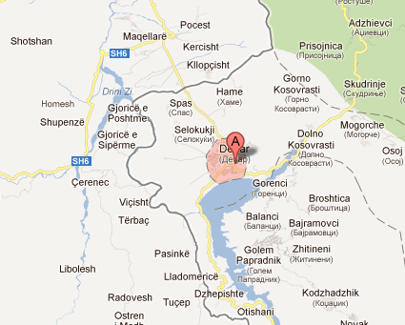
Fig. 1: The region of Dibra/ Debar (from: http://maps.google.com/maps)

The example of the state border in the region of Dibra is useful for analyzing very neatly the linguistic impact of the Albanian-Yugoslav/Macedonian state border.
This region has been divided for roughly 100 years into two parts, situated East and West of the border. The central question for our present purposes is to what extent the state border exerted influence on the local dialects, the local standard languages, language behavior, and perception of language among the local population. In other words: did the state border in Dibra also turn into a language boundary? The first results of this research are presented in the following section of this paper.
The first concrete example of the language situation in this border region is the language spoken by masons in Debar, analyzed as part of the project with the same name by the author at Humboldt University in Berlin. Technical innovation within the last 30-40 years, marking the most pronounced differences between the two parts of Dibra, clearly demonstrates the impact of the border on language development (Jusufi 2017).
The second example of the influence of the state border on the linguistic situation rests on the analysis of the difference in the perception of and the preference for languages and varieties, as shown in the following charts. The empirical data is gathered throughout 2015 in Debar, on both sides of the border. The charts are based on the issue of which language the informants believe to be the more prestigious one. The survey was divided into three age groups: 10-20 years, 30-40 years, and 50 and older. The large gap between the age groups has been deliberately built in to make the differences between them clearer. The material analyzed is based on written surveys using a broader questionnaire, which includes three questions, of which one is closed and two open. The questions refer to the prestige of many languages spoken in the region, including Turkish, and the attitude towards Turkish words in Albanian (Jusufi & Pani 2016).

Languages | 10-20 years,  25 respondents | 30-40 years,  25 respondents | from 50 years,  25 respondents
Macedonian | 3% | 0% | 0%
Turkish | 18,5% | 5% | 4,2%
Italian | 18,5% | 20% | 4,2%
English | 29,6% | 35% | 8,3%
Standard Albanian | 22,2% | 35% | 83,4%
own dialect | 7,4% | 5% | 0%
Table 1: Prestige languages in Albania (Jusufi & Pani 2016)

Languages | 10-20 years,  22 respondents | 30-40 years,  20 respondents | from 50 years,  24 respondents
Macedonian | 3,7% | 0% | 9%
Turkish | 37% | 0% | 0%
Italian | 29,6% | 3,7% | 0%
English | 29,6% | 40,7% | 0%
Standard Albanian | 18,8% | 44,4% | 91%
own dialect | 18,5% | 11% | 0%
Table 2: Prestige languages in Macedonia (Jusufi & Pani 2016)

These results show some very telling aspects of the language situation in the region. The differences attested in the first age group are first of all due to the discrepancy between standard Albanian and the interlocutors’ own dialect, which is more pronounced in Albania than in Macedonia –due to the effects of language purism in Albania. There are also differences in the perception of Turkish, which could either be ascribed also to language purism in Albania or might be a result of Turkish-Macedonian economic relationships, as well as the great number of Turkish TV series on Macedonian television at the time of the survey. We can see some parallels in the answers about Macedonian, which is not often preferred, as well as the global language, English, by observing the peak values on both sides of the border. The results concerning Italian were somewhat surprising. However, the youth on both sides of the border seems to somewhat prefer the less known languages: Turkish in Albania and Italian in Macedonia.
In the two probes of the middle-aged group, it appears that people have more in common with one another than in the first age group. People of that age on both sides of the border share the experience of the consequences of Albanian language politics 20-30 years ago (Hetzer 2001-2002). Some common results here are that the dialect counts as non-prestigious, whereas standard Albanian, hand-in-hand with English as a global language, are evaluated most positively. An additional interesting point here is that Turkish and Macedonian are barely ever mentioned in relation to prestige –this may be a result of these languages being categorized as the languages of the previous, or, in the latter case, still ongoing, “occupiers”, at least according to people’s perceptions.
The oldest group’s evaluation reflects the school education of their time. But what is even more striking in this case is the influence of foreign language education on both states concerned. The commonalities are based on similar schooling concepts and are therefore not an indication of convergence. Foreign languages are only sporadically evaluated positively, in accordance with the school programs when the members of this group were at aschool age. While standard Albanian holds the top position, the dialect has the lowest position with zero-values, which reflects Albanian language purism.
The third example of the language situation in this specific border region is a survey on the perception of and preference for the Turkish language. When asked what kind of language Turkish is, the first age group between 10 and 20 years of age answered as follows:

Albania, 25 respondents
Negative | neutral | Positive
less beautiful | don’t know | interesting
unpleasant |  | beautiful
less interesting |  | popular
Macedonia, 22 respondents
Negative | neutral | Positive
foreign | easy | precious
imposed | like the others | worth learning
worthless | rare here | interesting
melancholic | difficult | beautiful
boring | don’t know
unimportant
Table 3: Perception of the Turkish language in the youngest group (10-20 years)

The group of adolescents generally regards the Turkish language in Albania neutrally. Both positively and negatively implicated descriptions are a minority and balanced by six answers on each side. In Macedonia on the other hand, the perception of Turkish within this age group often holds a considerably negative meaning, by 52% of the respondents, or a neutral meaning, by 28%. Half of the positively implicated answers could also be evaluated as neutral. Only 8% show a positive assessment. On the whole, one can assert that the adolescents in Macedonia gave more accurate answers than their peers in Albania. It appears that the overall preoccupation with the Turkish language is more perceptible here, most likely because of the existence of numerous TV series (as traceable also in the answers above: melancholic, interesting, heavy). This fact is also reflected within the next age group.

Albania, 25 respondents
Negative | neutral | positive
foreign | don’t know | good
 |  | positive
 |  | very warm
 |  | beautiful
Macedonia, 20 respondents
Negative | neutral | positive
foreign | easy | beautiful
of the TV soaps | Balkan | pleasurable
worthless | here rare | interesting
heiress of the Ottomans | difficult | I like them
of the Turks | don’t know | with special elements
does not sound well
Table 4: Perception of the Turkish language in the middle age group (30-40 years)

The next age group, respondents between 30 and 40 years, regards the Turkish language neutrally or positively by 50%. In this case, the modifier “foreign” (20%) can be interpreted as neutral, when simply stated in comparison with Albanian as the mother tongue. In Macedonia, this age group evaluated the Turkish language rather negatively (48%) than neutrally (16%), a result which is, in line with linguistic purism. However, the answers themselves were striking: heiress of the Ottomans, language of the Turks (read: “occupying force”), but also the attribute Balkan, which is not always positively perceived (could be read as “antiquated/backward”). In view of the historical circumstances, these results are no surprise, as this age group took part in the nationalization process and the distribution of standard Albanian in Yugoslavia. The answers of the respective age group in Albania are similar. Nevertheless, it is clear that no distinction is made between Ottoman-Turkish and contemporary Turkish. The aforementioned TV series apparently exercise an influence on this age group, too.

Albania, 25 respondents
Negative | neutral | positive
outdated | don’t know | pleasant
don’t like them | existing | interesting
Macedonia, 24 respondents
Negative | neutral | positive
foreign | old | beautiful
don’t like them | easy | Interesting
of the Turks | common in Europe | Good
of the TV-soaps | don’t know | Sweet
gypsy language
alaturca, unintelligible
not nice sounding
Table 5: Perception of the Turkish language in the older age group (from 50 years)

The older age group regards the Turkish language neutrally to negatively. It is evident that the Turkish language is strongly identified with the Ottoman Empire (around 21%: archaic) and is therefore rejected (8.3%). The above-average answer don’t know can be interpreted in two ways, firstly as “neutral”, as already discussed, or, secondly, as “unknown”. In the worst case, this answer could stand for ignorance or even rejection. Compared to the Western part of Dibra in Macedonia, where this answer was given only twice in 75 respondents, the whole perception shifts to a negative direction in the Eastern part of Albania, although not to the outmost edge. The issue of regarding Turkish as responsible for unwanted language developments in Albanian is evident in the answer of a teacher of Albanian (54), who stated that Turkish had left deep traces in the Albanian language and that Turkisms would be harmful for Albanian. In Macedonia, on the other hand, respondents of this group were far more positive in their evaluation of the Turkish language (40%). The negative answers (32%) and the considerably less neutral answers (20%) come as a surprise. Therefore, sentiments are quite different, particularly regarding the intensity of the negatively connotated answers. Terms like alaturca, gypsy language, and language of the Turks are connotated highly negatively, and are considered almost insulting. The reason for this perception, in contrast to the far more positive and neutral attitudes towards Turkisms attested in other cases, might be due to the abundance of Turkish TV series, which really fill up the whole daily program and which are mostly consumed by middle-aged people.
The last example is about the perception of and preference for Turkish words (Turkisms) in the Albanian language:

Albania, 25 respondents
Negative | neutral | positive
old words | don’t know | positive
don’t like them | existing | beautiful
 |  | interesting
Macedonia, 22 respondents
Negative | neutral | positive
remains of the Turkish occupation | examples | ---
too much, too active | foreign, from the Turks | ---
words of the old people |  | ---
away with it |  | ---
harmful |  | ---
worthless |  | ---
Table 6: Perception of Turkisms in the youngest age group (10-20 years)

The majority of adolescents (77%) in Albania clearly regard Turkisms as neutral or rather descriptive (existing, old words). This comes as a surprise at first, but one needs to keep in mind that this is an age group born and socialized long after the socialist period. Although purism is still propagated by an older generation of leading linguists, it seems that they do not have any influence anymore, at least not on this age group. In Macedonia, the answers of this group are the most significant. Turkisms bear clearly negative connotations for 60% of the adolescents. Yet, the answer foreign, from the Turks (20%) is not completely neutral, either. Here, the negative perception of the Ottoman Empire as a result of the anti-Ottoman attitude of Albanian historiography clearly comes to the surface. For peers in Albania, the differentiation between Ottoman-Turkish and contemporary Turkish seems to have a positive effect towards the perception of Turkisms.

Albania, 25 respondents
Negative | neutral | positive
old words | don’t know | interesting
tough / assertive | existing | positive
outdated
Macedonia, 20 respondents
Negative | neutral | positive
barbarisms | borrowed | of a humane, peaceful folk
outdated | Turkism | cultural property
remains | still in use | language proficiency
imposed | adapted in Albanian
 | part of Albanian, as other foreign words
Table 7: Perception of Turkisms in the age group (30-40 years)

The middle-aged group in Albania regards Turkisms within the Albanian language equally neutrally and negatively (45% each). The attributes existing and old words are here evaulated in another context, possibly as “backward/antiquated” and with the co-text of “purism was not successful”, which would make them shift to the left (negative) area in the above chart. Only 10% of the asnwers involve clearly positive attributes. In Macedonia, this age group clearly regards Turkisms more neutrally than the younger group. But the negative perception is nonetheless four times higher than the positive one (48% compared to 12%). The neutral attitude with 36% modifies this to some extent. However, puristic attributes are remarkable (barbarisms, remains, imposed and outdated). Most notably, the expression barbarisms is a current term used within normative Albanology.

Albania, 25 respondents
Negative | neutral | positive
old words | don’t know | ---
outdated | existing | ---
Macedonia, 24 respondents
Negative | neutral | positive
barbarisms from the Turks | Turkish words, in use | ---
Imposed | high use | ---
remains of the Ottoman Empire, which we consider to be Albanian | borrowed from the Turks | ---
foreign | a few words | ---
 | don’t know | ---
 | very present | ---
Table 8: Perception of Turkisms in the older age group (from 50 years)

The old-aged group clearly regards Turkisms with a neutral to negative look. Not one of the respondents gave an answer with positive connotations. Here again, the attribute existing stands in a negative context. The answer “don’t know” was often accompanied by a gesture of disinterest or ignorance. This too, can be interpreted negatively. In Macedonia within this age group, one finds a neutral attitude (80%) towards Turkisms that is above average. Even far more neutral than their peer age group in Albania and more neutral than the general attitude towards Turkish, which deteriorated in value due to the opulence of TV series. The interrelation to the Ottoman past is on the fringes (16%).
These examples show that the state border running across Debar strongly influences the technical language of the masons, the perception of and preference for certain foreign languages in that region, as well as the relationship between standard language and dialect and the attitudes towards the shared Ottoman past. A purely pluricentric study of Albanian would hardly be able to achieve such clear results. An interdisciplinary perspective based on empirical findings and an awareness of the ideologization of normative approaches (Milroy 2001) is much more suitable for such research questions.

Conclusion
Border region research has appropriated methods from established fields of linguistics, for instance language borders, dialect borders, multilingualism, language contact, and language conflict as well as linguistic research on the language system and social factors (sociolinguistics). Only through combining all these different linguistic sub-disciplines and research fields does this approach acquire its all-encompassing character.
The research object of both pluricentrism and border region research –i.e., the state border– causes rivalry between these two disciplines. Border region research has revolutionized our understanding of language borders by conceptualizing them in a more narrow way, from an unclear zone, which is difficult to survey, to a clear line, which is almost uncrossable. It invalidates transition-zone theory (Auer 2004: 160-166) by changing the observation method from the pluricentric top-down to bottom-up, but it also expands to encompass many other aspects.

 | Pluricentrism | Border region research
Political context | Yes | yes
Standard language | Yes | Yes
Differences in the language system | Yes | Yes
Written language | Yes | yes (little)
Spoken language | yes (little) | Yes
Nonstandard variety | yes (little) | Yes
Historical development | No | Yes
Context of the differences | No | Yes
Speaker (Sociolinguistics) | No | Yes
Table 9: Pluricentrism vs. border region research

Pluricentrism and border region research can therefore be seen as complementary disciplines with different goals and different observation methods. As can be seen in Table 9, the two approaches have parallels in the areas of standard language, language-system linguistics and its typical levels –sound levels and lexis (cf. thisappears in white on the table). They also have parallels in most cases as regards the grey shaded areas (in the middle of the table). Pluricentrism concentrates mostly on written language and only in some individual cases on spoken language (e.g. on television discourse). Besides, it is based less on theoretical grounds but rather on research difficulties, because standard texts of spoken language are much harder to collect and analyze than written language ones, especially with regard to the criteria of pluricentricity. However, spoken language should definitely be researched and much further investgated in future research (Ammon et al. 2016). In contrast, border region research concentrates on spoken language and only touches on written language (e.g. in local print media). The aspects of linguistic research listed in the dark grey areas of the table (Historical development, Context of the differences, Speaker) are very new and characteristic of border region research.
The sociolinguistic approach –in which speakers are centrestage– is an innovation in border region research. Pluricentrism is not concerned with developing processes like border studies but with language differences as outcomes. Pluricentrism considers dialects as a source of enrichment for their own variety, i.e. dialects become instruments for the purposes of language policies. They are, however, the main research object in border region research, being influenced by several umbrella languages. The focus therefore shifts from top-down to bottom-up factors, which have increased considerably.
Fig. 2: Top-down and bottom-up factors

In conclusion, it can be said that pluricentric studies address other –and, indeed, fewer– questions than border region research does. In pluricentrism the questions to ask would be: What are the differences and how can we explain them against the background of existing language politics? In contrast, border region research asks more and wider questions: What are the differences? How did they originate?
Border region research provides a stronger and more linguistic argument than pluricentrism. It is linguistically based and uses empirically collected data. It is statistically verifiable and focuses on linguistic varieties in the narrow space of a state border. This purely linguistic approach is far removed from both language politics and the politicization of languages.
Returning to the title of this paper: border areas are a rediscovered classic in linguistics. Therefore, a classic can only become an innovation in science when we expand its research object, supplement and adjust it to new scholarly standards by opening up previously narrow themes. This is all true of current border region research, even though we are now merely at the first stages.

References
Ammon, U. 1995. Die deutsche Sprache in Deutschland, Österreich und der Schweiz: Das Problem der nationalen Varietäten. Berlin & New York: De Gruyter.
Ammon, U. 1996. “Typologie der nationalen Varianten des Deutschen zum Zweck systematischer und erklärungsbezogener Beschreibung nationaler Varianten.” Zeitschrift für Dialektologie und Linguistik 63: 157-175.
Ammon, U. 2011. “Deutsch als plurizentrische Sprache –mit Hinweisen auf die Nachfolgestaaten des früheren Jugoslawien.” In S. Gavrić (ed.), Sprach(en)politik in Bosnien und Herzegowina und im deutschsprachigen Raum. Sarajevo: Goethe-Institut, 38-46.
Ammon, U., Bickel, H. & A. N. Lenz (eds.). 2016. Variantenwörterbuch des Deutschen: Die Standardsprache in Österreich, der Schweiz, Deutschland, Liechtenstein, Luxemburg, Ostbelgien und Südtirol sowie Rumänien, Namibia und Mennonitensiedlungen. Berlin & Boston: De Gruyter.
Atanasov, P. 1990. Le mégleno-roumain de nos jours: Une approche linguistique [The Megleno-Romanian of our time: A linguistic approach]. Hamburg: Buske.
Atanasov, P. 2002. Meglenoromâna astăzi [Megleno-Romanian today]. Bucureşti: Ed. Academiei Român.
Auer, P. 2004. “Sprache, Grenze, Raum.” Zeitschrift für Sprachwissenschaft 23(1): 149-179.
Auer, P., Hinskens, F. & P. Kerswill. 2005. Dialect Change: Convergence and Divergence in European Languages. Cambridge: Cambridge Univ. Press.
Bochmann, K. 2004. Gesprochenes Rumänisch in der Ukraine: Soziolinguistische Verhältnisse und linguistische Strukturen. Leipzig: Leipziger Universitäts-Verlag.
Bochmann, K. 2005. Wie Sprachen gemacht werden: Zur Entstehung neuer romanischer Sprachen im 20. Jahrhundert. Leipzig: Verlag der Sächsischen Akademie der Wissenschaften zu Leipzig.
Bochmann, K., Dumbrava, V., Müller, D. & V. Reinhardt (eds.). 2012. Die Republik Moldau: Ein Handbuch. Leipzig: Leipziger Universitäts-Verlag.
Cajot, J. 1990. “Neue Sprachgrenzbildung an der deutschen Staatsgrenze zu Niederländisch-Ostlimburg, Ostbelgien und Luxemburg.” In L. Kremer & H. Niebaum (eds.), Grenzdialekte: Studien zur Entwicklung kontinentalwestgermanischer Dialektkontinua. Hildesheim & Zurich: Georg Olms, 125-152.
Clyne, M. (ed.). 1992. Pluricentric Languages: Differing Norms in Different Nations. Berlin & New York: De Gruyter.
Cvetković-Sander, K. 2011. Sprachpolitik und nationale Identität im sozialistischen Jugoslawien (1945-1991): Serbokroatisch, Albanisch, Makedonisch und Slowenisch. Wiesbaden: Harrassowitz.
Gerritsen, M. 1999. “Divergence of dialects in a linguistic laboratory near the Belgian-Dutch-German border: Similar dialects under the influence of different standard languages.” Language Variation and Change 11: 43-65.
Hetzer, A. 2001-2002. “Die Schaffung der albanischen Nationalsprache.” Studime 8-9: 67-99.
Jireček, K. 1911. Geschichte der Serben, 1911-18, Bd. 1 (bis 1371). Gotha: F. A. Perthes.
Jusufi, L. 2017. “Handwerk und Fachsprache(n) der Maurer aus der Region von Dibra.” Südost-Forschungen 74: 130-173.
Jusufi, L. & P. Pani. 2016. “Dem Purismus zum Trotz: Das Überleben der Turzismen im Albanischen.” Mediterranean Language Review 23: 127-161.
Kahl, Th. 2007. Hirten in Kontakt: Sprach- und Kulturwandel ehemaliger Wanderhirten in Epirus und Südalbanien. Berlin: LIT.
Kallen, J. L., Hinskens, F. & J. Taeldeman (eds.). 2000. Dialect Convergence and Divergence across European Borders. Berlin & New York: De Gruyter.
Kellermeier-Rehbein, B. 2014. Plurizentrik: Einführung in die nationalen Verietäten des Deutschen. Berlin: Erich Schmidt.
Klausmann, H. 1990. “Staatsgrenze als Sprachgrenze? Zur Entstehung einer neuen Wort- und Sprachgebrauchgrenze am Oberrhein.” In L. Kremer & H. Niebaum (eds.), Grenzdialekte: Studien zur Entwicklung kontinentalwestgermanischer Dialektkontinua. Hildesheim & Zürich: Georg Olms, 193-216.
Klausmann, H. 2000. “Changes of dialect, code-switching, and new winds of usage: The divergence of dialects along the border between Germany and France in and around the region of the Oberrhein.” In J. L. Kallen, F. Hinskens & J. Taeldeman (eds.), Dialect Convergence and Divergence across European Borders. Berlin & New York: De Gruyter, 109-130.
Kremer, L. 1990. “Kontinuum oder Bruchstelle? Zur Entwicklung der Grenzdialekte zwischen Niederrhein und Vechtegebiet.” In L. Kremer, H. Niebaum (eds.), Grenzdialekte: Studien zur Entwicklung kontinentalwestgermanischer Dialektkontinua. Hildesheim & Zurich: Georg Olms, 85-124.
Kremer, L. & H. Niebaum (eds.). 1990. Grenzdialekte: Studien zur Entwicklung kontinentalwestgermanischer Dialektkontinua. Germanistische Linguistik. Vol. 101-103. Hildesheim & Zurich: Georg Olms.
Milroy, J. 2001. “Language Ideology and the consequences of standardization.” Journals of Sociolinguistics 5(4): 530-555.
Muhr, R. 2012. “Lingustic dominance and non-dominance in pluricentric languages: A typology.” In R. Muhr (ed.), Non-Dominant Varieties of Pluricentric Languages. Getting the Picture. In Memory of Michael Clyne. Frankfurt am Main: Peter Lang, 23-48.
Pani, P. 2006. “Some differences between varieties of Albanian with special reference to Kosovo”. International Journal of Sociology of Language 178: 55-73.
Sasse, H.-J. 1992. “Theory of language death.” In M. Brenzinger (ed.), Language death: Factual and theoretical explorations with special reference to East Africa. Berlin & New York: De Gruyter, 7-30.
Steinke, K. & C. Voß (eds.). 2007. The Pomaks in Greece and Bulgaria: A Model Case for Borderland Minorities in the Balkans. Munich: Otto Sagner.
Taeldeman, J. 1990. “Ist die belgisch-niederländische Staatsgrenze auch eine Dialektgrenze? In: Grenzdialekte. Studien zur Entwicklung kontinentalwestgermanischer Dialektkontinua.” In L. Kremer & H. Niebaum (eds.), Grenzdialekte: Studien zur Entwicklung kontinentalwestgermanischer Dialektkontinua. Hildesheim & Zurich: Georg Olms, 275-314.
Voß, C. 2005. “Linguistic divergence and (re)convergence in the Macedonian standard/dialect-continuum.” In R. Detrez & P. Plas (eds.), Developing Cultural Identity in the Balkans: Convergence vs. Divergence. Brussels: Peter Lang, 45-58.
Voß, C. 2006. “Toward the peculiarities of language shift in northern Greece.” In D. Stern & C. Voß (eds.), Marginal Linguistic Identities: Studies in Slavic Contact and Borderland Varieties. Wiesbaden: Harrassowitz, 87-101.
Voß, C. & L. Jusufi. 2013. “Plurizentrik im Albanischen sowie im Serbokroatischen und seinen Nachfolgesprachen.” In D. Müller & M. Wingender (eds.), Typen slavischer Standardsprachen: Theoretische, methodische und empirische Zugänge. Wiesbaden: Harrassowitz, 177-195.
Woolhiser, C. 2005. “Political borders and dialect convergence/divergence in Europe.” In P. Auer, F. Hinskens & P. Kerswill (eds.), Dialect Change: Convergence and Divergence in European Languages. Cambridge: Cambridge University Press, 236-262.
Woolhiser, C. 2011. “Border effects in European dialect continua: Dialect divergence and convergence.” In B. Kortmann & J. von der Auwera (eds.), The Language and Linguistics of Europe: A Comprehensive Guide. Berlin: De Gruyter, 501-523.

AWPEL

Languages of loss and mourning beyond (the) borders: Bosnia

Snežana Stanković

Viadrina Research Center B/ORDERS IN MOTION, Humboldt-Universität zu Berlin
snezstankovic@gmail.com

To Remzija Suljić,
Anna Brägger,
Jelena Blažan
Abstract
The following paper deals with the language of commemoration of refugee women from ex-Yugoslavia, mainly Bosnia who escaped to Berlin during or after the violent conflicts in the 1990s. Handkerchiefs, personalised with names, birth and death dates of deceased family members, have arisen out of the embroidery therapy they have undertaken. These artefacts all resemble each other in that they recount the trauma of the loss of the beloved dead, whose remains were either found and then reburied, or the dead who remained missing. This micro-study aims at analyzing the verbal and visual means of expression employed by the refugee women in their embroidery. In treating language as a semiotic composition of oral and written verbal communication, image, sound, and movement, it leaves sociolinguistic discussions on the national languages which have emerged in the region behind and delves into the expression of loss and mourning inscribed on the handkerchiefs.

Introduction
More than 20 years after the wars of the 1990s, around two hundred intellectuals from the Yugoslav successor states signed the Declaration on the Common Language that was published on 30th March 2017 in Sarajevo. In opposition to the official view of the states of Bosnia, Croatia, Montenegro, and Serbia, the Declaration has proclaimed Bosnian, Croatian, Montenegrin, and Serbian to be four standardised variants of one pluricentric/polycentric language, as is true for Arabic, German, English, French, Portuguese, and Spanish. This means that, despite local and regional diversities, there is one language spread across the countries mentioned above.
When the wars of the 1990s ended, the break-up of Yugoslavia was followed by the emergence of new states, nations, and languages. (Re-)building their own nation, each state, as a political entity, wanted to detach itself from the (new) neighbouring one. The resulting demarcation included two essential political components: language and religion. Known before as Serbo-Croat(ian)/ Croato-Serb(ian), the language had to split into four entirely distinct systems, Bosnian, Croatian, Montenegrin, and Serbian. Following the ideology of one state-one language, language has gained a pivotal ‘boundary-function’ role. Politically integrating and separating, it started indexing ‘its associated culture’ (Fishman 1989: 35, 465). Within this framework, such labelling appears both as indexing (Ochs 1992: 338) and iconizing (Nöth 2000) social reality. Therefore, new national languages have developed as a result of specific planning where, as Bugarski mentions, “[…] languages have been imagined as unique national possessions, indispensable expressions of the collective spirit of their speakers […]” (Bugarski 2012: 233).
My paper aims at a somewhat different interpretation of (the) language(s) of former Yugoslavia. It deals with the commemoration language(s) of refugee women from ex-Yugoslavia, mainly Bosnia, and of some women from East and Southeast Asia, who have escaped to Berlin and undertaken embroidery therapy. Handkerchiefs, personalised with the names, birth- and death dates of the deceased, arose out of the therapy. They all resemble each other in telling the trauma of loss of the beloved dead, whose remains were either found and then reburied, or who remained missing. This process of working through trauma associated with conflict, violence and flight has grown into a project, The Roll of Remembrance [BCMS/Bosnian Rola Sjećanja], run by the Berlin Association for South-East European Culture [German Südost Europa Kultur e.V.]. In 2017, they were displayed as a textile memorial wall (Fig. 1) in the exhibition 1000 Handkerchiefs to Never Forget [German Tausend Tücher Gegen das Vergessen], organized by the Museum Europäischer Kulturen in Berlin.
This micro-study aims at analysing the verbal and visual expressions employed by the refugee women in their embroidery. In treating language as a semiotic composition of oral and written verbal communication, image, sound, and movement (van Leeuwen 2005), it leaves the sociolinguistic discussions on the emerged national languages behind by going into expressions of loss and mourning inscribed in the handkerchiefs. These expressions are those that stand “behind” and signify the “sensible world” (Greimas 1987: 17). For this reason, I analyse the handkerchiefs by also paying close attention to the interviews with the three women gathered around the embroidery-work.
Being shaped by the experience of global mobility and attendant superdiversity, to reference Jan Blommaert and Ben Rampton who follow Steven Vertovec (Blommaert & Rampton 2015), this paper prefers to reason in categories of cross-cultural communication. Therefore, despite ideologies and often artificially emphasized differences, it argues for reiterative, or formulaic, expressions that occur within different cultural and social settings. In this fashion, by referring to the Declaration on the Common Language, I aim to present how verbal and visual expressions of loss, mourning, and commemoration reveal forms that appear as shared or common, therefore going beyond cultural framing. Following Talal Asad and Peter van der Veer, I see culture(s) as a constant motion filled with translation(s) where we have to learn about “a new mode of life”, to look into “implicit meanings”, and bridge “different semantic universes” (van der Veer 2016: 11; Asad 1986).
This survey addresses questions of sociolinguistic understandings of language, building on interdisciplinary perspectives on the anthropology of death, mourning, and commemoration. Along with the scholars who study death and mourning, I treat the phenomenon of death as a mode of life that generates diverse but mutually interchangeable systems of belief, performance, and emotions (Rosaldo 2004 [1989]; Rosaldo & Hockey 2001; Eng & Kazanjian 2003; Butler 2004, 2009).
The paper is divided into three sections. The first shortly reflects upon the science of mourning, introducing the different ways survivors attempt to deal with the deaths of loved ones whose bodies have not yet been recovered or who were exhumed from mass graves and reburied. The second part looks into the gendered nature of the Roll of Remembrance. Women are survivors, “alive archives” (Halilovich 2014), who, by inscribing the names of their loved ones on textile pieces, compose monuments and participate in shared commemoration. The third section looks at the visual, verbal and auditive roles of language in composing the Roll of Remembrance. Plant motifs in the form of flowers, leaves, fruit, and trees appear as the most frequently used decorations that surround the written names. The patterned nature of listed names and pictorial depictions of plants and landscapes recall poetic strategies of oral poetry and monumental uniformity encountered on military gravestones. The article closes by moving the focus from the monumental (poetic) language of the handkerchiefs to its political employment in commemorative practices pertaining to the painful past, the disappeared persons, and individual and collective traumatic losses. This reflection leads to the last question on representational languages, the ethical and teleological positioning of museums, and academic work.

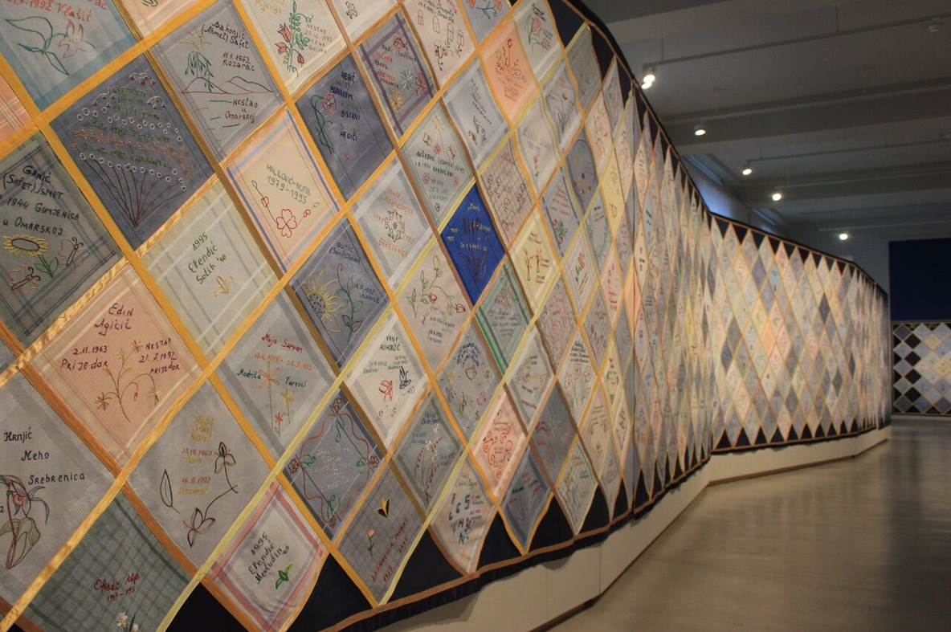
Fig. 1 Tausend Tücher Gegen das Vergessen [1000 Handkerchiefs to Never Forget], Museum Europäischer Kulturen, Berlin, Germany © Courtesy of Julian Nyča/Nitzsche (2017)

Distant and missing dead: Loss and mourning
The past of the 1990s, when the wars occurred in Former Yugoslavia, still lingers. It bears the scars of atrocities that shaped the 20th century in general and fundamentally changed the way we deal with remembrance and with writing history. Argentina, Bosnia, Chile, Cambodia, Rwanda, Spain, to name some of the places still suffering from their pasts, became topoi of dictatorship, genocidal violence, and disappearances. Persons that remained missing made grief/mourning in these countries impossible.
A disappearance refers to a legal status of unresolved absence from society. On a personal level, it involves a situation where the living wait, hope, and search for their loved ones. Furthermore, the search itself occurs as a hope of and fear for the absentee’s life. Such an uncertain loss implies a restless state of hovering between the abovementioned emotions.
How is one to grasp several simultaneous losses: when a person suddenly needs to flee their country due to war; has to leave their home and loved ones who, for some reason stay behind; and those who went missing?
Marc Nichanian interprets the eyewitness testimony by Zabel Essayan [Yessayan] Among the Ruins as “writing beyond the sayable”: to express testimony of the Turkish massacre of Armenians in Adana (southern Turkey) in 1909 is “beyond the representable, beyond all possible narration […]” (Nichanian 2003: 113). Reliving the “the catastrophe” through writing, Essayan searches for an “expression of limitless sorrow” and, by doing so, she transposes her written testimony onto the act of mourning (Nichanian 2003: 113, 116).
To address grief/mourning over a (violently) deceased person, a lost community, places or objects implies attaching to the context of the absence. The conceptual view of this paper interprets it as the totality that appals one’s world. In line with the authors of the volume An Anthropology of Absence: Materializations of Transcendence and Loss (Bille, Hastrup & Sørensen 2010), I read absence as a sedimented layer of material, experiential, and emotional worlds. The first section of the exhibition Tausend Tücher Gegen das Vergessen imminently announced the absence through the displayed photographs by Nihad Nino Pušija of the post-Yugoslav landscapes filled with stillness and alleged harmony (Fig. 2). However, through the attached interpretive descriptions and labels, they point to the hidden past filled with violence not to be forgotten. Writing about the exhibition Hidden, which contained photographs of Afghanistan during 2002, Fiona J. Doloughan underlines the ways Paul Seawright suggested the layeredness of reality and “a sensitivity to the unseen” (Doloughan 2011: 39) where, in the words of Mark Durden, Seawright’s “poetics of absence” indexes presence (Doloughan 2011: 39). The hidden or absent layers of this first section of the exhibition in Berlin were similarly revealed in the second section, containing the memorial handkerchiefs, as well as in the third part, on working through the past where history textbooks, teaching materials, and literary texts, mostly from ex-Yugoslav, countries were displayed.

Fig. 2 The first section presenting photographs of the post-conflict landscapes
© author (2017)
As can be observed, the second area with the exhibited kerchiefs was framed by additional contents (photographs, historical and literary texts) with the aim to more clearly communicate the reality of war that caused mass deaths and immense loss.
Departing from anthropological and historical approaches to death, I employ mourning to denote its performative nature, not necessarily including kinetic and material practices regarding “what is done” (Jakoby 2012: 681), but implicating specific behaviour, whether on an individual, group or collective level. Despite the different disciplines, researchers mostly speak of mourning contextually, as a process framed within feelings of grief, expressed inwardly and outwardly through specific mortuary practices (Hallam & Hockey 2001; Kastenbaum 2003; Kearl 1989; Metcalf & Huntington 1991; Williams 2006). In the discourse of ritual behaviours, mourning is emphasized as a liminal period that positions mourners between the dead and the living. Their bereavement and nearness to the world of the dead bear specific behavioural markers such as lamenting, clothing, hair and face treatments, and offerings at the grave –practices which are still observed worldwide. When describing totemic societies in Australia, Emile Durkheim explains that “mourning is an obligation imposed by the group” in the form of a socially constructed response to loss (Durkheim 1995: 400). As shared communication, these gestures (re)affirm communal ties (Metcalf & Huntington 1991: 35).
The similarly formalised language of such an iconography represents the thematic scope of this survey, as stated before. Analyzing the composition of the memorial handkerchiefs embroidered by the refugee women, this paper considers both ritualising flows and “the emotional force of death” (Rosaldo 2004 [1989]).
The embroidery program started as a therapy aide employed by the Swiss artist Anna Bräger to help traumatised women in the Südost Center. The personalised approach within the group made it possible to address each personal trauma. Over the years, the work has grown into both a private and a communal act of healing and commemoration. Joining the handkerchiefs together in a specific diagonal grid pattern, Anna Brägger then created the so-called Roll of Remembrance (BKMS/Bosnian Rola sjećanja).-

After these therapy sessions –usually on Fridays– the women would then move to Wittenbergplatz [Berlin] with the transparencies [on which they wrote the names of their loved ones […] to make Berliners aware of their painful situation]. Somehow they concluded that the transparencies were not an adequate medium to express their grief and desperation. Then they approached me and asked me whether I could help them find an artistically appropriate form of expression or even create it as a kind of movable object: one that brought people together, with their memories of the days when it all happened, especially in Srebrenica.
Anna Brägger

One such approach has been developed by the New York Donor Organ Network (NYODN). The aftercare program for families of donors helps them cope and express the extraordinary situations surrounding the loss and organ donation of their loved ones. Similarly to Anna Bräggerʼs approach, the families are guided to produce a work that would enable them to relive their memories (Jensen 2010: 63-80). The Memory Quilt and the Gift of Life Medal Donor belong to the most important “means of remembering the dead”, where each patch personalises a donor, their “personal life[s] and stories behind organ donation” (Jensen 2010: 71). In that sense, as Susanne Küchler notes, the patchwork refers to tangible “relations of kinship” that “by drawing discrete elements together into a tightly structured composition, […] schematizes and thus enables the recall of biographical time” (Küchler 2014: 104).
Categories of belonging, ties, and kinship are profoundly destabilised when dealing with war-stricken families. Writing about Srebrenica Potočari Memorial Centre, Lara Nettelfield and Sarah Wagner observe how the cemetery and its tombstones can reconstitute such families (Nettelfield & Wagner 2014: 43).
Death disrupts the wholeness of reality. The Great War has globally changed the perception and meaning of death. Persons remaining missing made grief/mourning impossible. War memorials, military cemeteries, and monuments listing the names of the missing or inscribed with the words “A Soldier of the Great War” or “Known unto God” have transformed grief into a communal or public act of mourning and celebration.

‘’Unknown’’ became a marked category for lists of the dead and, by extension, the essence of the entirely new cult predicated on deep namelessness of the Great War. On the one hand, hopelessly nameless bodies came to stand for all such bodies, for loss of name, for loss of life and personhood: the universal body. (Laqueur 2015: 418)

Yet this “universal” language does not seem to be suitable enough to express the contemporary reality of violent deaths throughout the world. Similarly to Zabel Essayan, Nettelfield and Wagner emphasize totality of “erasures and losses: of the killed loved ones, destroyed social and emotional spaces of the living” (Nettelfield & Wagner 2014: 22, 151). Returning to the handkerchiefs, we regularly read written and visual motifs regarding “destruction of structures” caused by the war. The labels nestao/nestala ‘disappeared’ and ekshumiran/a ‘exhumed’ refer to the events that happened to the dead and the remaining loved ones (Fig. 3).

The therapy, as rudimentary as it may have been, allowed the women to accept their fate […]. It was then when the first mass graves were opened, and the fears became a reality. Many women were panicking. What will happen now? Will my son, my husband be found? There was great unrest because many then had their loved ones whom they could bury, but many still did not.
Anna Brägger

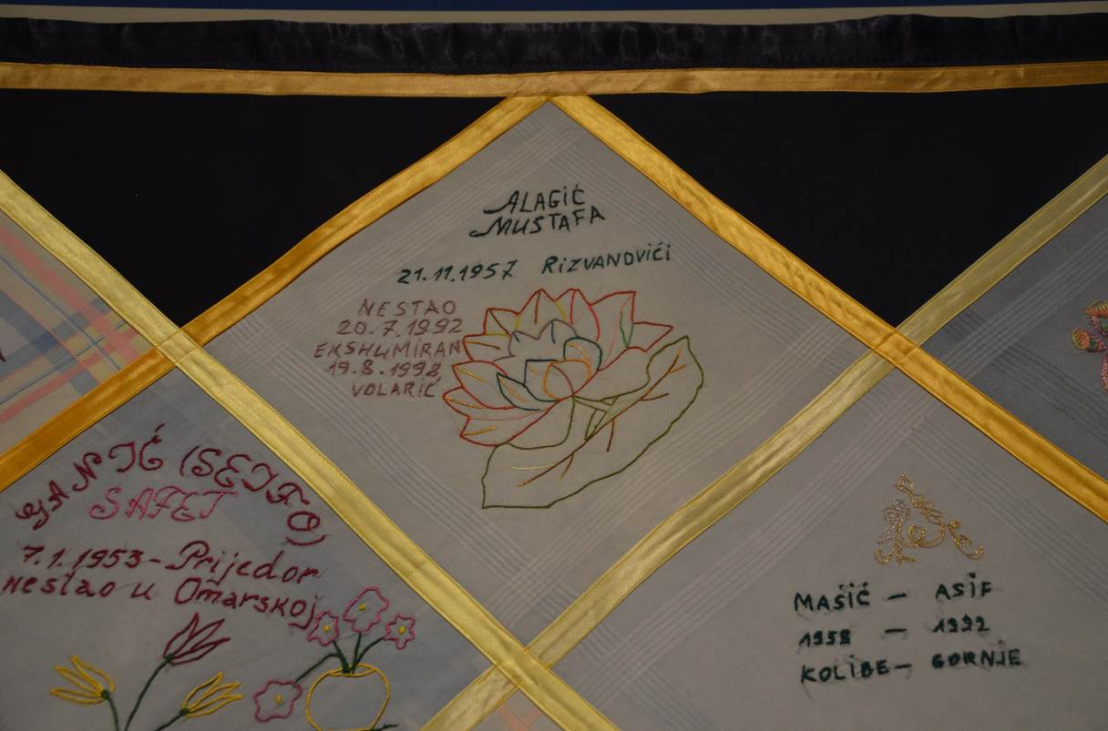
Fig. 3 “Alagić Mustafa / 21.11.1957 Rizvanovići./ Disappeared 20.7.1992 / Exhumed 19.8.1998. Volarić” © author (2017)

According to the explanations of my interviewees and Anna Brägger’s words quoted above, such expressions did not exist before the war. One would say “they died” or “they were killed.” These expressions referred to sporadic occurrences. Due to the wars, violent death was transformed from a particular and intermittent experience to a communal and continuous one. During the initial post-war years, the amount of found and identified bodies of the missing was low, so that both grief and commemoration, at the intimate and official sphere, stayed frozen for a while (Boss 1999). In such a frame, memorial books, inscribed with the names of the deceased and displaying their photographs, emerged as a response to the “impossibility of granting a place to the absent body” (Mandolessi 2014: 157). According to Jelena Blažan, a Berlin-based painter and designer who accompanies refugee women, and Anna Brägger, one of these books has served as a model for embroidering the memorial handkerchiefs (Fig.4).

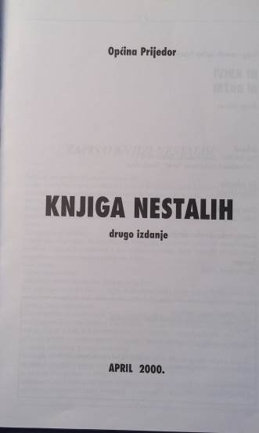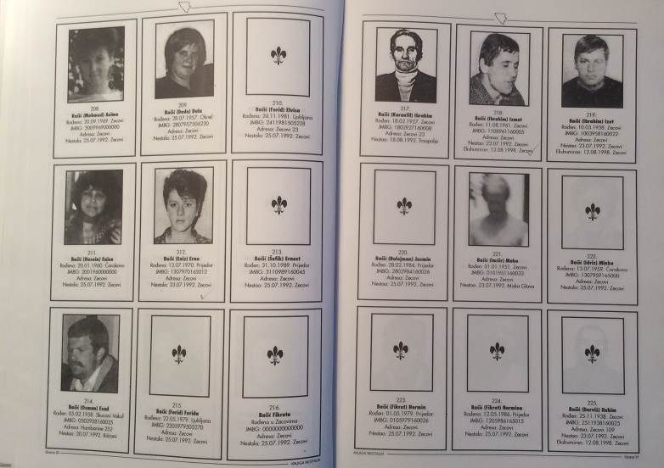
Fig. 4 “The Book of the Disappeared”. The lines beneath each photograph report persons as missing or/and exhumed © author (2017)

When a person goes missing or violently dies, which practices does one adopt to honour their memory? Here we deal with the community of mourning women who translate their missing and dead onto the “mundane spaces” of handkerchiefs, materialise their memories (Hallam & Hockey 2001: 192, 184) and fill in the emptiness with the meaning of their names.

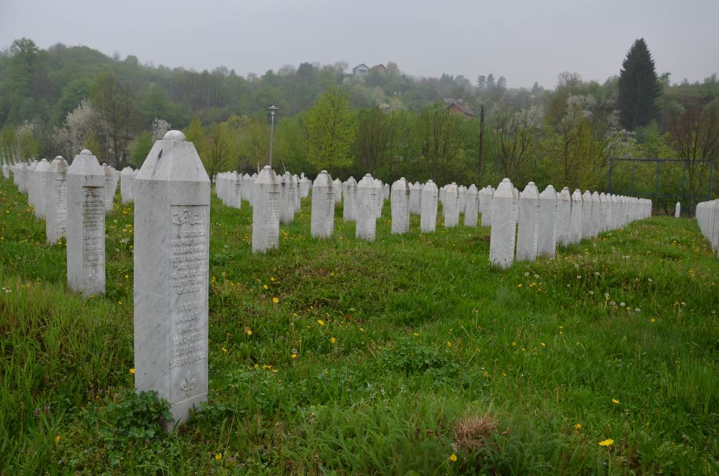

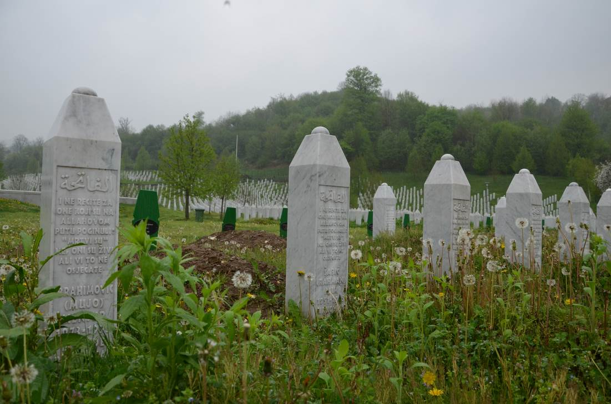
Fig. 5 and 6 The Srebrenica-Potočari Memorial and Cemetery © author (2018)

Monuments written by women

Gendered grief
As the previous lines show, the Roll of Remembrance is highly gendered: It voices a female community of mourners –mothers, wives, daughters, sisters, female friends, and neighbours. Such gendered grief is well known in ancient and contemporary oral lamentation for the dead. Ritualized mourning is not performed exclusively by women but also by men in, for instance, Montenegro, Albania, and Iran. However, here I will briefly relate the role of women. Be it patterned (formulaic) recitation, chanting or singing, their performance is a mediating act between the world of the living and that of the dead. From this perspective, the expression of individual and communal grief is an invocation whereby women appeal to the deceased to reconnect with their world. Besides establishing these vertical ties, at the same time they bond among themselves (Caraveli-Chaves 1980: 145). Anna Caraveli-Chaves refers to this bonding as “sisterhood in pain” when interpreting female performance in rural Epirus and Crete (Caraveli-Chaves 1986 cited in in Fishman 2008: 268).
The Roll of Remembrance embodies such a “sisterhood in pain” between the women from Former Yugoslavia and Asia. Beyond the familiar context, through the medium of the embroidered textile, they manifest the experiences of loss, pain, commemoration, displacement, and exilic life.
Nettelfield and Wagner devote particular attention to women survivors in the aftermath of the genocide in Srebrenica, showing how the burial rites and mourning practices they (had to) adopt enabled “[the gendered work of restoring and reordering families” (Nettelfield & Wagner 2014: 44). The new situation, affected by male absence, has translated traditional Islamic prohibitions around funerary practices into a necessity of the presence of women at burial and mourning sites.
This is precisely the too often forgotten sphere which Hariz Halilovich calls attention to. Death of male inhabitants in Bosnia meant “that womenʼs men were killed: husbands, sons, fathers, brothers, and lovers”; along with these losses, women also suffered various other brutalities, nevertheless remaining invisible (Halilovich 2014: 239). Despite that, as Halilovich significantly points out, they have a crucial role in the search for and identification of the disappeared. Therefore, through their own bodies and by preserving some material pieces of their loved ones, such as documents and evidence, women become archives carrying emotions and information about the past (Halilovich 2014: 239-241).
The Roll of Remembrance is, therefore, an extended after-part of materialised memories of deceased loved ones. Regardless of the initial therapeutic aim, we can see how “ordinary” acts and everyday consumer objects can change: embroidery itself and each decorated handkerchief reflect grief, remembrance, and offering. As Giunta and Sciorra note in their volume on womenʼs needlework in the Italian diaspora, such unique women handicraft is treasured as “an artefact of imagination, a repository of dreams, hopes, disappointments, desires. It is the material for memory work” (Giunta & Sciorra 2014: 4). What arose here from the ordinarily stereotyped domestic female handicraft was a textile memorial wall that, as I will show later, shares similarities with military gravestones, memorials, and monuments.
Beyond the mundane domestic sphere, women’s craft itself is endowed with specific meanings throughout mytho-historical tradition. In the daytime, Penelope weaves a burial shroud for Odysseus’s father, Laertes; at night, she unravels what she has woven. This work spans over three years in order to prolong her suitors’ waiting. Such interchange between creation and destruction unfolds several readings: its occurrence is marked by Odysseus’s absence that manifests as a delay in choosing a new husband and as the waiting for a return. To be awaited implies being alive to someone. In line with Barbara Clayton, Penelopean poetics suggests that the “retelling of a story” (Clayton 2004: 123) records the absence of the missing in terms of continuous life. This hope is thus a “life-affirming renewal and the constant possibility of new beginnings” (Clayton 2004: 124). Translating the handkerchief-work of the women, from (mainly) Bosnia, who suffer from the absence of their loved ones, into this poetics implies speaking of the continuous life of the dead. The connection between handiwork and story-telling is an old social practice as well as a poetic image. Narration as a process and a tale as a newly created world generate life. In the words of Jelena Blažan:

This work [embroidery] helped them talk more easily, speak about topics like who had lost a loved one, who had gone missing, or who had been found, who was buried the previous year, and by whom. As if they had built an altar that did not belong to them but to the whole world it [the altar] travelled through.
Jelena Blažan, Berlin, 2017

Conversational narration among the women (Norrick 2008: 84) creates a symbolic resting place that enables the return of the absent deceased and thus, to some extent, “normalises” their death (Renshaw 2010: 49). This “narrative presence” of the deceased (Jensen 2010: 72) and the portable altar materialise memories of the past life that can now be bridged to the new one. Whether performed among the community or at home, the sewing of a particular name and biographical data, along with images, resembles a sacred ritual: while their eyes follow the needle and its work, they dedicate the patch to a unique person who is present in their thoughts at that moment. In this sense, the sewn names embody real biographies that (can) overlap with those of the women who survived. As Derrida has shown, the name of a person (a friend) already implies their mortality; nevertheless, it also survives them (Derrida 2001). Therefore, names are not merely graphic signs, but wordings that show survival and gain the specific power to restore the presence of the absentee metonymically. Ernst Cassirer reminds us of the mythical notion in which the name itself is inseparably tied to personhood: “the unity and uniqueness of the name is not only a mark of the unity and uniqueness of the person, but actually constitutes it […]” (Cassirer 1946: 51). That is why the names of the dead listed on memorials appear indeed “monumental”, as Thomas Laqueur states (Laqueur 2015: 422), drawing attention to Vietnam Veterans Memorial and AIDS Memorial Quilt as “the most famous examples of monumental assemblages of names” (Laqueur 2015: 424). Furthermore, reflecting upon the memorialisation of the victims of the Holocaust, he draws a parallel between uttering prayers and reading the names of the dead, every year, when the names of Yad Vashem are read out (Laqueur 2015: 438). The prayer lists containing names of the living and the dead were and are still known in Christianity where they feature as a horizontal communication within the commemorating community and as a vertical communication that “sends” appeals and offerings towards the divine world (see also Ariès 2009 [1981]). From the Islamic point of view, making dua and reciting prayers for forgiveness and mercy, as well as performing acts of charity, is (also) mandatory, which can be quite the opposite of grave visiting, whether one discusses ritual prescriptions of the Sunnah, Shia or Sufi Islam. Nevertheless, as has been observed, tradition does change following the given situation as in the case of the commemoration that the women from Bosnia (have to) realise because their men are absent.
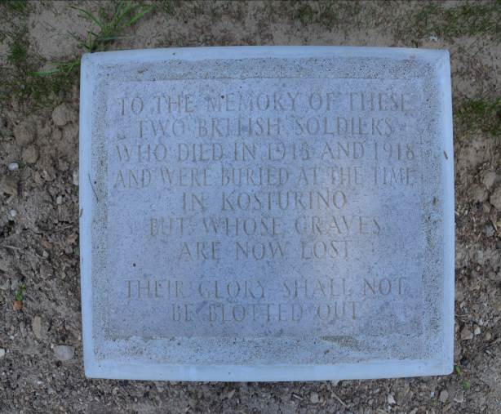
Fig. 7 “A soldier of the Great War/ Known unto God”/ “To the memory of these/ two British soldiers/ who died in 1915 and 1918/ and were buried at the time/ in Kosturno/ but whose graves/ are now lost/ Their glory shall not/ be blotted out.”
Karasouli Military Cemetery, Greece
© author (2015)

Regarding their “monumental” nature, the catalogue-like Roll of Remembrance recalls memorial lists drawn up in the aftermath of the Great War. Military cemeteries of the Salonika Front archive memories of persons “whose graves are now lost” and whose “names [stay] unknown” (Fig. 7). Like the words carved on military gravestones and memorial walls, the Roll of Remembrance speaks of the unidentifiable persons and those still scattered in anonymous burial grounds.

3.2. Perpetual poetic language
The similarity between the naming of military cemeteries and war memorials, and the handkerchiefs, denotes a particular formulaic language if we recognise it in terms of oral-formulaic theories. Formulas represent patterned (sets of) words and poetic images that function as a mnemotechnic tool, both within the fictitious world of the oral text and the real world of the singer/storyteller (Lord 2000 [1960]; Foley 2002; Honko 2000; Ong 2002 [1982]; Radulović 2015). In the case of the European cemeteries, including multicultural areas where mostly Christian, Muslim, and Jewish traditions merge, the formulaic funerary grammar comprises practices, epitaphial and visual expressions around and on graves in the form of offerings (prayers, conversations, flowers, messages, candles, toys, food). They imply a regular presence of visitors (Fig. 8). As can be seen in (Fig. 3), the Roll of Remembrance bears epitaphs, mostly in the form of biographical data, and decorative motifs as “[non-]temporary and [im]movable mementoes on graves” (Woodthorpe 2010: 121).

They [refugee women] could choose their own patterns. I explained to them that it could be a flower that holds particular meaning for them, or that they especially enjoy. It is like a gift they can give to the deceased.
Anna Brägger

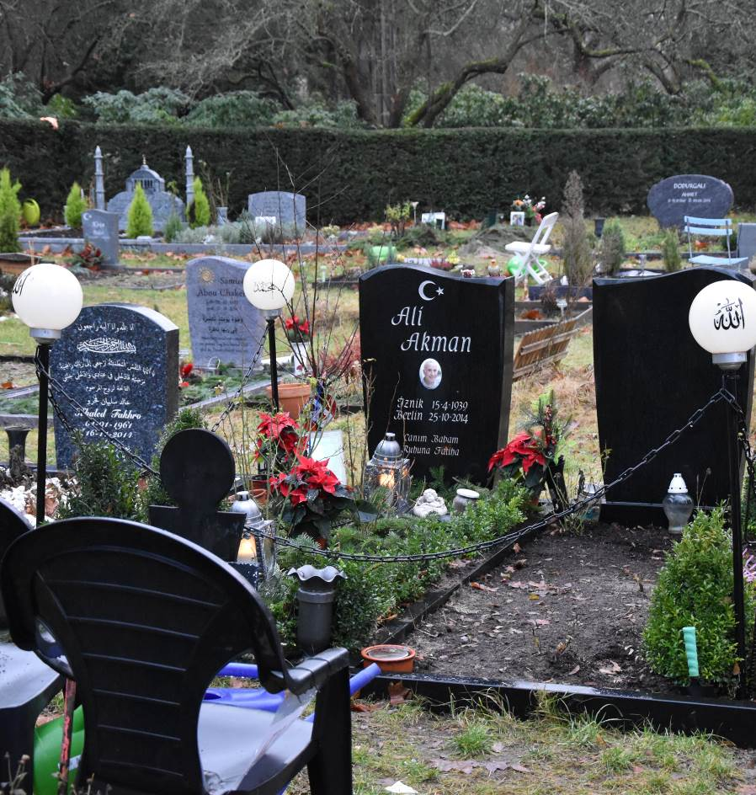
Fig. 8 Islamic Cemetery in Columbiadamm, Berlin, Germany © Courtesy of Michał Piasek (2016)

Within this embroidery frame one finds the formulaic epithet nestao ‘disappeared/missing’ that alters according to the state of recovery of the body: if it has been found, the adjective changes to ekshumiran ‘exhumed’. In both cases, these appellations strengthen the personal aspect of the displayed name. Among the names and dates, there are a few expressions that express grief, for example, “Ended Youth” and “Pain and sorrow last forever” (Fig. 9 and 10).

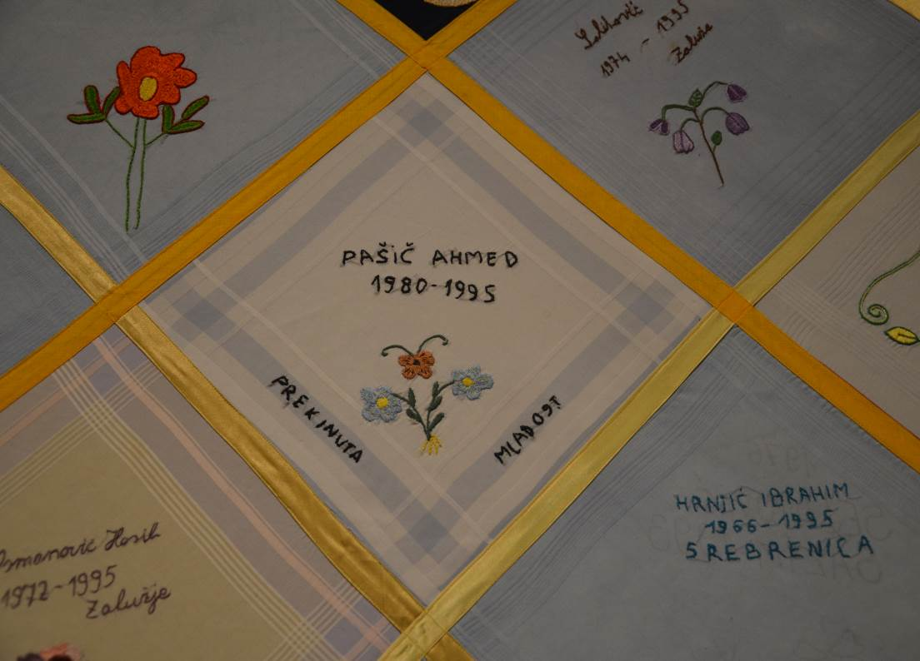
Fig. 9 “Pašić Ahmed / 1980-1995/ Ended Youth” © author (2017)

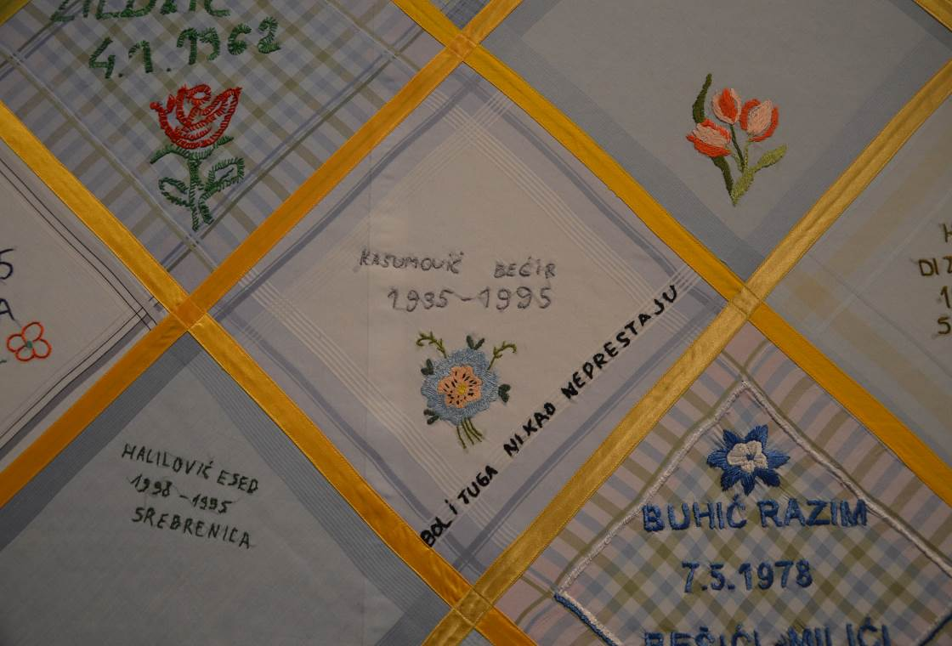
Fig. 10 “Kasumović Bećir. 1935-1995/ Pain and sorrow last forever” © author (2017)

Figurative motifs that emerge on the fabric correspond to mementoes left on military and civilian graves, and at monuments and memorial walls. The names are thereby framed by flowers, birds, butterflies, some structures (like a bridge and a town clock) as well as landscapes with mountains, ocean or gateways. As Jelena Blažan told me, the women would find the motifs in magazines, or they would recall the things the deceased was fond of like Fatima who “probably used to like cherries” (Fig. 11).

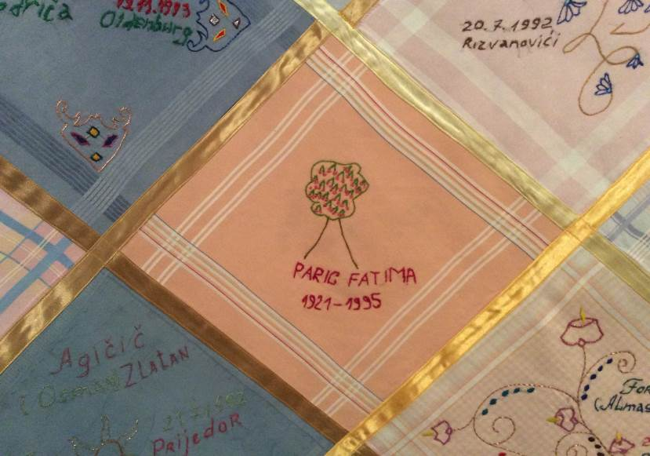
Fig. 11 “Paric Fatima. 1921-1995” © author (2017)

Remzija Suljić, my field-sister, is one of the women from the Südost Center who has embroidered around one hundred handkerchiefs. Her following words highlight this practice of visiting and decorating a grave by giving an offering to the dead.

I have embroidered one handkerchief for Ivan. He is Catholic. Whenever I am in Srebrenica, I visit his grave and bring him flowers. Eighty-one: the two of them are buried, the rest are not. Their bones cannot be found. But we have put them into flowers. Each flower has a specific meaning. When someone is recovered, it is a joy to the family. […] The mother of Ivan did not want to bury him in the Catholic graveyard. “He died/fell together with them [friends and neighbours], so he should be buried where they are.” We always visit the grave of the small Ivan. Bringing flowers. “This could only be Remzija” –[those are the words of his family when they come after me and see the flowers I left].
Remzija Suljić, Berlin, 2017 (Fig. 12)

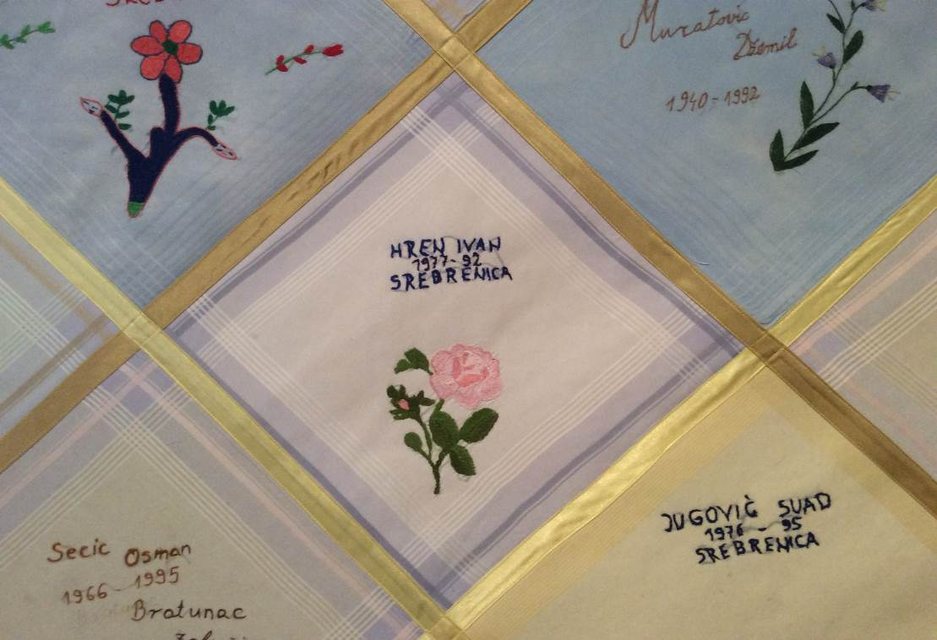
Fig. 12 “Hren Ivan. 1977-1992” © author (2017)

To “put” a dead person “into flowers” reveals a remarkable example of the poetics of translation. Translation of absent personhood and body into cheerful coloured motifs aimed to evoke an atmosphere of life itself –the life of the survivors and their memories of the dead. As Hallam and Hockey note, “the presence of the inscribed name –physicality– enhanced through the accumulation of material gifts […]” fuses “word, image and material”, restoring “to the dead the intimate worlds they had lost” (Hallam & Hockey 2001: 173).
As I mentioned in the beginning, not all the handkerchiefs were made by refugee women from ex-Yugoslavia. The work by the refugees from Asia, who also participated in the memorial embroidery in the Südost Center, shows a slightly different iconography of death and the dead. My interviewee could not tell me more about her embroidery peers, except that they “would come from Asia”. However, knowing that these women came from East and Southeast Asia, brief research and conversations with colleagues from the respective countries have confirmed echoes of Asian funerary beliefs and representations.
The motifs, like the bird and wall (with sea- and mountainscape), are originally Chinese and were used frequently in the funerary decorative style throughout the Han (206 BCE-220 CE), Tang (618-907 CE) and Song dynasties (960-1279 CE). As Wu Hung explains, analysing early Chinese tomb murals, the vision of the afterlife mirrored in the images of birds, mountain- and seascapes reflects “the hope of achieving a postmortem eternity” (Wu 2010: 54-55). We observe similar embroidered scenes (Fig. 13 and 14).

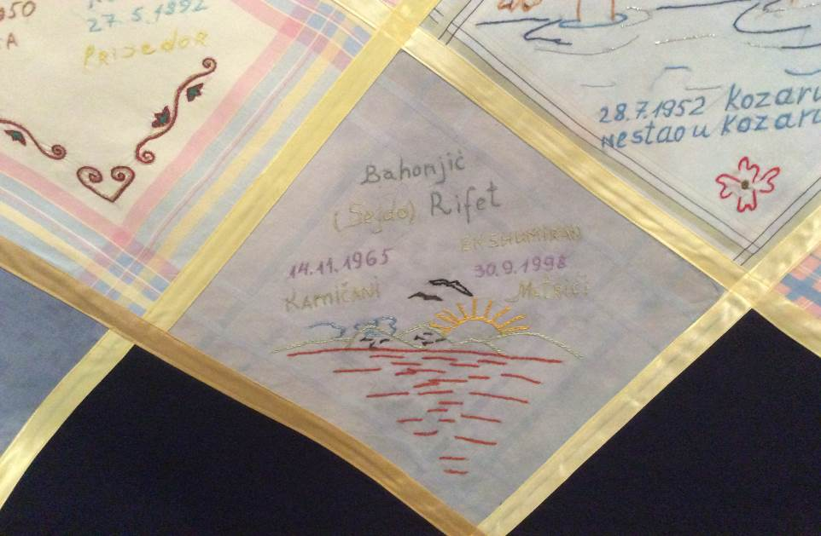
Fig. 13 “Bahonjić (Sejdo) Rifet. 14.11.1965. Kamičani/ Exhumed 30.9.1998. Mirići”
© author (2017)

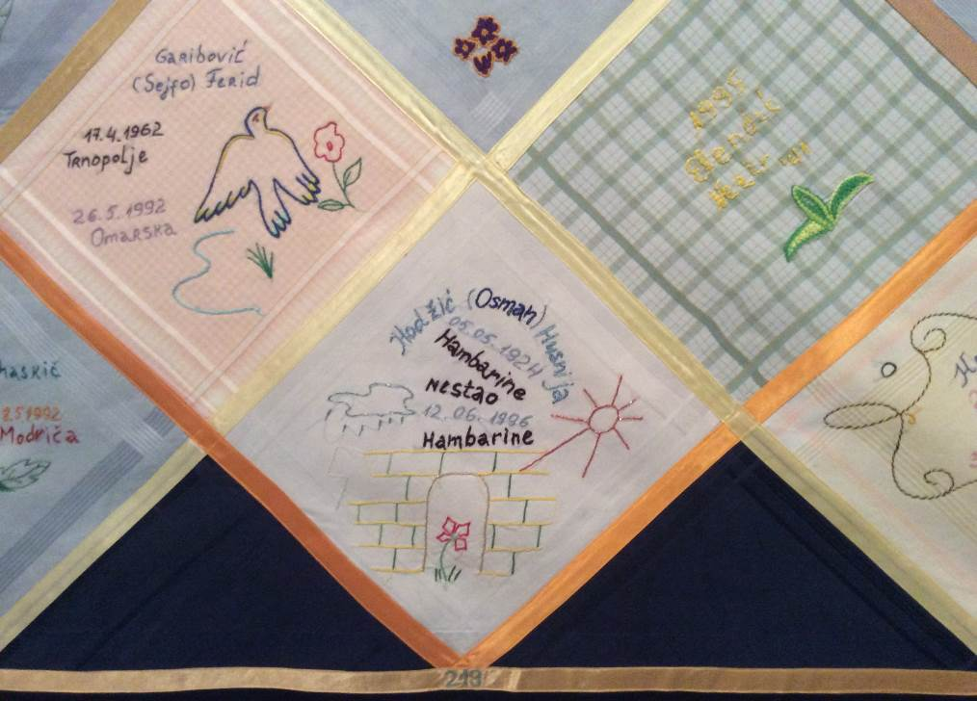
Fig. 14 “Hadžić (Osman) Husnija. 05.05.1924. Hambarine. Disappeared 12.06.1996 Hambarine”
© author (2017)

The passage-landscape, also seen among the motifs on the handkerchiefs, symbolises a soul’s passing onto the other world. As in other religious systems, the transition of the soul is characterised as a sensitive process that needs to be carefully maintained; in that regard, the ornamental system in the tomb was meant to ensure a pleasant eternity for the soul (Wu 2010; Rawson 2006: 385-386). This semantic register allows the following example to be also read as a trace of tomb-wall ornamentation. Birds, like the peacock and the swallow, feature as familiar symbols within the daily Chinese culture (Fig. 15). While a peacock is associated with virtue, happiness, and female beauty, the meaning of a swallow depends on the context, and it can refer to joy, love, melancholia, nostalgic longing and sorrow. These pictorial moments might echo the motif of the crane as an “immortal bird”, common to the Taoist funerary canon of the Tang Dynasty that symbolises postmortem life (Wu 2010: 59). The fan motif belonged to the furnishing register of “the majority of Eastern and Han casket graves […] as posthumous ‘home’ of the ‘dead” for, as Wu further highlights, following Xunzi and Hao Yixing,

[…] the practice of including “lived objects” among grave goods can also be comprehended from the perspective of a mourner: “Burying such articles is like moving house. The living cannot bear to treat the dead as dead.” (Wu 2010: 40, 165)

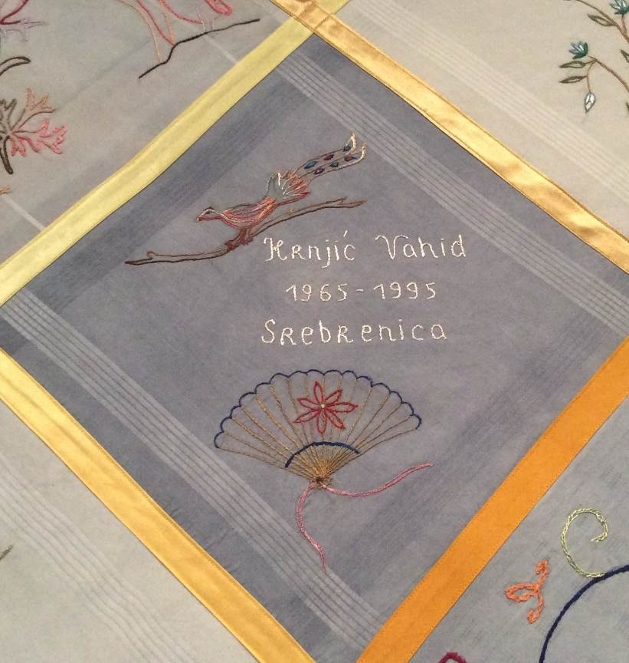
Fig. 15 “Krnjić Vahid. 1965-1995. Srebrenica” © author (2017)

Furthermore, the figures of the peacock and the fan denote feminine space, which has been already addressed in the important issue of the female mourners and the ways their voices reach the world. Here, reading the names tells us they have voiced mainly the absent young and older men. Nevertheless, some textile monuments, similar in oral composition and graphic patterns, are dedicated to women (Fig. 11).
If we consider floral and landscape themes with respect to sounds, the ornamental system that we have seen during the analysis constitutes women’s voices that address us through evocative language. Walking along the Roll of Remembrance, even if we do not read all the names, we read some of them, together with their surrounding messages. Through this act of internal reading, the language from the handkerchiefs transfers to our voices. This is how, in Hans Ulrich Gumbrechtʼs words, “as a physical reality, [spoken] language does not only touch and affect our acoustic sense but our bodies in their entirety” (Gumbrecht 2006: 320). Complete attention to a written name, which becomes acoustic upon reading it, produces the presence of the absentee. Here, I follow Gumbrecht’s notion of language as proximity that “under certain (varied) conditions, can make the past tangibly present”; thus, language becomes a “house of presence” (Gumbrecht 2006: 323, 326).

Conclusion
This paper has focused on language as a semiotic whole consisting of “resources” that (re)make meanings and produce different realities (van Leeuwen 2005: 3, 161). Reading, both visually and oral-verbally, the language employed by refugee women has shown its own “mobility and translocality” (Blommaert & Rampton 2011) in the way different cultural imageries have become interwoven. The embroidered handkerchiefs are, therefore, a work of double translation: the translation of loss, mourning, and commemoration from European (Christian and Islamic) cultures and of Asian (here, Chinese) funerary arts into one shared language. The participation of the women from Southeast and East Asia is an unusual situation: someone creates a gift, the monument, and dedicates it to an unknown receiver. Their position is reminiscent of the role of stone carvers who make a monument and engrave words supplied by an, often anonymous, family.
I have not dealt with the mythopoetic meanings of the particular motifs, for my interest focuses on how they constitute a compound poetic lexicon, which remains open to the interpretation of the viewer. Images of flowers and trees are common motifs in poetry, especially in oral poetry where they appear as recurring poetic phrases, i.e., formulas. Here we might read them in terms of metonymic concepts of the Edenic garden/Jannat [BKMS/Bosnian Dženet]: Pure Land where blessed souls are put to rest and can be reborn, according to a given belief system (Lakoff & Johnson 2003: 40).
Various ornamentations on antique ceramics, textiles, manuscripts, weapons, and architectural objects like gravestones and walls support the view of language as a domain beyond cultural differences where meanings appear as mutually close and apprehensive. Lakoff and Johnson speak of “metaphorical imagination” that is “a crucial skill in creating rapport and in communicating the nature of unshared experience” (Lakoff & Johnson 2003: 231). But what can be said about different cultural contexts that, nonetheless, show/have “shared experience”? Where Lakoff and Johnson see a need for “adjustment” to a worldview in different cultural contexts, I find the work of metaphoric “transport” and “translation” (see van Leeuwen 2005: 31) that creates cross-roads of contexts and experiences in the world of today inter-connected as never before. This is how our experiences, and that of others, allow us to address different sensibilities across cultures.
In such a way, the colleague who gave me some insights into Chinese funerary decoration also reported that she and her friends immediately recalled the motifs from the Tang poetry of Du Fu (712-770) when they observed and discussed the visual representations of the handkerchiefs. Du Fu’s poetry reflects the suffering of individuals during the military conflicts of the Tang times:

Sighting of Spring

The nation is in sunder, yet mountains and rivers still their stances hold and courses run,
Spring has come to Changan overgrown with unruly grass and trees.
Current affairs have me deep in sentiments, and tears overcome me at the sight of flowers,
Detesting separation from family so much, even the twitter of birds frightens me.
Military unrest has been continuing for months on end,
More valuable than tons of gold is a letter from family and kin.
My hair has greyed and grown thin,
There remains almost too little for the use of a hairpin.

The poem is composed of the contrast between the overgrown grass and trees in spring and the mourning subject, pictorially personifying mourning over the shattered nation and suggesting “military unrest” as a continuous totalising feeling, similar to the literary testimony of Zabel Essayan.
Choosing to speak about refugee women from Bosnia does not implicate any political affiliations; losses and sufferings swept across all the former Yugoslav republics involved in the war. My article has conveyed the worlds that I have personally encountered. I follow Peter van der Veer who argues for a “fragmentary approach to social life” whereupon a fragment can offer “a perspective on a larger whole” (van der Veer 2016: 9). Despite the incomparability of experiences of loss due to past fatalities, forms of mourning and commemoration can appear as paralleled, connected, and shared. Traces of these cross-cutting experiences and a sharedness can be seen among entries in the visitorsʼ book, bearing an exact witness to the above-defined poetics of translation (Fig. 16). The following words in Chinese read:

Fig. 16 © author (2017)

Peaceful coast, beautiful landscape, and subtle handkerchiefs bear longing, trust, suffering, and hope. One is moved and deeply touched by this.
Translation by Chang Liu

These lines show museological communication between exhibited objects, audience and mostly absent authors to whom the written messages are left. They convey visitors’ feelings about the displayed content which becomes a platform for reflecting on their biographies, similar experiences and likes or dislikes regarding the exhibited.
The audience of viewers and readers fully supports the world created by the museum: the visitors “utter the disappearance [absence] of these dead” and “grant life” by reading the names inscribed in the Roll of Remembrance (Laquer 2015: 433; Williams 2007). Moreover, some of them act upon the displayed items by adding personal reflections, thus leaving traces of their presence.
As a place where private and public domains meet and as a site of memory, a museum forces a closer observation of the way exhibited items (can) affect the registers of remembrance. Displayed in the museum, the names on the Roll of Remembrance no longer signify only lost loved ones and intimate worlds but, moreover, the events and narratives attached to them. Like the objects in memorial museums, restored from the past, these names act upon the so-called “museum-effect”, being “reported […], researched, arranged […], and written about”, they become “historicized artefacts” (Williams 2007: 28, 47). As artefacts, they fall into the inventory of items with extraordinary value ready to be addressed by new visitors or groups and their political agendas. In this fashion, Corinne A. Kratz speaks of “rhetorics of value” within the “double-sided exhibition experience”:

[…] it relies both on what visitors bring to exhibitions as well as what exhibitions bring to visitors, which is already the outcome of complex processes and decisions that shaped the exhibition. Rhetorics of value are part of what exhibitions bring to visitors, but visitors relate to exhibitions in different ways, through diverse interests and orientations. What they encounter in an exhibition provides resources through which they may experience and formulate their own values and identities, whether as individuals or members of social groups. People produce notions of value and identity in relation to objects and subjects on display, in relation to the experience they bring to the exhibition, and in relation to politics of representation at play in other contexts. (Kratz 2011: 29)

This raises the question of how intimate emotional languages of mourning and commemoration are overlaid with those languages that start iconizing certain narratives (Williams 2007: 54). As Renshaw notes, “the absent dead are a site of unresolved emotion and ongoing political tension, even ‘outliving’ generations of mourners” (Renshaw 2010: 49). While, in the words of my field-sister Remzija Suljić, women “put their dead into flowers” to provide them with a “place” to rest and thus regain order (see also Wagner 2010: 65), politically engaged readers ascribe other meanings to these dead.
The public language of mourning and commemoration bears strong axiological notions (Bartmiński [Бартмињски] 2011) through exterior sites where processes and objects are exhibited as values. When Paul Williams notes that the restored and exhibited objects from the past are “valued in entirely new ways” (Williams 2007: 28), he points to this axiological categorisation. That is why this language chooses distributional means to address potential political communities.
In light of this, there remains one important quest in dealing with language(s) that politically semiotize public sites. Here, Judith Butler observes the distributional force in addressing political communities (Butler 2009: 24, 2004: 22). Martha Nussbaum similarly defines language as a strategic means to generate “public emotions” via “public artworks, monuments and parks, through the construction of festivals and celebrations […]” (Nussbaum 2013: 203). As one of the public feelings, “love of the nation” creates competitive stories of victimhood. Dwelling on one’s loss often entails becoming exclusive about the other’s loss. In this manner, states mutually suspend the dignity of the missing. Within such a framework, being (un)identified, (un)claimed or never recovered, the body becomes a matter of political negotiations over victims, martyrs or perpetrators while the real individual past lives of the dead, as well as their families, remain invisible. Mustafa, Ivan, and Fatima are some of the exhibited names within the museum walls ready to receive new interpretations, values, and narratives they will stand for. Who they were and what they did and hoped for is insignificant “information” unless their lives turn out to be nationally desirable and “grievable”. In that case, families and their suffering over loss become visible, for they contribute “consecrat[ion of] the past” and feature as “iconic for the nation” (Butler 2009: 38; Rosenblatt & Wagner 2017: 237).
Departing from the tension surrounding the split into four languages and the concept of the Common Language, this paper has regarded the language displaced women from Former Yugoslavia and some women from Asia have employed to overcome war-related trauma. To offer a methodological and epistemological response regarding violent past(s) and personal or collective losses worldwide seems to be a matter of meta-academic awareness that should move towards self-reflexive and engaged research (Halilovich 2016: 80).
Turning from the iconography of handkerchiefs to the potential political role in the public, I intended to expose the vulnerability of such “materialization” that might be used as a “political strategy” for fixing and imposing specific meanings (Hodder & Hutson 2003: 67, 210). For this reason, this paper has hoped to propose a mutually “reflexive translation” (van der Veer 2016: 148) across diverse cultural, epistemological, and emotional realities.

Acknowledgements
This paper would not have been possible without the continuous support and trust of Remzija Suljić, Anna Brägger, and Jelena Blažan. They allowed me to put in words what is within them, so I hope the article is true to their their experiences of loss and healing. Thanks are also due to Beate Wild, the curator of the exhibition, for introducing me the project Roll of Remembrance. Moreover, I am deeply indebted to my dear colleague and friend Chang Liu for her thoughtful guidance through the section on the Chinese cultural universe. My sincere appreciation also goes to Professors Peter Rutland and Wu Hung for their time and generosity in sharing their expertise and views. A dear colleague, Jana Vijayakumaran, kindly provided valuable insights into the funerary cultures of Sri Lanka and India, while colleagues Neven Isailović, Michał Piasek, and Željana Tunić were kind enough to read and comment on earlier drafts of this paper, a debt I dutifully record.

References
Ariès, P. 2009 [1982]. Geschichte des Todes [L’homme devant la mort]. Munich: Deutscher Taschenbuch Verlag.
Asad, T. 1986. “The concept of cultural translation in British social anthropology.” In J. Clifford & G. E. Marcus (eds.), Writing Culture. The Poetics and Politics of Ethnography. Berkely & Los Angeles: University of California Press, 140-164.
Бартмињски, Ј. 2011. Језик-слика-свет: Етнолингвистичке студије. Београд: SlovoSlavia [Bartmiński, J. 2011. Language-Image-World: Ethnolinguistic Studies. Belgrade: SlovoSlavia].
Blommaert, J. & B. Rampton, 2011. “Language and superdiversity”. Diversities 13(2): 1-21.
Boss, P. 1999. Ambiguous Loss: Learning to Live with Unresolved Grief. Cambridge, MA & London: Harvard University Press.
Buch, L. 2010. “Derivative presence: Loss and lives in limbo in the West Bank.” In M. Bille, F. Hastrup & T. F. Sørensen (eds.), An Anthropology of Absence: Materializations of Transcendence and Loss. New York & Dordrecht: Springer, 83-98.
Bugarski, R. 2012. “Language, identity and borders in the former Serbo-Croatian area.” Journal of Multilingual and Multicultural Development 33(3): 219-235.
Butler, J. 2004. Precarious Life: The Power of Mourning and Violence. London & New York: Verso.
Butler, J. 2009. Frames of War: When is Life Grievable? London & New York: Verso.
Caraveli-Chaves, A. 1980. “Bridge between worlds: The Greek women's lament as communicative event.” The Journal of American Folklore 93(368): 129-157.
Caraveli-Chaves, A. 1986. “The bitter wounding: The lament as social protest in rural Greece.” In J. Dubisch (ed.), Gender and Power in Rural Greece. Princeton, N.J.: Princeton University Press, 169-194.
Cassirer, E. 1946. Language and Myth. New York: Dover Publications Inc.
Clayton, B. 2004. A Penelopean Poetics: Reweaving the Feminine in Homer’s Odyssey. Lanham, MD: Lexington.
Closterman, W. E. 2014. “Women as gift givers and gift producers in ancient Athenian funerary ritual.” In A. Avramidou & D. Demetriou (eds.), Approaching the Ancient Artifact: Representation, Narrative, and Function. Berlin & Boston: De Gruyter, 161-174.
Derrida, J. 2001. The Work of Mourning. Edited by A.-P. Brault & M. Naas. Chicago & London: University of Chicago Press.
Dimova, R. 2013. Ethno-Baroque: Materiality, Aesthetics, and Conflict in Modern-Day Macedonia. New York & Oxford: Berghahn Books.
Doloughan, F. 2011. Contemporary Narrative: Textual Production, Multimodality and Multiliteracies. London & New York: Continuum.
Durkheim, E. 1995. The Elementary Forms of Religious Life. New York & London: The Free Press.
Eng, D. L. & D. Kazanjian (eds). 2003. Loss: The Politics of Mourning. Berkeley: University of California Press.
Fishman, A. 2008. “Thrênoi to moirológia: Female voices of solitude, resistance, and solidarity.” Oral Tradition 23(2): 267-295.
Fishman, J. A. 1989. Language and Ethnicity in Minority Sociolinguistic Perspective. Clevedon, Philadelphia: Multilingual Matters.
Foley, J. M. 2002. How to Read an Oral Poem. Urbana & Chicago: University of Illinois Press.
Giunta, E. & J. Sciorra (eds). 2014. Embroidered Stories: Interpreting Women’s Domestic Needlework from the Italian Diaspora. Jackson, MS: University Press of Mississippi.
Greimas, A. J. 1987. On Meaning: Selected Writings in Semiotic Theory. Minneapolis: University of Minnesota Press.
Gumbrecht, H. U. 2006. “Achieved in language (with special attention given to the presence of the past).” History and Theory 45(3): 317-327.
Halilovich, H. 2014. “Reclaiming erased lives: Archives, records and memories in post-war Bosnia and the Bosnian diaspora.” Archival Science 14(3-4): 231-247.
Halilovich, H. 2016. “Re-imaging and re-imagining the past after ‘memoricide’: Intimate archives as inscribed memories of the missing.” Archival Science 16(1): 77-92.
Hallam, E. & J. Hockey. 2001. Death, Memory and Material Culture. Oxford: Berg.
Hasan-Rokem, G. 2014. “Bodies performing in ruins: The lamenting mother in Ancient Hebrew texts.” In I. Farber & P. Schwebel (eds.), Laments in Jewish Thought: Philosophical, Theological, and Literary Perspectives. Berlin: De Gruyter, 33-63.
Hodder, I. & S. Hutson. 2003. Reading the Past: Current Approaches to Interpretation in Archeology. Cambridge & New York: Cambridge University Press.
Honko, L. (ed.). 2000. Textualization of Oral Epics. Berlin & New York: De Gruyter.
Jakoby, N. 2012. “Grief as a social emotion: Theoretical perspectives.” Death Studies 36(8): 679-711.
Jensen, A. M. B. 2010. “A sense of absence: The staging of heroic deaths and ongoing lives among American organ donor families.” In M. Bille, F. Hastrup & T. F. Sørensen (eds.), An Anthropology of Absence: Materializations of Transcendence and Loss. New York & Dordrecht: Springer, 62-80.
Kastenbaum, R. (ed.). 2003. Macmillan Encyclopedia of Death and Dying. New York: Macmillan.
Kearl, M. C. E. 1989. A Sociology of Death and Dying. Oxford: Oxford University Press.
Kratz, C. A. 2011. “Rhetorics of value: Constituting worth and meaning through cultural display.” Visual Anthropology Review 27(1): 21-48.
Küchler, S. 2014. “Relational maps in the Cook sland transnational communities.” In C. De Cesari & A. Rigley (eds.), Transnational Memory: Circulation, Articulation, Scales. Berlin & Boston: De Gruyter, 99-123.
Lakoff, G. & M. Johnson. 2003. Metaphors We Live by. London: The University of Chicago Press.
Laqueur, Th. W. 2015. The Work of the Dead: A Cultural History of Mortal Remains. Princeton, NJ: Princeton University Press.
Lord, A. B. 2000 [1960]. The Singer of Tales. Cambridge, MA & London: Harvard University Press.
Mandolessi, S. 2014. “Haunted houses, horror literature and the space of memory in post-dictatorship Argentine literature.” In E. Schindel & P. Colombo (eds.), Space and the Memories of Violence. New York: Palgrave Macmillan, 150-161.
McLaren, A. E. 2008. Performing Grief: Bridal Laments in Rural China. Honolulu: University of Hawaii Press.
Metcalf, P. & R. Huntington. 1991. Celebrations of Death: The Anthropology of Mortuary Ritual. Cambridge: Cambridge University Press.
Nettelfield, L. J. & S. E. Wagner. 2014. Srebrenica in the Aftermath of Genocide. New York: Cambridge University Press.
Nichanian, M. 2003. “Catastrophic mourning.” In D. L. Eng & D. Kazanjian (eds.), Loss: The Politics of Mourning. Berkeley: University of California Press, 99-124.
Norrick, N. 2008. “Conversational storytelling.” In D. Herman, M. Jahn & M.-L. Ryan (eds.), Routledge Encyclopedia of Narrative Theory. London & New York: Routledge, 84-86.
Nöth, W. 2000. Handbuch der Semiotik. 2nd completely revised and augmented edition. Stuttgart & Weimar: Verlag J. B. Metzler.
Nussbaum, M. C. 2013. Political Emotions: Why Love Matters for Justice. Cambridge, MA & London: The Belknap Press.
Ochs, E. 1992. “Indexing gender.” In A. Duranti & C. Goodwin (eds.), Rethinking Context: Language as an Interactive Phenomenon. Cambridge: Cambridge University Press, 335-358.
Ong, W. J. 2002 [1982]. Orality and Literacy: The Technologizing of the Word. London & New York: Routledge.
Radulović, N. 2015. “Arbor mundi: Visual formula and the poetics of genre.” In M. Detelić & L. Delić (eds.), Epic Formula: A Balkan Perspective. Belgrade: Institute for Balkan Studies, 65-80.
Rawson, J. 2006. “Ornament as system: Chinese bird-and-flower design.” The Burlington Magazine: Decorative Arts and Design 148(1239): 380-389.
Renshaw, L. 2010. “Missing bodies near-at-hand: The dissonant memory and dormant grave of the Spanish civil war.” In M. Bille, F. Hastrup & T. F. Sørensen (eds.), An Anthropology of Absence: Materializations of Transcendence and Loss. New York & Dordrecht: Springer, 45-61.
Rosaldo, R. 2004 [1989]. “Grief and a headhunter’s rage.” In A. C. G. M. Robben (ed.), Death, Mourning, and Burial: A Cross-Cultural Reader. Malden, MA & Oxford: Blackwell, 167-178.
Rosenblatt, A. & S. Wagner. 2017. “Known unknowns: Forensic science, the nation-state, and the iconic dead.” In C. M. Stojanowski & W. N. Duncan (eds.), Forensic Biohistory: Anthropological Perspectives. Cambridge: Cambridge University Press, 237-266.
Seremetakis, N. C. 1991. The Last Word: Women, Death and Divination in Inner Mani. Chicago: The University of Chicago Press.
Sokoly, J. 2017. “Textile and identity.” In F. B. Flood & G. Necipoğlu (eds.), A Companion to Islamic Art and Architecture. Hoboken, NJ: Willey Blackwell, 275-299.
van der Veer, P. 2016. The Value of Comparison. Durham: Duke University Press.
van Leeuwen, T. 2005. Introducing Social Semiotics. London & New York: Routledge.
Wagner, S. 2010. “Tabulating loss, entombing memory: The Srebrenica-Potocari Memorial Centre.” In E. Anderson, A. Maddrell, K. McLoughlin & A. Vincent (eds.), Memory, Mourning, Landscape. Amsterdam: Rodopi, 61-78.
Williams, H. 2006. Death and Memory in Early Medieval Britain. Cambridge: Cambridge University Press.
Williams, P. H. 2007. Memorial Museums: The Global Rush to Commemorate Atrocities. Oxford & New York: Berg.
Woodthorpe, K. 2010. “Private grief in public spaces: Interpreting memorialisation in the contemporary cemetery.” In J. Hockey, C. Komaromy & K. Woodthorpe (eds.), The Matter of Death: Space, Place and Materiality. New York: Palgrave Macmillan, 117-132.
Wu, H. 2010. The Art of the Yellow Springs: Understanding Chinese Tombs. London: Reaktion Books.

Internet Sources
Movements of Mothers of Srebrenica and Žepa Enclaves:
http://enklave-srebrenica-zepa.org/english.onama.php (last accessed: December 2018).
Women in Black:
http://zeneucrnom.org/index.php?lang=en (last accessed: December 2018).
English translation of Chinese poetry:
https://28utscprojects.wordpress.com/2011/01/08/106/
(last accessed: December 2018).
Declaration on the Common Language:
http://jezicinacionalizmi.com/deklaracija/ (last accessed: December 2018).

About the guest-editor

Roswitha Kersten-Pejanić completed her PhD thesis on the interrelation of linguistic norms and gender perceptions in Croatian in 2016 at Humboldt University. She is a postdoc fellow at the Center for Advanced Studies- Southeastern Europe in Rijeka, where she is working on her project on linguistic landscapes in Croatian post-conflict border regions, which is funded by the German Research Foundation (DFG).

About the authors

Lumnije Jusufi is a linguist, translator, and teacher of German as a foreign language. She completed a research project on pluricentrism and albanology at Humboldt University in Berlin and is teaching German for foreigners at TU Dortmund. She completed her PhD on Albanian dialects in Macedonia in 2009 and worked as a lecturer at LMU Munich (2006-2012) and at various German and Southeast European universities.

Branimir Stanković is an assistant professor at the Serbian language Department (Faculty of Philosophy) at the University of Niš, Serbia. He is interested in different linguistic areas, covering more theoretically and formally oriented linguistic issues (generative syntax, formal semantics, and pragmatics), as well as broader, sociolinguistic and ethnographic linguistic questions, such as hypercorrection and language policy.

Snežana Stanković is a PhD candidate at the Humboldt University of Berlin and a research fellow at the Viadrina Center B/ORDERS IN MOTION (Frankfurt am Oder). Rooted in narratology, historical and visual anthropology, her research work concerns funerary and mourning cultures. In her PhD-project, she follows (dis)continuities of the past (conflicts, displacement, absence) of the Banat border region (Serbia/Romania) using cemeteries, archival sources, and oral testimonies as research lenses.

Marija Stefanović received her first MA degree in Literature and Serbian Language and her second MA in Sociology, both at the Faculty of Philosophy of the University of Niš, Serbia. During her research career she has gathered extensive experience in qualitative research, with special emphasis on ethnography. Her additional fields of interest include sociology of culture and language, and Bourdieusian theory.

Christian Voß has held the Chair of South Slavic Languages and Cultures at Humboldt University in Berlin since 2006 and is the director of the recently founded Centre of Border Studies. Prof. Voß has conducted and supervised research projects on a range of topics such as language and (national and ethnic) minorities, gender, narratives, and diverse accounts of border issues in Southeast Europe.

Available at: http://jezicinacionalizmi.com/deklaracija/ (last accessed: November 2018).
Comparing the respective Wikipedia articles on the Deklaracija is really interesting in this respect. These are available in Bosanski, Hrvatski, Српски / srpski and Srpskohrvatski / српскохрватски and show significantly different evaluations of the document, with especially the Croatian Wikipedia entry being highly critical, mirroring majoritarian official reactions in Croatia.
While the linguistic macro-level is displayed in official, often state-level, approaches to linguistic meaning-making, language politics, and/or authoritative language management, the micro-level is what can be observed in individual, local, everyday and sometimes non-obliging language usage to authoritative language regulations.
Original: “дуго очекиван[a] Одлук[a]” in the press release on http://hronograf.net/2017/10/12/sanu-borkinja-psiholoskinja-vojnikinja-sekretarka-gramaticki-nepravilne/ (last accessed: November 2018).
The very telling examples of professions that do not need female word form are: ‘борац’ (engl. fighter_{+MASC}), ‘пилот’ (pilot_{+MASC}), and ‘академик’ (academician_{+MASC}) (Odbor za standardizaciju srpskog jezika 2018).
More than theoretical enquiries, empirical evidence from many languages has shown the factual non-comprehensiveness of masculines used generically (i.a. Khosroshahi 1989; Braun, Sczesny & Stahlberg 2002; 2005; Liben, Bigler & Kogh 2002; Valdrová 2008; Gygax, Gabriel & Sarrasin et al. 2008; Kusterle 2011; Steiger-Loerbroks & von Stockhausen 2014; Alvanoudi 2015; Vervecken & Hannover 2015). See also Kersten-Pejanić (2018) for a perception study in Croatian and a short overview of existing studies on the perception of generically intended masculines. See Kersten-Pejanić (2017: 92-114) for a more comprehensive overview of the long tradition of testing ‘masculine generics’ with regard to their supposed gender neutrality and more detailed results of the above-mentioned perception study of Croatian person appellatives.
The research project “Linguistic Landscapes at the margins: Performativity of ethnic belonging and memory politics in Croatian post-conflict border regions” is made possible by the much-appreciated financial support of the German Research Foundation (DFG) under project number 401363951.
“Suočeni s negativnim društvenim, kulturnim i ekonomskim posljedicama političkih manipulacija jezikom i aktualnih jezičnih politika u Bosni i Hercegovini, Crnoj Gori, Hrvatskoj i Srbiji, mi, doljepotpisani, donosimi […].”
Published by the “Fond istine o Srbima”, online version cf. svevlad.org.rs/srbistika/slovo.html.
This prompts Bulić to ask already in the title of his response to the Declaration, if the common language should in fact be called Serbian (Bulić 2017).
For the Macedonian part of this map, cf. Trifunovic (2015).
Recent statements by the Serbian Foreign Minister Ivica Dačić regretting Serbian recognition of the Republic of Macedonia under its constitutional name, however, continue a post-colonial discourse on Macedonia; cf. http://meta.mk/en/dacic-serbia-made-a-mistake-by-recognizing-macedonia-under-its-constitutional-name/
The best description of the BCMS issue is still: Alexander 2002-2003; historically: Naylor 1980.
Cf. the exhaustive descriptions of the pluricentric variance in the German-speaking world (A–CH–D) by Ammon, Bickel & Ebner 2004.
For a more detailed comparison of the European Union and Yugoslavia cf. Voß 2008.
On the Montenegrin “green” national movement before and after World War I cf. Banac (1984: 270-291).
“Ilinden” refers to the day of St. Elias and is the most important lieu de mémoire of Macedonian nationalism. It commemorates the one and only anti-Ottoman uprising in 1903 in the city of Kruševo.
Language policy in Skopje since the 1950s was in the hands of Blaže Koneski and three others: Korubin, Dimitrovski and Stamatoski (later Vidoeski), who were able to adapt to new political circumstances over the decades.
For a concise introduction, see Friedman (1985).
Engl. (my translation): “That we lead a constant fight for the purity of our language”, cf. the editorial in the first volume of Makedonski jazik 1950/1: 1-2).
Engl. (my translation): “[…] we are far from the degree of linguistic ‘cleansing’ that we see for example in the early stage of Czech literary language”.
Cf. the text of the Novi Sad Agreement in Greenberg (2004: 172-174): the keyword in this document is the ravnopravnost ('equality') of nations and languages.
Engl. (my translation): ‘The national language of Serbs, Croats and Montenegrins is one language’.
Engl. (my translation): ‘standard language expression’.
A good insight in this political process is provided by Rajka Glušica, who was a member in the standardisation council (Glušica 2009, 2011, 2013).
All these examples are taken from the 2009 Pravopis; cf. Glušica (2010: 41).
The grapheme does not yet exist in Unicode.
The name Njegoš here is highly symbolic, since the Vladika (‘bishop’) and poet Petar II Petrović Njegoš (Gorski vijenac, his opus magnum, dates back to 1847), Montenegro's most famous author, was himself inclined politically and religiously to Serbdom.
The Serbian Language Standardization Committee was founded in 1997 by members of three Academies of Sciences and Arts (Serbia, Montenegro, Republika Srpska), along with representatives from Matica Srpska (Novi Sad), Institute for the Serbian language (Serbian Academy of Sciences and Arts), Faculties of Philology and Philosophy at the universities of Belgrade, Novi Sad, Priština, Niš, Kragujevac, Nikšić, Srpsko Sarajevo, Banja Luka and the Serbian Literary Cooperative.
Cf. the myths identified for English in the seminal book by Bauer and Trudgill (1998).
Discrimination based on language variety spoken; i.e. linguistic discrimination.
We follow Bugarski (1992: 18) who defines language policy as “the policy of a society in the area of linguistic communication—that is, the set of positions, principles and decisions reflecting that community’s relationships to its verbal repertoire and communicative potential. Language planning is understood as a set of concrete measures taken within language policy to act on linguistic communication in a community, typically by directing the development of its languages”.
Schiffman defines linguistic culture as “the set of behaviours, assumptions, cultural forms, prejudices, folk belief systems, attitudes, stereotypes, ways of thinking about language, and religio-historical circumstances associated with a particular language” (Schiffman 1996: 5).
An idea which, according to Bourdieu (Ibid.), “haunts all linguistic theory”.
Incidentally, this jibes well with what Blommaert (2015b) calls chronotopes.
More recent work by a variety of scholars has of course tackled these issues, especially in the framework of Critical Discourse Analysis (Fairclough 2011, Wodak 1989).
Greenberg (2010) identifies three different groups of Serbian linguists: i) advocates of the status quo (most SLSC members), ii) advocates of rediscovering the Serbian of nineteenth-century Serbian language reformers Vuk Karadžić and Đura Daničić (Radoje Simić and Miloš Kovačević), and iii) extreme Serbian nationalists seeking an "Orthodox Serbian" language and orthography (Radmilo Marojević).
It is important to notice that the Serbian Language Standardization Committee was established in the middle of the nineties, i.e. in the post-Yugoslav era.
Bugarski (2012) gives a very informative overview of the history of language policy in the South Slavic terrain from the beginning of 19th century.
Serbian is standardized on the basis of the so-called novoštokavian (i.e. neostokavian) variety, which consists of two vernacular segments: the ekavian variety, spoken mostly in Serbia, and the ijekavian variety, used in parts of Serbia, Bosnia and Herzegovina, Croatia and Montenegro.
The authors of the paper translated the Serbian terms kodifikatori, edukatori and realizatori as codifiers, educators and implementors (we thank an anonymous reviewer for suggesting the translation for the last term, implementors). These notions, as far as the authors are aware, were introduced for the first time by Piper and Klajn (2013).
The grammar was published 2013 by the initiative of the Serbian Language Standardization Committee.
In Serbian literature one even finds the notion of “balkanization of the Serbian standard language”, a term intended to cover two processes: the process of decomposition into many standardized languages after the disintegration of Yugoslavia and the influence to the standard from Southern non-standard varieties, resulting in language change (see Radić 2003).
Similar rhetoric can be heard from Serbian statespersons and politicians, and not just language professionals. It is symptomatic that identical phrases and sentences are repeated in the media. For example, a report in the newspaper Danas quotes the current Serbian president Aleksandar Vučić, regarding the Declaration of Serbian identity, which should appear soon in Parliament both in Serbia and in Republika Srpska, reminiscing of the 19th century language reformer Vuk Karadžić: “Without Vuk Karadžić, we would not exist today, we would not know who we are, nor where do we come from, we would not have our roots –said Vučić, adding that Serbia gained its name and identity in 1847, when Karadžić published a new translation of the New Testament. It is due to this, that we have become a nation, a Serbian nation –stated Vučić, reminding that all great reforms in history started with language. As he emphasized, this is the reason why we will take care, nurture and protect what has been bequeathed to us from Vuk Karadžić, our beautiful Serbian language, illuminating not just Serbia, but everywhere where its people reside. Vučić also pointed out that Vuk Karadžić has urged us not to forget that our future is language itself” (Danas, 09/17/2017).
http://www.unesco.org/languages-atlas/index.php (last accessed: December 2018).
Pavle Ivic was a co-founder and first chairman of the Serbian Language Standardization Committee until his death in 1999.
“(…) or, more precisely, between the unification of the educational (and linguistic) market, linked to the introduction of educational qualifications valid nation-wide, independent (at least officially) of the social or regional characteristics of their bearers, and the unification of the labor market (including the development of the state administration and the civil service), which played the most decisive role in devaluing dialects and establishing the new hierarchy of linguistic practices.” (Bourdieu 1991: 48–49).
http://www.rts.rs/page/stories/sr/story/125/drustvo/2121345/brboric-kampanja-negujmo-srpski-jezik-dala-rezultate.html (last accessed: December 2018).
Unlike standard Serbian, which has a stress system consisting of four accents and a case system of seven cases, the Southern Torlak dialect has only one accent and three case forms.
This example is in a somewhat different form found in Jusufi & Pani 2016.
Dialects spoken at home often need to be differentiated as either the mother’s or the father’s dialect: Within the existing patriarchal framework of this study, “own dialect” refers to the father’s dialect.
This example is in a somewhat different form also found in Jusufi & Pani 2016.
This example can be found in a somewhat different form also in Jusufi & Pani 2016.
Original text to be found here http://jezicinacionalizmi.com/deklaracija/ (last accessed: December 2018).
Slovenia and Macedonia were also constituent republics declared independence from Yugoslavia in 1991 and 1992.
Here, I refer to the perspective of the exhibition where the language was labelled Bosnian.
http://www.suedost-ev.de/ueber_uns/wirueberuns.php (last accessed: December 2018).
Although Greimas (1987) points to the distinction between natural and constructed (“artificial”) semiotic systems, he clearly emphasizes its fuzziness, speaking of mutual translations within different languages defined as mythological, ideological, cinematographic or oneiric.
Talal Asad’s poetics of cultural translation implies several layers: He underlines “the fact that the anthropologist’s translation is not merely a matter of matching sentences in the abstract, but of learning to leave another form of life and to speak another kind of language” [141]; however, “learning to leave a new mode of life” differs from “learning about” [159]. Herewith, Asad introduces the second layer of “cultural translation” which occurs after returning from fieldwork, according to the “discipline, institutional life, and wider society” (Asad 1986: 159).
The wars of separation in Former Yugoslavia were followed by “ethnic cleansing” and cruelties of genocidal proportions. In the aftermath of these events, the work through the past(s) has exposed the sensitive nature of language in its legal, political, and emotional use. In 2001, the ICTY and ICJ declared the 1995 killings in Srebrenica a genocide. I use the term “genocide” not only in line with a legal decision but also to transmit the absoluteness of violence and loss. Herewith, my intention is not to suspend any traumatic experience of the Yugoslav civil wars in Bosnia-Herzegovina and Croatia with respect to Bosnian Muslims/Bosniaks, Croats, Montenegrins, and Serbs, but rather to implicitly address the denial, politicization, and banalization of violence.
This paper speaks of loss mainly concerning unrecoverable separation from a deceased person. There are valuable studies that have addressed the (im-)materiality and semantic complexity of loss. Rozita Dimova deals with experiences of loss and lack of social privileges reflected in “consumed materiality” that ethnic Macedonians could afford during socialist Yugoslavia (Dimova 2013). In her article about the Palestinian women whose husbands were detained (“detainees”) or dead (“martyrs”), Lotte Buch analyses “the intertwining of intangible loss and the texture of absence” in their lives (Buch 2010:86).
Psychology scholars often differ in their treatment of grief, bereavement, and mourning. The Freudian concept of mourning as resolved grief and melancholia as endless grieving takes various interpretative directions. These interpretations remain, however, beyond the framework of this article, which regards the abovementioned emotions as states, processes, and actions that continuously intermingle and, therefore, are inseparable. For this reason, the paper will interchangeably use the terms “grief” and “mourning”.
See Paul Seawright Hidden: http://www.paulseawright.com/hidden/ (last accessed: December 2018).
To mention an example, men from the Balkans or Iran, abstain from shaving for forty days while in some rural parts of Montenegro and Serbia lamenting is still present.
For a broader perspective on the connection between emotions and mortuary rituals, see, for instance, the explanation provided by Durkheim who writes about “sadness” and “anger” within the ceremony of lamentation; we can observe similar feelings of anger –“headhunter's rage” – in the survey provided by Rosaldo. Durkheim underlines that the emotions expressed here are a matter of obligation, as “a ritual facade that must be adopted out of respect for the custom” (Durkheim 1995: 397, 401; Rosaldo 2004 [1989]: 167-178).
More than forty-five meters long at the time of the exhibition in 2017.
This segment originates from the interview displayed in the exhibition.
The empty row in the first photograph means that some members of the family gathered in the burial ground remain missing. The second picture shows new grave markers, behind the white gravestones, erected in 2017, after the bodies of the disappeared had been recovered.
It is necessary to note here that the paper refers to the elegiac forms which are orally performed. Islamic scholars officially prohibit the institution of lamenting. In contrast, it is a topos in the Hebrew Bible. My research is along the lines of Galit Hasan-Rokem’s work on laments and motherhood, where both oral and written traditions of laments show similarities across the world, e.g. in the Balkans, Ireland as well as in some parts of Africa, Asia, and South-America (cf. Hasan-Rokem 2014; and also Seremetakis 1991; Fishman 2008; McLaren 2008).
The role of women in memory-making and breaking the silence on what happened to the victims during wars and dictatorships worldwide has gained much attention since the Mothers of the Plaza de Mayo started the struggle for the “truth” over their dead children who disappeared, the desaparecidos, during the dictatorship in Argentina (1976-1983). A similar case is to be recognised in Iran where the so-called Mourning Mothers protested against the state violence where people (their children) were detained, missing or killed. Orgnizations such as Movements of Mothers of Srebrenica and Žepa Enclaves (see http://enklave-srebrenica-zepa.org/english.onama.php) or Women in Black (see http://zeneucrnom.org/index.php?lang=en) participate in the search for the disappeared and pursue their requests for a dignified acknowledgement of the victims and a confrontation of the past.
Textiles are used widely in funerary customs worldwide. Whether it serves as an epitaph or as a burial shroud, such a piece of cloth has a sacred character. Wendy E. Closterman writes about “well ornamented” textiles as “women’s funerary gifts” in ancient Greece that “served to take direct care of the dead” (Closterman 2014: 168-172).
In the Derridian concept of aporetic mourning that precedes the death of a living friend, it never ends and yet it seems impossible, the name of the deceased cannot “become a vocation, address or apostrophe […]” (Derrida 2001: 10) for it is captured only within ourselves. This paper, however, looks at inscribing or recalling the names of the dead as a healing and ritual mnemotechnic.
In 1915, during the Great War, Allied Forces opened the Salonika Front to help what was then Serbia against the Central Powers (Germany, Austria-Hungary, and Bulgaria).
Islamic symbols and the context itself are syncretised with mostly Christian elements/symbols like poinsettias or star-flowers as Christmas decorations, angel-sculpture, the picture of the deceased. A bench is a somewhat neutral element but doesn’t belong to Islamic funerary context, for a cemetery is a place of rest where visits do/should not occur.
Here, Remzija Suljić does indeed speak in the present as if Ivan were still alive.
In oral Southslavic poetry, there is a well-known motif of a metamorphosis of the dead into a plant or a tree that would grow out of the grave.
They came to Berlin as refugees as well. The organisation Goldnetz [Golden Network] directed them to the Südost Center where they could volunteer and do creative work that, in the beginning, would help them better socialize and connect with others who had similar experiences.
This is standard knowledge within the contemporary Chinese cultural world. These dynastic tomb murals witness the life of the royal families, their belief systems, after-death and cosmological imageries.
Religious concepts are diffused and should not be observed as strongly separated systems. The soulʼs immortality is universal in almost all of them where the turning point is the transfer from death to afterlife that has to be carefully prepared during life and then accompanied.
Translated by Betty Tseng, https://28utscprojects.wordpress.com/2011/01/08/106/ (last accessed: December 2018).
Textiles often plays a culturally and politically representational role. See works by Jochen A. Sokoly (2017) who writes about “the institution of the tiraz”, the inscribed textiles, under the Umayyads, Abbasids, and Fatimids, that played an important role in symbolizing dynastic supremacy as well as the religious identity within the funerary practices. See, for example, the short video on the keffiyeh headscarf and various cultural-political appropriations and modifications: https://nationalismwatch.com/2012/12/21/appropriating-the-keffiyeh/ (last accessed: December 2018).

