General instructions
Font: Times New Roman
Font size: 12 for the main body
Spacing: single space everywhere
Page settings: normal
Justification: left and right

Title: Times New Roman, bold, 14, centered. One empty line follows.

Authors: First name, last name, Institution, e-mail in Times New Roman, italics, 11, centered, two lines left empty after all authors e.g. Angeliki Chrysanthopoulou, Department of Early Childhood Education, University of Patras, achrysanthopoulou@upatras.gr
Ioanna Stella, 31st Kindergarten of Patras, ioastel@gmail.com

ABSTRACT
Times New Roman, 11, max 250 words.

KEY WORDS: Student-teacher relation, Kindergarten, Action research, Science Education (3-5 key words).

INTRODUCTION (HEADINGS IN CAPITAL LETTERS)
The main text of the work is written in Times New Roman, 12, justified. There are no empty lines left between paragraphs.
The spacing is single space everywhere. After each unit 2 lines are left empty. For references within the text you can follow the example (Fleer 1997, Robbins 2005). All references follow the instructions of the American Psychological Association (APA) (http://www.apastyle.org).

METHODOLOGY

Subtitles: Times New Roman, 12, justified, bold, italics, no empty line left after. Please avoid subtitles of a third level.
Pictures, diagrams, tables must be in the main text, the closest possible to the relevant text. Picture titles and captions should be underneath each picture, while the table title above. Please see the examples that follow.

Table 1. Students participating in the research.

 | Pupils from rural areas |  | Pupils from urban areas | Total number of pupils
2013-2014 | 12 (1st) | 30 (2nd) | 20 (2nd) | 62
2014-2015 | 30 (2nd) |  | 25 (2nd) | 55
(1st): First grade pupils
(2nd): Second grade pupils

Pictures must be in a jpeg format, max 600 pixel (the big size).

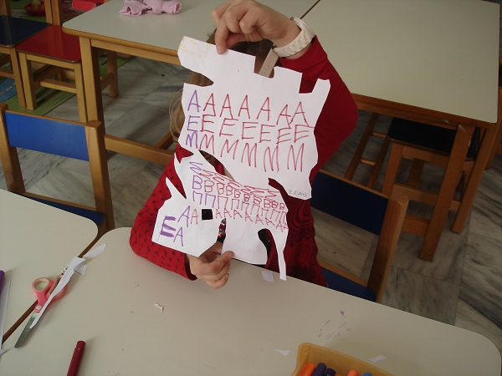

Picture 1. Spontaneous artwork of a Kindergarten child including letters

Please avoid using footnotes. Two empty lines are left before References.

References (all references are presented in alphabetic order according to the American Psychological Association (APA) (http://www.apastyle.org)

Cohen, L., Manion, L., & Morrison, K. (2007). Research Methods in Education (6th Ed.). London & New York: Routledge.
Δαφέρμου, Χ., Κουλούρη, Π., & Μπασαγιάννη, Ε. (2006). Οδηγός Νηπιαγωγού. Εκπαιδευτικοί σχεδιασμοί - Δημιουργικά περιβάλλοντα μάθησης. Αθήνα: Ο.Ε.Δ.Β.
Fleer, M. (1997). A cross-cultural study of rural Australian Aboriginal children’s understanding of night and day. Research in Science Education, 27, 101–116.
ΥΠ.Ε.Π.Θ./Π.Ι. (2002). Διαθεματικό Ενιαίο Πλαίσιο Προγραμμάτων Σπουδών για το Νηπιαγωγείο (Δ.Ε.Π.Π.Σ) και πρόγραμμα σχεδιασμού και ανάπτυξης δραστηριοτήτων. Αθήνα: Ο.Ε.Δ.Β.

