ΕΜΠΕΙΡΙΚΗ ΕΡΓΑΣΙΑ | RESEARCH PAPER
Metacognition and executive functions: Developmental interrelations and interactions with cognitive performance in the preschool and primary school years
Smaragda KAZI¹, Alexandra KAROUSOU², Angelos MARKOS³, Dimitra ECONOMACOU³, Tryfonas BIKOS³, Nikos MAKRIS⁴
¹Department of Psychology, Panteion University of Social and Political Sciences
²Department of Early Childhood Education and Care, University of West Attica
³Department of Primary Education, Democritus University of Thrace
⁴Department of Psychology, Democritus University of Thrace
KEYWORDS |  | ABSTRACT
Metacognition  Monitoring  Executive Functions  Cognitive development  Children |  | A large body of research highlights the important role of both executive functions (EF) and metacognitive monitoring (MM) in children's cognitive functioning in general, and in their performance on specific cognitive tasks in particular. Recent approaches suggest that EF and MM constitute different expressions of cognitive self-regulation. Despite the theoretical interest, there has been limited research on the complex interactions between EF, MM, and cognitive performance. In this paper, we study the relationship between EF and MM and their association with cognitive performance in mathematical and spatial problem-solving while taking into account children's age and performance in a fluid intelligence task. Specifically, based on a sample of 277 children aged 4 to 11 years, two alternative hypotheses are explored: (1) Cognitive performance mediates the relationship between EF and MM, and (2) MM mediates the effect of EF on cognitive performance. The results highlight the relationship between some aspects of these two theoretical constructs and their effect on children's cognitive performance. MM emerged as a significant mediator in the relationship between EF and cognitive performance. The alternative hypothesis was not supported. Results are discussed on the basis of previous studies on the development of metacognitive monitoring and executive functions.
CORRESPONDENCE
Smaragda Kazi
Department of Psychology
Panteion University of Social and Political Sciences
136 Syngrou Av., 17671
Athens, Greece
kazisma@panteion.gr

Introduction
Over the past decades, extensive research has examined the development of cognitive and metacognitive processes in childhood, yielding substantial insights into children's executive functioning (EF). Additionally, studies have explored the application of metacognitive monitoring to broader cognitive abilities and its interaction with specific EF components, including working memory (WM), inhibition, and cognitive flexibility. However, our understanding of the dynamic interplay among EF, metacognition, and cognitive performance remains limited, as does our knowledge of metacognition’s role as a mechanism underlying cognitive development.
Executive functions: Development and contribution to cognitive functioning
Despite the diversity in theoretical and empirical approaches to studying executive functioning (EF), it is broadly defined as “self-regulatory and complex cognitive processes, including adaptive and flexible mental operations that are activated in new and demanding situations to improve performance on tasks” (Roebers & Feuer, 2016, p. 40). This definition underscores EF as a comprehensive theoretical construct encompassing various higher-order processes aimed at the deliberate execution of cognitive tasks.
Miyake and colleagues (Miyake et al., 2000; Miyake & Friedman, 2012) have identified three core EF components: (i) inhibition, which involves resisting distractions, suppressing proactive interference, and overriding prepotent responses to maintain focus on a given task; (ii) cognitive flexibility, which refers to the ability to flexibly switch between mental sets or adapt to changing task demands, also known as shifting; and (iii) updating, which entails continuously monitoring and revising task-relevant information. Additionally, substantial evidence highlights the ability to simultaneously maintain and manipulate information in working memory and its critical role in cognitive task performance (see Baddeley, 2000).
The debate regarding the origins of executive functioning (EF), its developmental trajectory, and the influence of genetic and environmental factors remains ongoing (Best & Miller, 2015; Roebers & Feuer, 2016). While the three core functions identified by Miyake et al. (2000) may not be fully differentiated before middle childhood (Karr et al., 2018; Nelson et al., 2017, 2022; Wiebe et al., 2008), evidence indicates that early expressions of inhibition, working memory, and cognitive flexibility emerge in infancy.
Despite individual differences, certain developmental patterns appear to be established early. Infants exhibit foundational EF skills, such as attentional control, allowing them to focus on relevant stimuli while ignoring distractions. During early childhood (2–5 years), EF continues to advance, with improvements in working memory capacity and the emergence of more refined inhibitory control, enabling children to better suppress automatic or impulsive responses. By middle childhood (6–12 years), EF undergoes further maturation, characterized by enhanced cognitive flexibility, which facilitates more efficient task switching and adaptive problem-solving (Diamond, 2013; Zelazo & Carlson, 2012).
The study of executive functioning (EF) has attracted significant scientific interest due to its pivotal role in individuals’ overall adjustment. Notably, early EF proficiency has been identified as a strong predictor of both academic success (Gunzenhauser & Nückles, 2021; Nelson et al., 2017) and social adaptation in early adulthood (see Diamond, 2013). Research suggests that EF serves as a more robust predictor of long-term outcomes—such as achievement, health, wealth, and overall quality of life—than intelligence quotient (IQ) or socioeconomic status (SES). Furthermore, several studies indicate that EF is more critical than IQ, early reading skills, or math proficiency in preparing children for school entry and remains a stronger predictor of academic success from preschool through university (Diamond & Ling, 2016). From a developmental perspective, young children are expected to engage in EF-driven behaviors in everyday contexts, such as following teacher instructions, taking turns, and raising their hands before speaking (Kubota et al., 2023). Additionally, both concurrent and longitudinal studies have demonstrated significant associations between EF assessments and various cognitive abilities, including social reasoning, logical thinking, and biological reasoning (Doebel, 2020).
There is also extensive research investigating the role of executive functioning (EF) in domain-specific problem-solving. One well-established finding is that working memory (WM), as a core EF component, plays a crucial role in mathematical problem-solving (Passolunghi & Costa, 2019). However, an ongoing debate persists regarding the differential contribution of verbal working memory (verbWM) and visuospatial working memory (vsWM) to mathematical achievement. Conflicting findings suggest that verbWM, vsWM, or both may be more influential depending on factors such as participant age and the nature of the mathematical tasks (Chen et al., 2023). Beyond WM, other EF components have also been shown to contribute to mathematical performance, both directly and indirectly. For instance, studies have highlighted the roles of inhibition alongside WM (Cragg et al., 2017) and the combined influence of WM, inhibition, and cognitive flexibility (Cragg & Gilmore, 2014).
A similar pattern emerges in the relationship between EF and spatial thinking. While the role of visuospatial working memory (vsWM) in spatial problem-solving—such as mental rotation tasks—is well established in early childhood (Lehmann et al., 2014), the contributions of inhibition and cognitive flexibility remain relatively understudied. One notable exception is the study by He and colleagues (2019), which found that, among children aged 8 to 12 years, stronger inhibitory control was associated with better performance in mental rotation tasks, particularly in younger participants. Moreover, in even younger children (4 to 6 years old), Garcia and colleagues (2022) demonstrated that inhibition, cognitive flexibility, and WM were all linked to spatial task performance.
Metacognition: Development and relation to cognitive functioning
The term metacognition, introduced by Flavell (1979), refers to an individual’s awareness and understanding of their own cognitive processes. It consists of two core components: metacognitive knowledge and metacognitive regulation. Metacognitive knowledge (also known as declarative metacognition) encompasses an individual's accumulated understanding of their own cognitive abilities, learning processes, and the strategies they use to acquire and apply knowledge. Metacognitive regulation (also referred to as procedural metacognitive skills) involves the active monitoring and control of cognitive processes, including planning, tracking progress, and evaluating the effectiveness of one's thinking and learning strategies.
The concept of metacognition has been the focus of extensive research due to its central role in cognitive functioning and learning. As Nelson and Narens (1994, p. 1) state, “Metacognition is simultaneously a topic of interest in its own right and a bridge between areas, e.g., between decision-making and memory, between learning and motivation, and between learning and cognitive development.” Building on Flavell’s (1979) foundational theory, various alternative theoretical frameworks have been proposed (see Efklides, 2011; Kuhn, 2000; Nelson & Narens, 1994; Zimmerman, 2000). Despite differences in emphasis, all approaches converge on the significance of metacognition in academic success, even when controlling for the effects of cognitive abilities and other self-regulated learning factors, such as motivation (Marulis & Nelson, 2021).
In the study of metacognitive development, several key milestones have been identified across different ages. Around 2 to 3 years old, children begin to show rudimentary awareness of their cognitive abilities (Flavell, 1979). By ages 4 to 5, as their Theory of Mind develops (Wellman, 2014, 2018; Wellman & Woolley, 1990), they start to recognize that others may have different knowledge and perspectives. This emerging understanding of "how the mind works" supports the development of metacognitive awareness by enhancing their insight into their own cognitive processes. Between ages 6 and 8, as children enter formal education, they begin to apply basic metacognitive strategies (Schneider & Pressley, 1989), such as using memory aids and planning, while also improving their ability to regulate cognitive processes. From pre-adolescence through adolescence, metacognitive abilities—particularly metacognitive awareness—show significant refinement (Weil et al., 2013).
The trajectory of metacognitive development is complex, with an ongoing debate regarding whether metacognitive skills are domain-specific or domain-general (for an overview, see Geurten et al., 2018). Research suggests that while metacognitive judgments improve with age, metacognitive skills initially emerge in a domain-specific manner, being constrained within particular cognitive tasks, before gradually generalizing across domains as children mature (van der Stel & Veenman, 2014). Supporting this perspective, Geurten and colleagues (2018) examined strategy selection in arithmetic and memory tasks, finding that before the age of 10, metacognition is task-specific, later expanding into a more domain-general framework as cognitive development progresses. This shift from domain-specific to domain-general metacognition highlights the increasing cognitive flexibility and adaptability of metacognitive skills as children grow. While early metacognitive processes are tied to particular contexts, with experience and maturation, these skills become more generalized, allowing individuals to apply metacognitive strategies across different learning domains and problem-solving situations.
The reciprocal relationship between cognitive performance and various metacognitive components has been extensively studied, revealing two major trends in literature. The first trend emphasizes the impact of cognitive development on metacognition. For example, Bryce and Whitebread (2012), in a study of children aged 5 to 7 years, identified two key metacognitive developments during early childhood: (i) a qualitative shift in the types of planning and monitoring strategies employed by young children, and (ii) a quantitative improvement in overall metacognitive abilities. Notably, their findings indicate that while failures in metacognitive skills are primarily influenced by task-specific ability rather than age, monitoring processes tend to improve with age, whereas control processes improve as a function of both age and task-specific ability.
The second trend highlights the reciprocal relationship between cognition and metacognition. Research has consistently demonstrated that effective problem-solving, knowledge transfer, and self-regulated learning are positively associated with metacognitive regulation. In other words, metacognitive regulation plays a crucial role in enhancing students' learning across various academic subjects, including science, arithmetic, reading, and writing (Zepeda & Nokes-Malach, 2023). In line with this, studies have shown that greater metacognitive monitoring accuracy can lead to—or be associated with—more effective control decisions and self-regulation, ultimately contributing to improved learning outcomes and test performance (e.g., Demetriou et al., 2018; Destan et al., 2014; Scheibe et al., 2023; Thiede, 1999).
Metacognition and executive functions: Developmental interactions
As discussed above, both metacognition and executive functions (EF) play fundamental roles in human cognition, supporting self-regulation, goal-directed behavior, and adaptive learning. In an influential theoretical proposal, Roebers (2017) introduced a unified framework that integrates EF and metacognition, providing a structured approach to examining their interrelations. Based on theoretical and empirical findings, Roebers (2017) argued that a key feature of any overarching framework connecting EF and metacognition lies in an individual’s ability to form and utilize metarepresentations—mental representations of their own cognitive and learning processes. This capacity enables individuals to step back and evaluate their own actions from an external perspective, ideally with objectivity, and to adjust their behavior based on this higher-order reflection. Within this framework, EF and metacognition are conceptualized as first-order, domain-specific processes, operating within a shared, domain-general, second-order self-regulatory system (Best & Miller, 2010; Kuhn, 2000). This model suggests that rather than being separate constructs, EF and metacognition are interrelated expressions of the same underlying self-regulative system, working together to optimize cognitive performance and learning.
Building upon Roebers’s theoretical framework, Marulis et al. (2020) offer a complementary perspective on the relationship between EF and metacognition. They argue that the integration of these two constructs should ultimately empower children as active agents in their own learning process. According to their view, metacognition plays a crucial role in fostering this sense of agency “…by making it clear when, how, and why to use EF” (p. 50). Despite the substantial overlap in the contributions of EF and metacognitive monitoring to self-regulated adaptive behavior, research on their complex interactions across development remains limited. Marulis et al. (2020) contend that while metacognition and EF follow parallel developmental trajectories, their co-occurrence does not necessarily imply simultaneous activation during goal-directed behavior.
Recent longitudinal findings further illuminate the developmental interrelations between EF and metacognitive monitoring. Kälin and Roebers (2022) demonstrated that although EF and metacognitive monitoring show moderate associations across early childhood (ages 5 to 8), their relationship strengthens as children develop greater monitoring accuracy and self-regulation skills. These findings suggest that the interaction between EF and metacognition is dynamic and evolves with age, rather than being a fixed, static relationship. Further evidence comes from Bablekou et al. (2023), who examined EF, listening comprehension, and metacognitive processes in childhood. Their results indicated distinct developmental profiles for these constructs, reinforcing the notion that while EF and metacognition are interdependent, they may develop at different rates and in different ways, depending on task demands and cognitive domain.
Against the backdrop of the current theoretical and empirical landscape, it can be argued that while the theoretical relationship between EF and metacognition is well-founded, empirical evidence remains inconclusive. The moderate correlations observed between different EF and metacognitive components may be attributed to methodological limitations, theoretical discrepancies, or variations in conceptualization and measurement approaches.
Aims of this study
Considering the above, in the present study, we aim to empirically co-examine children’s EF efficiency, cognitive performance, and the respective metacognitive monitoring of cognitive performance. We tapped EF by administering visuospatial and verbal working memory, and cognitive flexibility. Cognitive performance addressed mathematical and visuospatial problem-solving by administering tasks of different levels of difficulty within each domain. Metacognition was measured with offline monitoring by asking preschool and school-aged children to provide metacognitive judgments of tasks’ similarity across and within cognitive domains (mathematical and visuospatial problem solving), varying as a function of their difficulty.
Given the limited empirical evidence on the interplay between EF efficiency, cognitive performance, and metacognitive monitoring, the present study adopts an exploratory approach. Rather than testing predefined hypotheses, we aim to empirically investigate these relationships, contributing to a more nuanced understanding of their developmental dynamics.
Building on previous research, this study seeks to shed light on the following issues:
1. To reveal the interplay among two components of EF efficiency (working memory and cognitive flexibility), cognitive performance in mathematical and visuospatial tasks, and metacognitive monitoring, controlling for the effect of age and fluid intelligence.
2. We aimed to test whether cognitive performance and its development is a prerequisite that leads to the development and accuracy of metacognitive monitoring as posited by relevant data (see Bryce and Whitebread, 2012). Alternatively, to reveal whether metacognitive development boosts and facilitates cognitive performance, as stated by a line of research (see Demetriou et al., 2018; Destan et al., 2014; Scheibe et al., 2023; Thiede, 1999; Zepeda & Nokes-Malach, 2023).
Method
This study used data from tasks administered to the participants of a larger research project that focused on the mechanisms underlying cognitive development in children and adolescents. The study has a cross-sectional design with three measures of EF as predictor variables. A measure of metacognitive monitoring, as well as children’s performance in two cognitive tasks, were tested alternatively, either as criterion variables or as mediators. Two additional predictors —children’s age and score in a fluid intelligence task— were also measured and used as control variables.
Participants
The sample consisted of 277 children (mean 7.58 years, SD 2.11; 52% girls) ranging from 4;00 to 11;11 years of age. Table 1 presents the sample distribution according to age and sex. All children were monolingual Greek-speaking, raised in Greek-speaking families. Children with any diagnosed sensory, physical, cognitive, or language impairment were not included in the sample.
Table 1. Distribution of students per age and gender
Age | Gender |  | Total
 | Boy | Girl
4 | 9 | 9 | 18
5 | 22 | 20 | 42
6 | 20 | 16 | 36
7 | 20 | 23 | 43
8 | 14 | 17 | 31
9 | 16 | 27 | 43
10 | 19 | 20 | 39
11 | 13 | 12 | 25
Total | 133 | 144 | 277
Procedure
The research was conducted following an ethics approval by the Research Ethics Committee of the Department of Primary Level Education (Ref. ΔΠΘ/ΠΤΔΕ/62180/1866/2020) and permission from the Ministry of Education to access public schools (Φ15/110217/ΕΚ/126648/Δ1). Participants’ data were treated anonymously throughout the research. The consent of the Director of each school was granted, followed by the informed consent of the children’s caregivers and the class teachers.
Children were tested individually at their school. Testing was conducted by five well-trained research assistants. Tasks were administered in a randomized order, with the condition that the offline metacognitive monitoring task should follow the two problem-solving tasks. Testing of each child was conducted by the same research assistant on three different days/sessions to avoid children’s fatigue.
Measures
Executive Control. Executive control was measured by cognitive flexibility and working memory (verbal and visuospatial).
Cognitive flexibility. The number of switches children made during an ‘animals’ semantic verbal fluency task (Troyer et al. 1997) was measured. The exact instructions given to children in the fluency task were, “I want you to tell me in one minute as many animals as you can think of. Go as fast as you can. Ready? Go!”. Analyses were aided by the Python Semantic Network and Fluency Utility library (SNAFU; Zemla et al. 2020). For that purpose, a data file with each child’s words (including perseverations and intrusions) was produced according to the specifications of SNAFU. The number of switches, i.e., the number of transitions between clusters of different subcategories, was calculated using the scheme and spelling file developed by Karousou and Thomaidou (2023) and following the procedure detailed in Karousou et al. (2023).
Working memory was examined by two tasks: A verbal working memory task, namely a serial recall of non-words (Gathercole & Picketing, 1999). Children were presented orally with 2-syllable non-words. There were six levels of difficulty, requiring recalling from 1 to 6 non-words, respectively. There were 2 trials in each level. Children should succeed in at least one trial of each level to pass on to the next level. The visuospatial working memory was measured by the Corsi block tapping test (Corsi, 1972; Kessels et al., 2000). In the Corsi task, children saw a 3 x 3 matrix where two or more squares lit up in succession. There were also six levels from 2 to 7 squares lighting up. Primary school children had to click on the cells that lit up in order of their appearance after all cells were switched off. Preschool children pointed to cells by hand. Alpha reliability for the three tasks was .73.
Cognitive Performance. Two tasks were developed for addressing Mathematical and Visuospatial problem solving. The items of both tasks were inspired on items included in past papers (2009-2021) of the international mathematical school contest “Kangaroo Sans Frontières”. Items of all levels of difficulty within papers of all classes (from preschool to high school) were initially screened, selected, adapted and piloted to a sample of students aged 4 to 18 years (N=126). The final versions of the tasks are described below.
Mathematical problem solving. The battery involved a series of mathematical problems presented verbally and illustrated with pictures. The task comprised a total of 22 problems presented in ascending difficulty (based on the % of correct-incorrect answers/age, in the pilot study). Children aged 4-9 years were administered the task starting from the easiest item (counting up to four objects). Children over 9 years old were not administered the first 3 items (0% of incorrect answers / 100% success in preliminary study). The testing procedure was interrupted when a student made more than 3 consecutive mistakes. Examples of mathematical problems of differing levels of difficulty are presented in Figure 1. The examiner presented each problem to each participant without giving any clarification except for repeating the problem orally.
Visuospatial problem solving. This battery addressed three dimensions of visuospatial ability: mental rotation, composition of mental images, and image transformations. A total of 13 items of ascending level of difficulty were selected after piloting. All participants were examined in the entire battery. One point was given for every correct response. Examples are illustrated in Figure 2.
Figure 1. Examples of mathematical problems
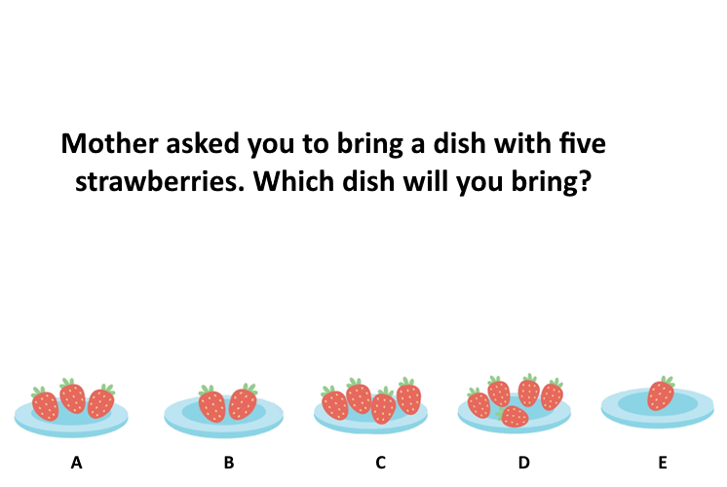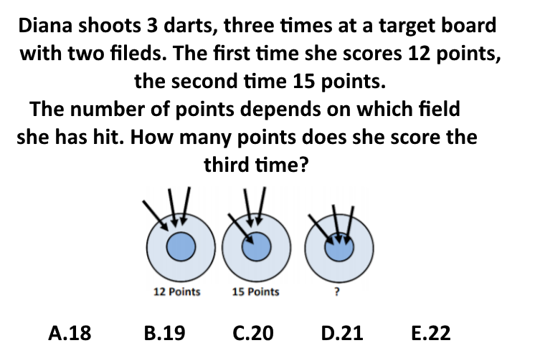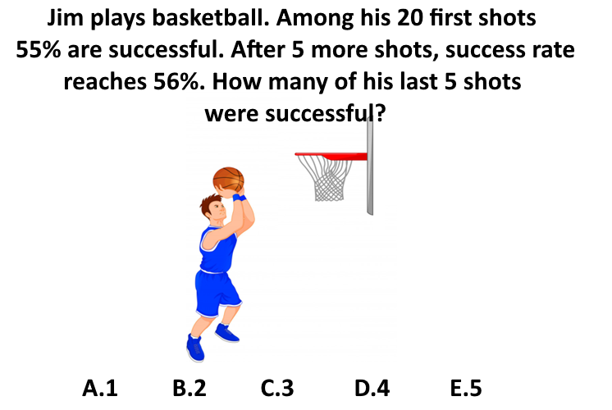

Figure 2. Examples of visuospatial problems
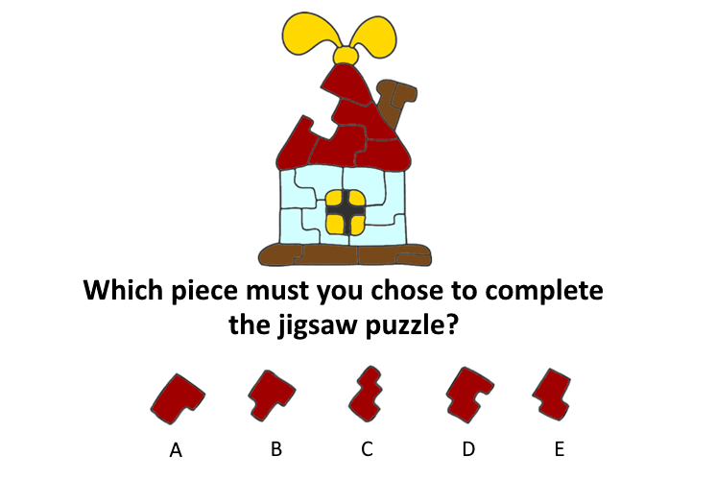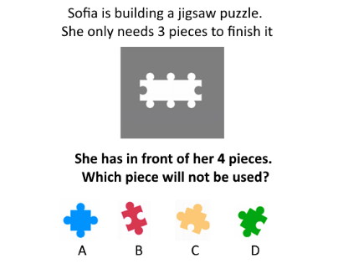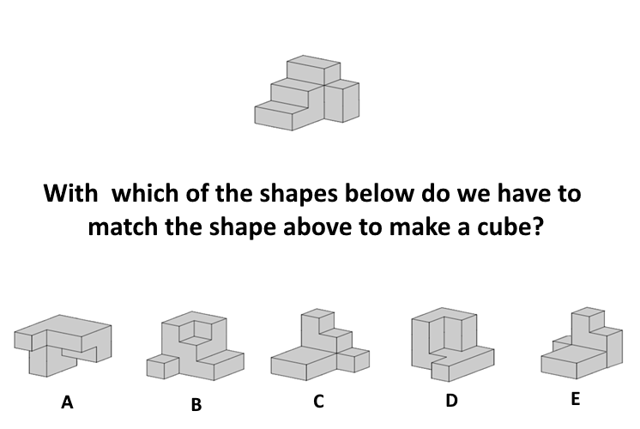

Metacognitive awareness. Children assessed the similarity of five pairs of problem-solving tasks they had previously solved (see Demetriou & Kazi, 2006; Kazi et al., 2012). Four of these pairs involved within-domain comparisons, specifically two pairs of mathematical tasks and two pairs of visuospatial tasks, each varying in difficulty level. The fifth pair required a cross-domain comparison between a mathematical and a visuospatial task. To encourage reflection on their cognitive processes, the experimenter presented children with two task-related pictures per comparison, each depicting a problem they had previously solved, while also providing a verbal description of the tasks. Then, children were asked to describe each task in their own words. Afterwards, they answered the following question: “What you had to do in this game, is it similar to what you had to do in that game?”, pointing accordingly.
For within-domain comparisons, children were presented with two mathematical tasks (e.g., pictures 1A and 1B) or two visuospatial tasks (e.g., pictures 2A and 2C). For cross-domain comparisons, they were shown one mathematical and one visospatial task (e.g., pictures 1B and 2A). Regardless of their initial response, they were always asked “Why?” to explain their reasoning, yielding a total of five similarity estimations. The order of the task pairs was randomized.
Children’s responses were scored based on increasing levels of awareness of the cognitive processes involved: 0: No response, incorrect or irrelevant responses, 1: Repetition of task instructions / Reference to perceptual features (e.g., candies vs. kg, response format, answer choices), 2: Reference to a common process (e.g., "finding how many" in both tasks), 3: Complete response with reference to mathematical operations and their differences (e.g., subtraction of different quantities). Alpha reliability for the five tasks was .76.
Fluid Intelligence. A Raven-like matrix test (Kazi et al., 2012) including 27 matrices addressed inductive reasoning at several levels of complexity. The missing item was chosen from among six choices. At the lower levels of complexity, children had to integrate one or two dimensions to reach a solution. At the next level, three dimensions or two dimensions systematically transformed according to a rule into a third dimension had to be integrated. At the third level, a combination of transformations had to be captured to integrate dimensions. Items were scored on a pass (1)-fail (0) basis, and level scores were obtained by adding across level-specific items. Alpha reliability was .90. Examples are presented in Figure 3.
Figure 3. Examples of Figures used in the Raven-like matrices test
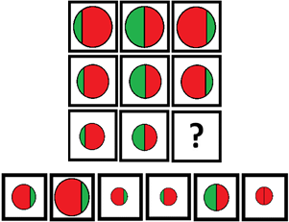
Data Analysis
All analyses were performed within the framework of structural equation modeling (SEM). Initially, we examined the direct effects of executive functions—specifically, working memory and cognitive flexibility—on metacognitive awareness and problem-solving abilities in mathematical and spatial domains, while controlling for age and fluid intelligence. Subsequently, two mediation models were estimated to test the study hypotheses. The first model (Model 1) explored the role of metacognitive monitoring as a mediator in the relationship between executive functions and problem-solving performance. The second model (Model 2) assessed whether problem-solving tasks could act as mediators between executive functions and metacognitive monitoring. Both models accounted for age and fluid intelligence to isolate the specific effects of EF components.
To assess the robustness of the model estimates and to provide more accurate standard errors and confidence intervals, a bootstrapping method with 5,000 bootstrap samples was employed. The analyses were conducted using the lavaan package in R (Rosseel et al., 2012). Model fit was assessed using the following indices: Chi-Square (χ²), Root Mean Square Error of Approximation (RMSEA), Comparative Fit Index (CFI), Tucker-Lewis Index (TLI), and Standardized Root Mean Square Residual (SRMR). Acceptable model fit was defined as RMSEA values below .08, CFI and TLI values above .90, and SRMR values below .08.
Results
Descriptive results
Table 2 presents the descriptive results (mean score, standard deviation, distribution of scores) for each of the 7 factors contemplated in the study.
Table 2. Descriptive Statistics
 | Mean | SD | Min | 25% | 50% | 75% | Max
Raven (RAVEN) | 8.75 | 5.33 | 0 | 5 | 8 | 13 | 22
Metacognitive monitoring (METACOG) | 4.22 | 2.93 | 0 | 2 | 4 | 6 | 12
Cognitive Flexibility (FLEX) | 7.51 | 3.23 | 0 | 5 | 7 | 10 | 18
Verbal WM | 2.13 | .83 | 0 | 2 | 2 | 3 | 4
Spatial WM | 4.97 | 2.76 | 0 | 3 | 5 | 7 | 12
Visuospatial Problem Solving (PSS) | 5.44 | 2.03 | 1 | 4 | 5 | 7 | 12
Math Problem Solving (PSM) | 6.41 | 2.67 | 1 | 4 | 6 | 8 | 14
Preliminary Analyses
Table 3 presents the correlations among all study variables. The pattern of correlations suggests substantial relationships among executive functions, metacognitive monitoring, and problem-solving performance, warranting further investigation of their interrelationships through model testing.
Table 3. Correlations Among the Study Variables
 | 1 | 2 | 3 | 4 | 5 | 6 | 7 | 8
1. AGE | - | .596** | .730** | .175* | .547** | .547** | .556** | .739**
2. Raven (RAVEN) |  | - | .449** | .330** | .333** | .392** | .509** | .606**
3. Metacognitive monitoring (METACOG) |  |  | - | .402** | .359** | .462** | .482** | .567**
4. Cognitive Flexibility (FLEX) |  |  |  | - | .278** | .291** | .373** | .444**
5. Verbal WM (verbWM) |  |  |  |  | - | .337** | .319** | .464**
6. Spatial WM (vsWM) |  |  |  |  |  | - | .426** | .572**
7. Visuospatial Problem Solving (PSS) |  |  |  |  |  |  | - | .545**
8. Math Problem Solving (PSM) |  |  |  |  |  |  |  | -
*Note. *p < .05; **p < .01
Mediation models
To examine the complex relationships between executive functions, metacognitive monitoring, and problem-solving performance, we tested two competing theoretical models. Model 1 investigated whether problem-solving performance mediates the relationship between EF and metacognitive monitoring, while Model 2 tested whether metacognitive monitoring mediates between EF and problem-solving performance. Age and fluid intelligence were included as control variables in all analyses to account for developmental effects and general cognitive ability. Both models showed acceptable fit indices (Table 4), though Model 2 demonstrated more stable parameter estimates.
Table 4. Fit indices of the two alternative mediation models
Model 1  (mediators: PSS, PSM; dependent variable: METACOG) | Model 2  (mediator: METACOG; dependent variables: PSS, PSM)
χ² = 65.403 | χ² = 66.777
df = 32 | df = 32
p < .001 | p < .001
CFI = .955 | CFI = .958
TLI = .920 | TLI = .926
RMSEA = .063 [90% CI: .041, .085], p = .110 | RMSEA = .065 [90% CI: .043, .087], p = .126
SRMR = .034 | SRMR = .034
Model 1 (Figure 4), which proposed problem-solving performance as a mediator between EF and metacognitive monitoring, showed weaker support. While the model demonstrated acceptable fit indices, the analysis revealed nonsignificant indirect effects of EF on METACOG through either PSS or PSM. Specifically, the indirect effects of vsWM on METACOG through PSS and PSM were nonsignificant (β = .004, p = .123, CI: [.000, .011], β = .007, p = .077, CI: [.000, .016]). The indirect effects of verbWM and FLEX on METACOG via PSS and PSM were also nonsignificant (verbWM via PSS: β = .008, p = .218, CI [-.005, .021]; verbWM via PSM: β = .014, p = .074, CI [-.001, .029]; FLEX via PSS: β = .002, p = .112, CI [-.001, .006]; FLEX via PSM: β = .003, p = .327, CI [-.003, .009]). These results indicate that problem-solving performance does not effectively mediate the relationship between EF and metacognitive monitoring.
Figure 4. Mediation model (Model 1) of the effects of Problem-Solving tasks on metacognitive monitoring via EF
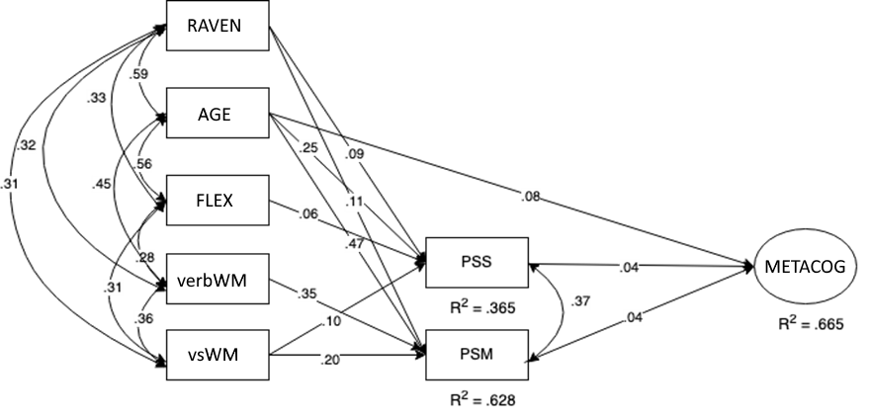
*Note. Control variables (age [AGE], fluid intelligence [RAVEN]) and independent variables (cognitive flexibility [FLEX], verbal working memory [verbWM], visuospatial working memory [vsWM]), along with visuospatial problem solving [PSS], mathematical problem solving [PSM], metacognitive monitoring [METACOG], with RAVEN, FLEX, verbWM, vsWM, PSS, PSM as composite variables and METACOG as a latent variable. The reported beta values are standardized coefficients. Nonsignificant paths have been omitted for clarity. All reported parameters in the model were significant at the p < .05 level.

Figure 5. Mediation model (Model 2) of the effects of EF on Problem-Solving tasks via metacognitive monitoring
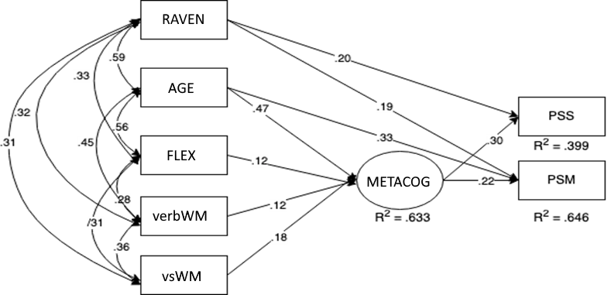
*Note. Control variables: age [AGE] and fluid intelligence [RAVEN]. Main predictors: cognitive flexibility [FLEX], verbal working memory [verbWM], and visuospatial working memory [vsWM]. Outcome variables: visuospatial problem solving [PSS] and mathematical problem solving [PSM]. Mediator: metacognitive monitoring [METACOG]. RAVEN, FLEX, verbWM, vsWM, PSS, and PSM were treated as composite variables, while METACOG was modeled as a latent variable. The reported beta values are standardized coefficients. Nonsignificant paths have been omitted for clarity. All reported parameters in the model were significant at the p < .05 level.
Model 2 (Figure 5) emerged as the better-supported model, demonstrating that metacognitive monitoring (METACOG) serves as a significant mediator in the effects of executive functions on both visuospatial problem-solving (PSS) and mathematical problem-solving (PSM), after controlling for age (AGE) and fluid intelligence (RAVEN). The paths from executive functions to the mediator (METACOG) revealed significant relationships with visuospatial working memory (vsWM; β = .18, p = .021, CI [.007, .061]), verbal working memory (verbWM; β = .12, p = .038, CI [.003, .141]), and cognitive flexibility (FLEX; β = .12, p = .042, CI [.003, .047]). The direct paths from METACOG to the dependent variables were significant for both visuospatial problem-solving (PSS; β = .30, p < .001, CI [.195, 3.931]) and mathematical problem-solving (PSM; β = .22, p < .001, CI [.180, 2.644]). The direct effects of verbWM (to PSS: β = .09, p = .182, CI [-.042, .221]; to PSM: β = .11, p = .163, CI [-.045, .265]), vsWM (to PSS: β = .07, p = .275, CI [-.056, .196]; to PSM: β = .08, p = .241, CI [-.054, .214]), and FLEX (to PSS: β = .05, p = .384, CI [-.063, .163]; to PSM: β = .06, p = .342, CI [-.064, .184]) on PSS and PSM were nonsignificant. Significant indirect effects through METACOG were observed for vsWM on both PSS (β = .06, p = .024, CI [.005, .117]) and PSM (β = .04, p = .034, CI [.005, .106]), as well as for verbWM on PSS (β = .04, p = .039, CI [.004, .104]) and FLEX on PSS (β = .04, p = .041, CI [.003, .100]). Among the control variables, age showed a significant effect on METACOG (β = .47, p < .001, CI [.061, .154]) and PSM (β = .33, p < .001, CI [.034, .161]), while fluid intelligence significantly predicted both PSS (β = .20, p = .002, CI [.029, .125]) and PSM (β = .19, p = .003, CI [.034, .161]).
Discussion
This study explores how executive functions - specifically working memory and cognitive flexibility - relate to metacognitive monitoring and how these constructs influence problem-solving performance in mathematical and visuospatial tasks. The findings provide strong evidence that metacognitive monitoring acts as a key mechanism linking EF to cognitive performance, rather than EF directly predicting problem-solving success.
The results indicate that visuospatial working memory, verbal working memory, and cognitive flexibility are all significantly associated with metacognitive monitoring, suggesting a close relationship between EF skills and the ability to evaluate, regulate, and refine cognitive processes. Among these, visuospatial working memory emerged as the strongest predictor, underscoring the crucial role of spatial memory capacity in metacognitive processes, particularly when tasks involve comparing and manipulating mental representations. Given that children in this study judged metacognitive similarities between mathematical and visuospatial tasks, this result may reflect the established link between spatial skills and mathematical performance (Geer et al., 2019).
Although verbal working memory contributed to metacognitive monitoring, its influence was weaker compared to visuospatial working memory, suggesting that spatial memory capacity may be more critical for metacognitive monitoring in non-verbal problem-solving contexts. One possible explanation is that visuospatial working memory plays a more general role in metacognitive monitoring by enabling individuals to mentally structure and organize complex information during cognitive reflection. Another explanation relates to the study’s methodology. Both cognitive tasks and metacognitive estimations were presented using visual representations, requiring children to compare tasks depicted in corresponding images. This approach was deliberately chosen to accommodate the young age of the participants, as a highly verbal format could have placed excessive cognitive demands on them. However, it remains to be determined whether the observed relationship between visuospatial working memory and metacognitive monitoring would hold in older children, particularly if cognitive tasks (mathematical and visuospatial) and metacognitive estimations were introduced using a different methodology.
Cognitive flexibility was also a significant predictor of metacognitive monitoring, highlighting its role in regulating thought processes, particularly in shifting perspectives and strategies when evaluating one’s cognitive performance. However, unlike working memory, cognitive flexibility did not directly predict problem-solving performance, suggesting that its primary function lies in self-regulation rather than direct problem-solving (Cragg & Gilmore, 2014).
Interestingly, at the ages examined, metacognitive monitoring appeared to function as a domain-general process, as all relevant measures, both within and across domains, loaded onto a unified metacognitive monitoring factor. This finding contrasts with previous research suggesting that metacognition initially develops in a domain-specific manner before transitioning into a domain-general process (Geurten et al., 2018; van der Stel & Veenman, 2014). A possible explanation for this discrepancy lies in the different aspects of metacognition assessed in each study. The present study focused on judgments of similarity across cognitive tasks, which may reflect a more fundamental and early-emerging aspect of metacognitive monitoring that generalizes across domains sooner. In contrast, previous studies have primarily examined strategy selection and application, which involve more deliberate and task-specific metacognitive control mechanisms that may indeed follow a domain-specific-to-domain-general trajectory over time. Thus, rather than contradicting previous research, these findings suggest that different components of metacognition may follow distinct developmental pathways. Basic metacognitive monitoring processes, such as similarity judgments, may exhibit domain-general properties earlier in development, while more complex metacognitive control mechanisms, such as strategy selection, may initially be domain-specific and generalize later. This interpretation aligns with the broader theoretical view that metacognition is not a unitary construct but consists of multiple components that may mature at different rates (Efklides, 2011; Roebers, 2017). Future research should further explore these distinctions by investigating whether different types of metacognitive monitoring and control processes follow distinct developmental trajectories across cognitive domains.
The role of age and fluid intelligence
The role of age and fluid intelligence was also examined. Age significantly predicted both metacognitive monitoring and mathematical problem-solving, reinforcing the developmental nature of these abilities, which improve as children grow older. This aligns with previous findings suggesting that metacognitive skills and mathematical reasoning are continuously refined through cognitive maturation and formal education. However, age did not significantly predict visuospatial problem-solving performance. A possible explanation is that the visuospatial tasks used in this study, which involved mental rotation and transformations of mental images, rely on core spatial abilities that develop early and remain relatively stable compared to mathematical reasoning skills (Frick et al., 2013). Unlike mathematical skills, which benefit from structured learning, spatial problem-solving may depend more on individual differences in visuospatial working memory and exposure to spatially enriching experiences rather than age-related cognitive growth (Levine et al., 2005; Uttal et al., 2013). Additionally, the weak correlations between age and visuospatial performance suggest that other cognitive mechanisms, such as visuospatial working memory, may play a more prominent role in determining success on these tasks (Wang et al., 2018a, 2018b).
Fluid intelligence significantly predicted both visuospatial and mathematical problem-solving, confirming that general cognitive ability remains a key factor in problem-solving performance (Ohtani & Hisasaka, 2018; Primi et al., 2010; Ren et al., 2015). However, fluid intelligence did not directly predict metacognitive monitoring, suggesting that its influence is mediated through EF and cognitive performance, rather than having a direct impact on self-regulation skills (Roebers & Feurer, 2016).
Metacognitive monitoring as the mediating mechanism
One of the most notable findings is that metacognitive monitoring plays a crucial role in problem-solving performance. The significant direct effects of metacognitive monitoring on both mathematical and visuospatial problem-solving in the mediation model, combined with the nonsignificant direct paths from executive functions to problem-solving performance, reinforce the idea that metacognition enhances cognitive performance by improving self-regulation, strategic thinking, and problem-solving efficiency (Demetriou et al., 2018). Rather than directly predicting problem-solving performance, executive functions appear to exert their influence indirectly through metacognitive monitoring. The significant indirect effects observed in the mediation analysis suggest that the relationship between EF and cognitive performance is mediated by metacognitive abilities, which are associated with more effective problem-solving. These findings indicate that EF alone is not sufficient to enhance problem-solving abilities. Instead, metacognitive monitoring serves as the key interface where EF and cognitive performance converge, reinforcing the idea that metacognitive processes play a central role in regulating and optimizing cognitive performance (Demetriou et al., 2018; Marulis et al., 2020). By enabling individuals to assess their own cognitive processes, adjust their strategies, and regulate their problem-solving approaches, metacognitive monitoring emerges as a crucial mechanism through which EF indirectly relates to problem-solving success. This aligns with self-regulated learning theories, which emphasize the role of metacognition in academic success (Zimmerman, 2000).
Theoretical implications and future directions
These findings seem to have important theoretical implications. First, they suggest that metacognitive monitoring may be the mechanism that links EF to problem-solving. Our findings provide strong empirical support for the idea that metacognitive monitoring serves as a crucial bridge between EF and cognitive performance.
Second, visuospatial working memory appears to play a dominant role in metacognitive monitoring, at least at the ages examined and the methodology applied. The strong effect of visual working memory on metacognitive monitoring suggests that spatial memory capacity may be essential for reflective thinking and self-regulation.
Third, cognitive flexibility influences metacognition but not problem-solving. While cognitive flexibility contributed to metacognitive monitoring, it did not directly predict problem-solving abilities. This supports the idea that cognitive flexibility may be more about regulating cognitive processes than executing problem-solving strategies.
Fourth, fluid intelligence affects problem-solving but not metacognitive monitoring, suggesting that metacognitive skills develop somewhat independently from general intelligence.
Future research should further explore the relationships among EF, metacognitive monitoring, and problem-solving performance by adopting longitudinal, experimental, and intervention-based approaches. Given the cross-sectional nature of this study, longitudinal research is needed to examine how these constructs develop over time and whether metacognitive monitoring consistently mediates the EF–cognitive performance relationship across different ages. Additionally, our findings suggest that metacognitive monitoring may function as a domain-general process earlier than previously thought. Future studies should compare different aspects of metacognition, such as monitoring versus control, to determine whether certain components generalize across domains sooner than others.
Another important direction concerns the dissociation of different types of working memory. The strong role of visuospatial working memory in metacognitive monitoring may be influenced by the image-based nature of the tasks used in this study. Future research should examine whether this effect persists when tasks are presented differently and whether verbal working memory plays a more prominent role in metacognition when verbal reasoning is required.
The role of fluid intelligence in metacognitive monitoring also warrants further investigation. Its lack of direct influence suggests that metacognitive development may be somewhat independent of general intelligence. Future studies should explore whether metacognitive training can enhance problem-solving performance across different intelligence levels and whether fluid intelligence interacts with EF and metacognition depending on task demands.
Finally, the educational implications of these findings should be considered. If metacognitive monitoring plays a crucial role in cognitive performance, interventions aimed at improving self-monitoring and cognitive regulation may be particularly effective. Future research should explore whether training EF skills, such as working memory, indirectly benefits problem-solving by strengthening metacognitive abilities. By addressing these questions, future studies can provide a more comprehensive understanding of how EF, metacognition, and problem-solving interact, ultimately informing educational strategies to support cognitive development.

Funding
The research project was supported by the Hellenic Foundation for Research and Innovation (H.F.R.I.) under the “1st Call for H.F.R.I. Research Projects to Support Faculty Members and Researchers and the Procurement of High-and the procurement of high-cost Research Equipment Grant” (Project Number: HFRI-FM17-13).
References
Bablekou, Z., Chrysochoou, E., & Kazi, S. (2023). Executive functions, listening comprehension, and metacognitive processes in childhood: Developmental profiles. Psychology: The Journal of the Hellenic Psychological Society, 28(2), 48–68. https://doi.org/10.12681/psy_hps.36222
Baddeley, A. (2000). The episodic buffer: a new component of working memory?. Trends in Cognitive Sciences, 4(11), 417-423. https://doi.org/10.1016/S1364-6613(00)01538-2
Best, J. R., & Miller, P. H. (2010). A developmental perspective on executive function. Child Development, 81(6), 1641-1660. https://doi.org/10.1111/j.1467-8624.2010.01499.x
Bryce, D., & Whitebread, D. (2012). The development of metacognitive skills: Evidence from observational analysis of young children’s behavior during problem-solving. Metacognition and Learning, 7(3), 197-217. https://doi.org/10.1007/s11409-012-9091-2
Chen, C., Liu, P., Lu, S., Li, S., Zhang, C., & Zhou, X. (2023). Verbal but not visual-spatial working memory contributes to complex arithmetic calculation. British Journal of Developmental Psychology, 41(4), 385-399. https://doi.org/10.1111/bjdp.12458 https://psycnet.apa.org/doi/10.1111/bjdp.12458
Corsi, P. M. (1972). Human memory and the medial temporal region of the brain [Unpublished doctoral dissertation]. McGill University.
Cragg, L., Keeble, S., Richardson, S., Roome, H. E., & Gilmore, C. (2017). Direct and indirect influences of executive functions on mathematics achievement. Cognition, 162, 12-26. https://doi.org/10.1016/j.cognition.2017.01.014
Cragg, L., & Gilmore, C. (2014). Skills underlying mathematics: The role of executive function in the development of mathematics proficiency. Trends in Neuroscience and Education, 3(2), 63-68. https://doi.org/10.1016/j.tine.2013.12.001
Demetriou, A., & Kazi, S. (2006). Self-awareness in g (with processing efficiency and reasoning). Intelligence, 34, 297-317. https://doi.org/10.1016/j.tine.2013.12.001
Demetriou, A., Makris, N., Kazi, S., Spanoudis, G., Shayer, M., & Kazali, E. (2018). Mapping the dimensions of general intelligence: An integrated differential-developmental theory. Human Development, 61, 4–42. https://psycnet.apa.org/doi/10.1159/000484450
Destan, N., Hembacher, E., Ghetti, S., & Roebers, C. M. (2014). Early metacognitive abilities: The interplay of monitoring and control processes in 5- to 7-year-old children. Journal of Experimental Child Psychology, 126, 213-228. https://doi.org/10.1016/j.jecp.2014.04.001
Diamond, A. (2013). Executive Functions. Annual Review of Psychology, 64, 135-168. https://doi.org/10.1146/annurev-psych-113011-143750
Diamond, A., & Ling, D. S. (2016). Conclusions about interventions, programs, and approaches for improving executive functions that appear justified and those that, despite much hype, do not. Developmental Cognitive Neuroscience, 18, 34-48. https://doi.org/10.1016/j.dcn.2015.11.005
Doebel, S. (2020). Rethinking executive function and its development. Perspectives on Psychological Science, 15(4), 942-956. https://doi.org/10.1177/1745691620904771
Efklides, A. (2011). Interactions of metacognition with motivation and affect in self-regulated learning: The MASRL model. Educational Psychologist, 46(1), 6-25. https://doi.org/10.1080/00461520.2011.538645
Flavell, J. H. (1979). Metacognition and cognitive monitoring: A new area of cognitive–developmental inquiry. American Psychologist, 34(10), 906–911. https://doi.org/10.1037/0003-066X.34.10.906
Frick, A., Hansen, M. A., & Newcombe, N. S. (2013). Development of mental rotation in 3- to 5-year-old children. Cognitive Development, 28(4), 386–399. https://doi.org/10.1016/j.cogdev.2013.06.002
Garcia, N. L., Dick, A. S., & Pruden, S. M. (2022). Contributions of executive function to spatial thinking in young children. Infant and Child Development, 31(4), n/a. https://doi.org/10.1002/icd.2317
Gathercole, S. E., & Pickering, S. J. (1999). Estimating the capacity of phonological short-term memory. International Journal of Psychology, 34(5-6), 378–382. https://doi.org/10.1080/002075999399729
Geer, E. A., Quinn, J. M., & Ganley, C. M. (2019). Relations Between Spatial Skills and Math Performance in Elementary School Children. Developmental Psychology, 55 (3), 637-652. https://doi.org/10.1037/dev0000649
Geurten, M., Meulemans, T., & Lemaire, P. (2018). From domain-specific to domain-general? the developmental path of metacognition for strategy selection. Cognitive Development, 48, 62-81. https://psycnet.apa.org/doi/10.1016/j.cogdev.2018.08.002
Gunzenhauser, C., & Nückles, M. (2021). Training executive functions to improve academic achievement: Tackling avenues to far transfer. Frontiers in Psychology, 12, 624008. https://doi.org/10.3389/fpsyg.2021.624008
He, Z-H., Li, B-H., & Yin, W-G. (2019) Executive function and mental rotation during middle childhood: The effect of age. The Journal of Genetic Psychology, 180(2-3), 96-102. https://doi.org/10.1080/00221325.2019.1582474
Kälin, S., & Roebers, C. M. (2022). Longitudinal associations between executive functions and metacognitive monitoring in 5- to 8-year-olds. Metacognition and Learning, 17(3), 1079-1095. https://doi.org/10.1007/s11409-022-09306-x
Karousou, A., Economacou, D., & Makris, N. (2023). Clustering and Switching in Semantic Verbal Fluency: Their Development and Relationship with Word Productivity in Typically Developing Greek-Speaking Children and Adolescents. Journal of Intelligence, 11(11), 209. https://doi.org/10.3390/jintelligence 11110209
Karousou, A., & Thomaidou, V. (2023). Greek clustering scheme & spelling file for Semantic Verbal Fluency data analysis in Python with SNAFU. Open Science Framework. https://doi.org/10.17605/osf.io/k6h3v
Karr, J. E., Areshenkoff, C. N., Rast, P., Hofer, S. M., Iverson, G. L., & Garcia-Barrera, M. A. (2018). The unity and diversity of executive functions: A systematic review and re-analysis of latent variable studies. Psychological Bulletin, 144(11), 1147–1185. https://doi.org/10.1037/bul0000160
Kazi, S., Demetriou, A., Spanoudis, G., Kui Z.X., & Wang, Y. (2012). Mind–culture interactions: How writing molds mental fluidity in early development. Intelligence, 40, 622-637. https://doi.org/10.1016/j.intell. 2012.07.001
Kessels, R. P. C., van Zandvoort, Martine J. E., Postma, A., Kappelle, L. J., & de Haan, Edward H. F. (2000). The corsi block-tapping task: Standardization and normative data. Applied Neuropsychology, 7(4), 252-258. https://doi.org/10.1207/S15324826AN0704_8
Kubota, M., Hadley, L. V., Schaeffner, S., Könen, T., Meaney, J., Morey, C. C., Auyeung, B., Moriguchi, Y., Karbach, J., & Chevalier, N. (2023). The effect of metacognitive executive function training on children’s executive function, proactive control, and academic skills. Developmental Psychology, 59(11), 2002-2020. https://doi.org/10.1037/dev0001626
Kuhn, D. (2000). Metacognitive Development. Current Directions in Psychological Science, 9, 178–181. https://doi.org/10.1111/1467-8721.00088
Lehmann, J., Quaiser-Pohl, C., & Jansen, P. (2014). Correlation of motor skill, mental rotation, and working memory in 3- to 6-year-old children. European Journal of Developmental Psychology, 11(5), 560-573. https://doi.org/10.1080/17405629.2014.888995
Levine, S. C., Vasilyeva, M., Lourenco, S. F., Newcombe, N. S., & Huttenlocher, J. (2005). Socioeconomic status modifies the sex difference in spatial skill. Psychological Science, 16(11), 841–845. https://doi.org/10.1111/j.1467-9280.2005.01623.x
Marulis, L. M, Baker, S. T., & Whitebread, D. (2020). Integrating metacognition and executive function to enhance young children’s perception of and agency in their learning. Early Childhood Research Quarterly, 50, 46–54. https://doi.org/10.1016/j.ecresq.2018.12.017
Marulis, L. M., & Nelson, L. J. (2021). Metacognitive processes and associations to executive function and motivation during a problem-solving task in 3–5 year olds. Metacognition and Learning, 16(1), 207-231. https://doi.org/10.1007/s11409-020-09244-6
Miyake, A., & Friedman, N. P. (2012). The nature and organization of individual differences in executive functions: Four general conclusions. Current Directions in Psychological Science, 21(1), 8-14. https://doi.org/10.1177/0963721411429458
Miyake, A., Friedman, N. P., Emerson, M. J., Witzki, A. H., Howerter, A., & Wager, T. D. (2000). The unity and diversity of executive functions and their contributions to complex “frontal lobe” tasks: A latent variable analysis. Cognitive Psychology, 41, 49–100. https://doi.org/10.1006/cogp.1999.0734
Nelson, T. O., & Narens, L. (1994). Why investigate metacognition? In J. Metcalfe & A. P. Shimamura (Eds.), Metacognition: Knowing about knowing (pp. 1–25). MIT Press.
Nelson, T. D., Nelson, J. M., James, T. D., Clark, C. C., Kidwell, K. M., & Espy, K. A. (2017). Executive Control Goes to School. Developmental Psychology, 53(5), 836-844. https://doi.org/10.1037/dev0000296
Ohtani, K., & Hisasaka, T. (2018). Beyond intelligence: A meta-analytic review of the relationship among metacognition, intelligence, and academic performance. Metacognition and Learning, 13(2), 179-212. https://doi.org/10.1007/s11409-018-9183-8
Passolunghi, M. C., & Costa, H. M. (2019). Working memory and mathematical learning. In A. Fritz, V.G. Haase, & P. Räsänen (Eds.), International Handbook of Mathematical Learning Difficulties (pp. 407-421). Springer International Publishing. https://doi.org/10.1007/978-3-319-97148-3_25
Primi, R., Ferrão, M. E., & Almeida, L. S. (2010). Fluid intelligence as a predictor of learning: A longitudinal multilevel approach applied to math. Learning and Individual Differences, 20(5), 446-451. https://doi.org/10.1016/j.lindif.2010.05.00
Ren, X., Schweizer, K., Wang, T., & Xu, F. (2015). The prediction of students' academic performance with fluid intelligence in giving special consideration to the contribution of learning. Advances in Cognitive Psychology, 11(3), 97-105. https://doi.org/10.5709/acp-0175-z
Roebers, C. M. (2017). Executive function and metacognition: Towards a unifying framework of cognitive self-regulation. Developmental Review, 45, 31-51. https://doi.org/10.1016/j.dr.2017.04.001
Roebers, C. M., & Feurer, E. (2016). Linking executive functions and procedural metacognition. Child Development Perspectives, 10(1), 39–44. https://doi.org/10.1111/cdep.12159
Rosseel, Y. (2012). lavaan: An R package for structural equation modeling. Journal of Statistical Software, 48(2), 1-36. https://doi.org/10.18637/jss.v048.i02
Scheibe, D. A., Was, C. A., Dunlosky, J., & Thompson, C. A. (2023). Metacognitive cues, working memory, and math anxiety: The regulated attention in mathematical problem solving (RAMPS) framework. Journal of Intelligence, 11(6), 117. https://doi.org/10.3390/jintelligence11060117
Schneider, W., & Pressley, M. (1989). Memory Development between Two and Twenty. Erlbaum.
Thiede, K. W. (1999). The importance of monitoring and self-regulation during multitrial learning. Psychonomic Bulletin and Review, 6, 662–667. https://doi.org/10.3758/bf03212976
Uttal, D. H., Meadow, N. G., Tipton, E., Hand, L. L., Alden, A. R., Warren, C., & Newcombe, N. S. (2013). The malleability of spatial skills: A meta-analysis of training studies. Psychological Bulletin, 139(2), 352–402. https://doi.org/10.1037/a0028446
van der Stel, M., & Veenman, M. V. J. (2014). Metacognitive skills and intellectual ability of young adolescents: A longitudinal study from a developmental perspective. European Journal of Psychology of Education, 29(1), 117-137. https://doi.org/10.1007/s10212-013-0190-5
Wang, L., Bolin, J., Lu, Z., & Carr, M. (2018a). Visuospatial working memory mediates the relationship between executive functioning and spatial ability. Frontiers in Psychology, 9, 2302-2302. https://doi.org/10.3389/fpsyg.2018.02302
Wang, Y., Yang, H., & Chen, S. (2018b). The relationship between working memory and mental rotation in early childhood. Cognitive Development, 47, 133–144. https://doi.org/10.1016/j.cogdev.2018.05.003
Weil, L. G., Fleming, S. M., Dumontheil, I., Kilford, E. J., Weil, R. S., Rees, G., Dolan, R. J., & Blakemore, S. (2013). The development of metacognitive ability in adolescence. Consciousness and Cognition, 22(1), 264-271. https://doi.org/10.1016/j.concog.2013.01.004
Wellman, H. M. (2014). Making minds: How theory of mind develops. Oxford University Press.
Wellman, H. M., & Woolley, J. D. (1990). From simple desires to ordinary beliefs: The early development of everyday psychology. Cognition, 35(3), 245-275. https://doi.org/10.1016/0010-0277(90)90024-E
Wiebe, S. A., Espy, K. A., & Charak, D. (2008). Using confirmatory factor analysis to understand executive control in preschool children. developmental psychology, 44(2), 575-587. https://doi.org/10.1037/0012-1649.44.2.575
Zelazo, P. D., & Carlson, S. M. (2012). Hot and cool executive function in childhood and adolescence: Development and plasticity. Child Development Perspectives, 6(4), 354-360. https://doi.org/10.1111/j.1750-8606.2012.00246.x
Zemla, J. C., Cao, K., Mueller, K. D., & Austerweil, J. L. (2020). SNAFU: The Semantic Network and Fluency Utility. Behavior Research Methods 52, 1681–99. https://doi.org/10.3758/s13428-019-01343-w
Zepeda, C. D., & Nokes-Malach, T. J. (2023). Assessing metacognitive regulation during problem solving: A comparison of three measures. Journal of Intelligence, 11(1), 16. https://doi.org/10.3390/jintelligence11010016
Zimmerman, B. J. (2000). Attaining self-regulation: A social cognitive perspective. In M. Boekaerts, P. R. Pintrich, & M. Zeidner (Eds.), Handbook of self-regulation (pp. 13–39). Academic Press.

ΕΜΠΕΙΡΙΚΗ ΕΡΓΑΣΙΑ | RESEARCH PAPER
Μεταγνώση και εκτελεστικές λειτουργίες: Αναπτυξιακές σχέσεις και αλληλεπιδράσεις με τη γνωστική επίδοση κατά την προσχολική και σχολική ηλικία
Σμαράγδα ΚΑΖΗ¹, Αλεξάνδρα ΚΑΡΟΥΣΟΥ², Άγγελος ΜΑΡΚΟΣ³, Δήμητρα ΟΙΚΟΝΟΜΑΚΟΥ³, Τρύφωνας ΜΠΙΚΟΣ³, Νίκος ΜΑΚΡΗΣ⁴
¹Τμήμα Ψυχολογίας, Πάντειο Πανεπιστήμιο Κοινωνικών και Πολιτικών Επιστημών
²Tμήμα Αγωγής και Φροντίδας στην Πρώιμη Παιδική Ηλικία, Πανεπιστήμιο Δυτικής Αττικής
³Παιδαγωγικό Τμήμα Δημοτικής Εκπαίδευσης, Δημοκρίτειο Πανεπιστήμιο Θράκης

⁴Τμήμα Ψυχολογίας, Δημοκρίτειο Πανεπιστήμιο Θράκης

ΛΕΞΕΙΣ-ΚΛΕΙΔΙΑ |  | ΠΕΡΙΛΗΨΗ
Μεταγνώση  Παρακολούθηση  Εκτελεστικές λειτουργίες  Γνωστική ανάπτυξη  Προσχολική, σχολική ηλικία |  | Πολλές είναι οι έρευνες που αναδεικνύουν τον σημαντικό ρόλο τόσο των εκτελεστικών λειτουργιών (ΕΛ), όσο και της μεταγνωστικής παρακολούθησης (ΜΠ) στη γνωστική λειτουργία των παιδιών γενικά, αλλά και στην επίδοσή τους σε συγκεκριμένα γνωστικά έργα ειδικότερα. Πρόσφατες προσεγγίσεις, δε, προτείνουν ότι οι ΕΛ και η ΜΠ αποτελούν διαφορετικές εκφάνσεις της γνωστικής αυτορρύθμισης. Παρά το θεωρητικό ενδιαφέρον, ελάχιστες είναι οι έρευνες που έχουν μελετήσει τις σύνθετες αλληλεπιδράσεις μεταξύ ΕΛ, ΜΠ και γνωστικής επίδοσης. Στην εργασία αυτή μελετάται η σχέση μεταξύ της ΜΠ και των ΕΛ, καθώς και η σύνδεσή τους με τη γνωστική επίδοση στη λύση μαθηματικών και χωροταξικών προβλημάτων, λαμβάνοντας ταυτόχρονα υπόψη την ηλικία και την επίδοση των παιδιών σε έργο ρέουσας νοημοσύνης. Ειδικότερα, σε δείγμα 277 παιδιών ηλικίας 4 έως και 11 ετών, ελέγχονται δύο εναλλακτικές υποθέσεις: (1) Η ΜΠ διαμεσολαβεί στην επίδραση των ΕΛ στη γνωστική επίδοση, και (2) Η γνωστική επίδοση διαμεσολαβεί στη σχέση μεταξύ ΕΛ και ΜΠ. Τα αποτελέσματα αναδεικνύουν τη σχέση μεταξύ των πτυχών αυτών των διεργασιών και την επίδρασή τους στην επίδοση των παιδιών στα γνωστικά έργα. Η ΜΠ αναδείχθηκε ως σημαντικός διαμεσολαβητής στη σχέση μεταξύ των ΕΛ και της γνωστικής επίδοσης. Τα αποτελέσματα συζητούνται στη βάση προγενέστερων μελετών για την ανάπτυξη της μεταγνωστικής παρακολούθησης και των εκτελεστικών λειτουργιών.
ΕΠΙΚΟΙΝΩΝΙΑ
Σμαράγδα Καζή
Τμήμα Ψυχολογίας
Πάντειο Πανεπιστήμιο Κοινωνικών και Πολιτικών Επιστημών
Λεωφ. Συγγρού 136, 17671, Αθήνα, Ελλάδα
kazisma@panteion.gr

© 2023, Σμαράγδα Καζή, Αλεξάνδρα Καρούσου, Άγγελος Μάρκος, Ψυχολογία: Το περιοδικό της Ελληνικής Ψυχολογικής Εταιρείας
Δήμητρα Οικονομάκου, Τρύφωνας Μπίκος, Νίκος Μακρής https://ejournals.epublishing.ekt.gr/index.php/psychology
Άδεια CC-BY-SA 4.0
https://doi.org/10.12681/psy_hps.36234

