**Exclamation mark - Wikipedia**IF THE MANUSCRIPT IS SUBMITTED FOR A **SPECIAL ISSUE / TOPIC**, PLEASE SUBMIT IT BY Ε-MAIL DIRECTLY TO THE EDITORS OF THE SPECIAL ISSUE

ΕΜΠΕΙΡΙΚΗ ΕΡΓΑΣΙΑ | RESEARCH PAPER *(κάντε κλικ στο κείμενο και επιλέξτε το κατάλληλο)*

**Paper title: Capitalize only the first letter of the sentence, font size 16, bold, 1.15 spacing - space after the paragraph 18 pt (up to 20 words)**

Name SURNAME Α1, Name SURNAME Β2, Name SURNAME C3

1 Department/School, University/Institution

2 Department/School, University/Institution

3 Department/School, University/Institution

|  |  |  |
| --- | --- | --- |
| KEYWORDS |  | ABSTRACT |
| Keyword 1  Keyword 2  Keyword 3  etc |  | Provide the summary (up to 250 words) in English in a single paragraph.  [On the last page of the paper, you should include the abstract as well as the title of the paper, the keywords and the authors' details in Greek]. |
| CORRESPONDENCE |
| Name and surname  Affiliation  Postal address  Email |

**Level 1 heading (size 13, bold; space after paragraph 6 pt)**

The first paragraph of each section is not indented. The font of the text is Stitka Heading, size 11. The line spacing is 1.15. There are no gaps between successive paragraphs.

All the following paragraphs begin with a 0.75 cm indent. After the last paragraph of each section or subsection, leave one line blank. More guidelines for authors are provided below.

***Level 2 heading (size 12, bold, italic; space after paragraph 6 pt)***

Below is an example of dot alignment.

* Dot alignment example
* Dot alignment example
* Dot alignment example

**Level 3 heading (size 11, bold).** Level 3 headings begin without indentation and end with a full stop. The body of the paragraph follows in the same line.

All subsequent paragraphs begin with a 0.75 cm indent.

***Level 4 heading (size 11, bold, italic).*** Level 4 headings begin with a 0.75 cm indent and end with a full stop. The body of the paragraph follows in the same line. All subsequent paragraphs also begin with a 0.75 cm indent. An example of numbered footnote formatting follows at the bottom of the page[1].

*Level 5 heading (size 11, italics)*. Level 5 headings begin with a 0.75 cm indent and end with a full stop. The body of the paragraph follows in the same line.

Below is an example of an **original source** text transfer. When the text is 40 words or less, it is moved into the paragraph using quotation marks "...." (reference, page number). However, when the text that is transferred consists of more than 40 words, then it is a separate paragraph which is stacked as follows:

"Example of a long text from a verbatim transcription. Example of a long text from a verbatim transcription. Example of a long text from a verbatim transcription. Example of a long text from a verbatim transcription." (reference, page number)

Table 1Example of Table Title Formatting

|  |  |  |
| --- | --- | --- |
| Title | Title 1 | |
| Title 1* | Title 2 |
| Text | 0.00 | 0.00 |
| Text | 0.00 | 0.00 |
| Text | 0.00 | 0.00 |

\**Note*. Example of formatting a table footnote.

**Graph 1.** *Example of Graph Title*

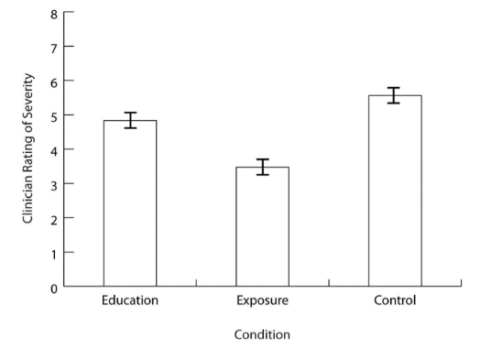

*Note.* An explanation of the graph elements can be included here *(optional).*

**References**

APA (2019). *Publication Manual of the American Psychological Association* (7th ed.). American Psychological Association.

**Exclamation mark - Wikipedia**FOR NON GREEK-SPEAKING AUTHORS, THIS SECTION CAN BE FILLED IN BY THE JOURNAL EDITORS

ΕΜΠΕΙΡΙΚΗ ΕΡΓΑΣΙΑ | RESEARCH PAPER *(click on the text to select)*

**Τίτλος εργασίας: Κεφαλαίο μόνο το πρώτο γράμμα της πρότασης, μέγεθος γραμματοσειράς 16, έντονα, διάκενο 1,15 - κενό μετά την παράγραφο 18 pt (μέχρι 20 λέξεις)**

Όνομα ΕΠΩΝΥΜΟ Α1, Όνομα ΕΠΩΝΥΜΟ Β2, Όνομα ΕΠΩΝΥΜΟ Γ3

1 Τμήμα/Σχολή, Πανεπιστήμιο / ‘Ίδρυμα

2 Τμήμα/Σχολή, Πανεπιστήμιο / ‘Ίδρυμα

2 Τμήμα/Σχολή, Πανεπιστήμιο / ‘Ίδρυμα

|  |  |  |
| --- | --- | --- |
| KEYWORDS IN GREEK |  | ABSTRACT IN GREEK |
| Λέξη κλειδί 1  Λέξη κλειδί 2  Λέξη κλειδί 3  κλπ |  | Enter the summary of the paper (up to 250 words) in Greek language. |
| CORRESPONDENCE |
| Ονοματεπώνυμο  Ίδρυμα  Ταχυδρομική Διεύθυνση  Email |

© 2024, Συγγραφείς Ψυχολογία: Το περιοδικό της Ελληνικής Ψυχολογικής Εταιρείας

Άδεια CC-BY-SA 4.0 <https://ejournals.epublishing.ekt.gr/index.php/psychology>

https://doi.org/10.12681/psy_hps.xxxx

1. Footnote format