

Paper Title (All articles in Greek should have the first page translated in English)

Author, Second Author, Third Author

Abstract: The abstract is a one-paragraph summary between 150 and 250 words, without references. It contains main theoretical background, purpose, scope, methodology, results, and conclusions. In case of articles in Greek language, this first page should contain all the relative info in English and the provided abstract should be extended to a length of 250 to 300 words.
Keywords: social behaviour, individual differences, human complex systems, cultural psychology (include up to 5 keywords)

Tίτλος (Στα Ελληνικά)

Πρώτος Συγγραφέας, Δεύτερος Συγγραφέας, Τρίτος Συγγραφέας

Περίληψη: Η περίληψη αποτελείται από μια παράγραφο με έκταση από 150 ως 250 λέξεις, χωρίς να περιέχει παραπομπές. Περιλαμβάνει περιληπτικά τις κύριες θεωρητικές βάσεις, το σκοπό και τους στόχους της εργασίας, τη μεθοδολογία, τα αποτελέσματα και τα συμπεράσματα.
Λέξεις κλειδιά: δυνητικές κοινότητες, πολύπλοκα συστήματα, ψηφιακή κουλτούρα, δυνητοποίηση (μέχρι 5 λέξεις κλειδιά)

Εισαγωγή

Το κείμενο σε όλη την εργασία είναι γραμματοσειράς Calibri, 12 p, συμπεριλαμβανομένης της περίληψης. Όπου αλλού υπάρχει διαφοροποίηση στο μέγεθος ή στο είδος (έντονο), είναι όπως φαίνεται σε αυτό το πρότυπο. The main text begins on a new page. The subsections of the main text do not begin on a new page. Headings are used to better organize the document and reflect the relative importance of sections. No strict structuring is required, such as Methods, Results, Discussion, and References headings. The Method section may have subheadings of Participants, Apparatus, and Procedure (if empirical paper). Use footnotes instead of endnotes, sequentially numbered in the text with superscript Arabic numerals. Source citations are made in the text, not in the footnotes.

Κυρίως μέρος (ενότητες)

Οι πηγές στο κείμενο πρέπει να αναφέρονται με ένθετες παραπομπές ακολουθώντας το σύστημα APA 6th edition. Για παράδειγμα: (Koskinas, 2018; Brailas et al. 2017; Tsekeris et al. 2012). Don’t use “ibid”. The direct quotation should include the author, year, and page number(s) as part of the citation. Full source citation should be provided at the list of references that follows the main text. An extract of over 40 words must appear (without quotes) in block format with each line indented five spaces from the left margin.

Τίτλος ενότητας

Figures, photographs, and tables must be reproducible and carefully numbered and labeled (placed within the text at the appropriate points, rather than at the end). They must have descriptive captions and be mentioned in the text. The References section begins on a new page. Entries must be organized alphabetically by surnames of first authors. If English is not your first language, you should have your manuscript professionally proofread before submission. Upon acceptance, editors may require additional copy editing. Try to use clear and concise language.

Εικόνα 1: Calibri, 12 font size
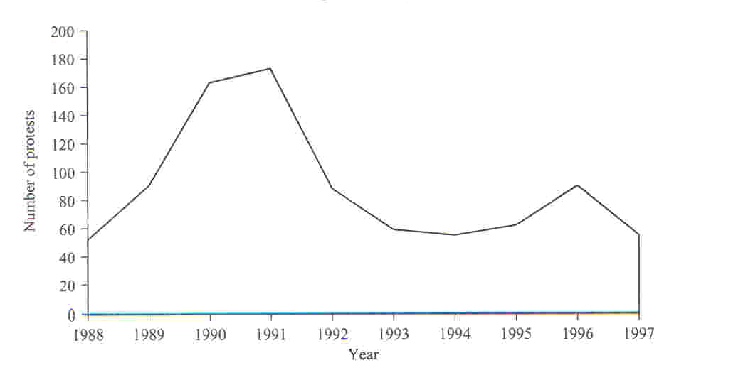
Source: Calibri font style, 11 font size

Βιβλιογραφία

Aldridge, A (1999) Prediction in Sociology: Prospects for a Devalued Activity, Sociological Research Online, 4(3). http://www.socresonline.org.uk/4/3/aldridge.html
Bhaskar, Roy (1989). Reclaiming Reality: A Critical Introduction to Contemporary Philosophy. London: Verso.
Steier, F (1991) Introduction: Research as Self-Reflexivity, Self-Reflexivity as Social Process, in F Steier (ed.) Research and Reflexivity. London: Sage.

Οι συγγραφείς

Include a short author biography here (no more than 150 words each author).

Author’s title, departmental/institutional affiliation, and email/postal address for correspondence
Author’s title, departmental/institutional affiliation, and email/postal address for correspondence

